Hello! 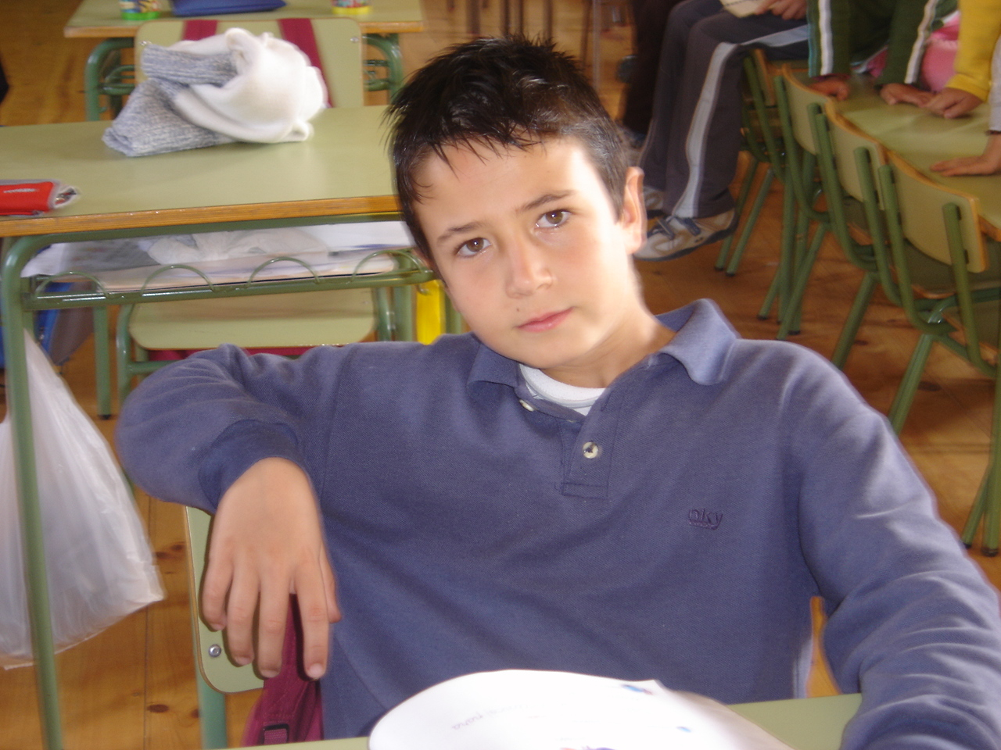
My name’s Marcos
My birthday is in November
My favourite food is macaroni.

My favourite colour is red
My favourite pet is dog
My favourite number is 10
My favourite month is November

BYE, BYE
Marcos

