[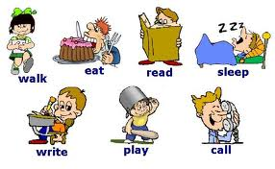](http://www.google.com.pa/imgres?sa=X&hl=es&rlz=1T4NDKB_esPA533PA534&biw=1024&bih=474&tbm=isch&tbnid=ACT9jr9BnH7flM:&imgrefurl=http://tx.english-ch.com/teacher/jocelyn/level-b/kinds-of-verbs-exercise/&docid=V3noaIvex5zyUM&imgurl=http://tx.english-ch.com/teacher/jocelyn/verb.jpg&w=540&h=334&ei=hSWLUaCBHorG9gTM84GoCg&zoom=1&ved=1t:3588,r:48,s:0,i:312&iact=rc&dur=491&page=4&tbnh=176&tbnw=286&start=42&ndsp=16&tx=226&ty=93)