[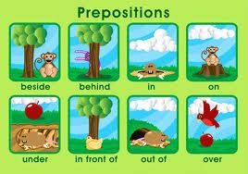](http://www.google.com.pa/imgres?sa=X&hl=es&qscrl=1&rlz=1T4NDKB_esPA533PA534&biw=1024&bih=474&tbm=isch&tbnid=D3nDHtbNpJ2_NM:&imgrefurl=http://samogaathome.blogspot.com/2012/05/prepositions-in-english.html&docid=ELqSVm2DdD-aUM&imgurl=http://2.bp.blogspot.com/-UdLzmlMGmfw/T0S1ih79AYI/AAAAAAAAAgE/rnY2CHQCU98/s1600/preps.gif&w=450&h=316&ei=bySLUc60DJP49gTol4DgDA&zoom=1&ved=1t:3588,r:7,s:0,i:180&iact=rc&dur=760&page=1&tbnh=177&tbnw=252&start=0&ndsp=9&tx=163&ty=93)