[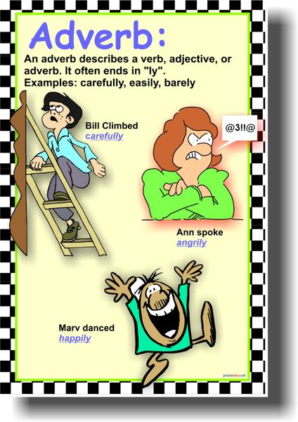](http://www.google.com.pa/url?sa=i&rct=j&q=&esrc=s&frm=1&source=images&cd=&cad=rja&docid=xvFS1hU9xTtFIM&tbnid=GEDG1vnBbV5LCM:&ved=0CAUQjRw&url=http://www.posterenvy.com/servlet/the-1781/adverb-parts-of-speech/Detail&ei=uiOLUfPdJY3Y9ATH_YCIAw&bvm=bv.46226182,d.eWU&psig=AFQjCNFa8E30rLPNgiiLWc1NOUyQdlIgWQ&ust=1368159196798761)