[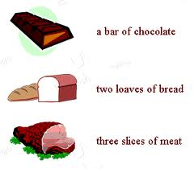](http://www.google.com.pa/imgres?um=1&sa=N&hl=es&qscrl=1&rlz=1T4NDKB_esPA533PA534&biw=1024&bih=474&tbm=isch&tbnid=-mNwIsJx-aOwkM:&imgrefurl=http://tx.english-ch.com/teacher/yuri/level-c/useful-expressions-how-to-count-noncount-nouns/&docid=DNn62Xs2qeol3M&imgurl=http://tx.english-ch.com/teacher/yuri/nc_pic1.jpeg&w=316&h=276&ei=ByCLUdfHA4iu8QSMv4CoAg&zoom=1&ved=1t:3588,r:82,s:0,i:414&iact=rc&dur=729&page=6&tbnh=204&tbnw=221&start=67&ndsp=18&tx=95&ty=57)