[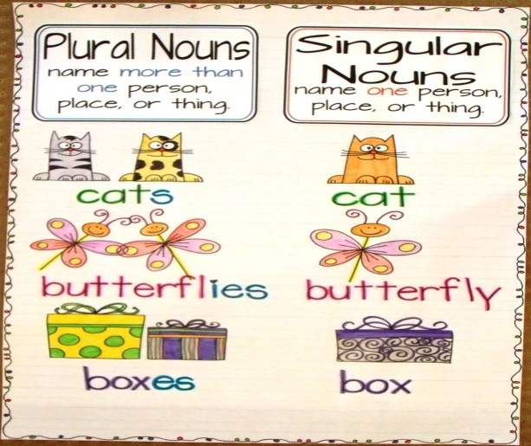](http://www.google.com.pa/url?sa=i&rct=j&q=&esrc=s&frm=1&source=images&cd=&cad=rja&docid=mH-AW_9G2oU85M&tbnid=sYmXGFvam1znFM:&ved=0CAUQjRw&url=http://sandbergsmartyarties.blogspot.com/2012/10/singular-and-plural-nouns-anchor-chart.html&ei=mxyLUaCoIoyw8QSkmYHADA&bvm=bv.46226182,d.eWU&psig=AFQjCNG10o2DYkZc_kVk9mdqYdqW6wrepg&ust=1368157714503043)