[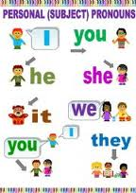](http://www.google.com.pa/imgres?sa=X&hl=es&rlz=1T4NDKB_esPA533PA534&biw=1024&bih=474&tbm=isch&tbnid=M7X2ABxAhchdPM:&imgrefurl=http://tx.english-ch.com/teacher/jun/level-b/grammar-focus-personal-pronouns/&docid=8OUFNwW3crKD1M&imgurl=http://tx.english-ch.com/teacher/jun/personal_pronouns.jpg&w=180&h=256&ei=EiSLUeTNKIbg8ASRz4GABw&zoom=1&ved=1t:3588,r:61,s:0,i:338&iact=rc&dur=563&page=5&tbnh=204&tbnw=144&start=49&ndsp=15&tx=62&ty=102)