Answering Questions with Databases
NURS 602
Athabasca University
Miley, Bank-Ki, Emma
Professor Jack Yensen

Abstract
Utilizing informatics can allow nurses and other healthcare professionals to combine technology and science to improve patient care. Understanding and assessing datasets can help answer questions to healthcare problems. Wait times for surgical procedures in Canada have been a healthcare problem for years. A 10-year plan was developed Canada wide to address the issue of wait times, with each province implementing their own strategies. Using raw wait time data we will attempt to answer a question regarding wait times for knee replacement surgeries.
Keywords: Canada, surgery, data, dataset, benchmark, percentiles

Answering Questions with Databases
Wait times for surgical procedures are high across Canada resulting in delays in care and increased patient suffering. In 2004, First Ministers of Canada developed a 10-year plan to reduce wait times and improve access for surgical procedures such as total knee replacement (TKR) (Statistic Canada, 2006). Each province developed initiatives to meet the national wait time benchmark of 182 days. In this paper we will discuss how informatics can be used to address the problem of surgical wait times.
Formulation and Scope of Problem
Across Canada, significant amounts of healthcare data are collected daily. Healthcare informatics allow provinces to measure performance and use data to develop plans for budgeting, trending, containing costs, improving workflow and creating decision support tools (McGonigle, Hunter, Sipes, & Hebda, 2014). Raw data is converted to wisdom by creating context to give meaning; information increases knowledge of health professionals and can finally be used to inform decision (McGonigle et al., 2014). Obvious data variances are observed in Canada’s provincial TKR wait time data. The group used deductive reasoning to form a hypothesis from raw data that different provincial strategies impact wait time trends in individual provinces.
Dataset and Source
The chosen dataset is accessible from the Canadian Institute for Health Information (CIHI, n.d.b), an “independent, not-for-profit organization that provides essential information on Canada’s health system and the health of Canadians” (CIHI, n.d.a). While a variety of data is available, for the purposes of this assignment, we have focused on TKR data (Appendix A). The dataset provides the number of patient days waiting meeting the national benchmark, as well as 50th and 90th percentiles of days waiting.
Structure of Data
The dataset was accessed online as raw data in an Excel spreadsheet. Data rows representing interval data of Canadian provinces are separated by rows representing nominal data of years. The columns of the spreadsheet include the surgery or intervention (nominal data) and are further divided into additional columns representing the number of patients waiting for treatment, the percentage of surgeries that met the national benchmark, the number of days waiting in the 50th percentile, and the number of days waiting in the 90th percentile (CIHI, n.d.b).
Question Posed
In 2015, the province of British Columbia (BC) invested $10 million and included private clinics in a strategy to timely complete procedures, such as TKR. The goal was to address wait times longer than 40 weeks (Shaw & Robinson, 2015). Reasoning for the decision to emulate Saskatchewan’s (SK) model of using third-party facilities was increased surgical capacity and improved patient satisfaction (BC Ministry of Health, 2015). Newfoundland and Labrador (NL) alternatively implemented an orthopaedic wait time strategy in 2012 using only public facilities (Government of Newfoundland and Labrador, 2012). Our question posed is: Which province when compared to BC demonstrates more effective TKR wait time management, SK, which contracts private surgical facilities, or NL, which uses only public facilities?
Results
Wait time data includes adults aged 18 years and older waiting for TKR including primary procedures and revisions at all priority levels. The data excludes emergency cases, knee resurfacing techniques, and days a patient was unavailable for the procedure (CIHI, n.d.c). Wait time is defined as the number of days from the patient and physician agreeing to a service to the date the patient received TKR (CIHI, n.d.c). The data sets for BC, SK, and NL were entered into an Excel table and analyzed based on the percentage of patients meeting benchmark, and the number of days that 50% and 90% of patients wait. Linear regression was used to forecast trends for each province in all three (3) areas (Appendix B). The percentage of BC patient wait times meeting the national benchmark has declined since 2009. Alternatively, both SK and NL have seen an increase in the number of patients meeting the benchmark. In 2013, NL achieved the highest percentage of procedures meeting the benchmark at 93% while SK had 66% and BC had 65%. As both SK and NL decreased the number of days that 50% of the patients wait, BC has increased the days at 50th percentile in 2013. Graphing the 90th percentile data again illustrates SK and NL improving while BC is only slightly improving the number of days 90% of patients wait. As BC is projected to fail in its ability to meet benchmarks and worsen in its ability to reduce days that 50% of the patients wait, both NL and SK are projected to improve.
Evaluation and Conclusion
The data indicates that both NL and SK have been more effective than BC at improving TKR wait times. NL is outperforming SK and providing an example of effective TKR wait time management. The dataset, however, does not provide enough information to fully answer the question. While the variance between provincial waitlist targets can be compared, the reasons for differences in success are not identified. The reported data is limited to four (4) years for NL and six (6) years for the other two provinces limiting the comparison of trends over time. As provinces actively implement surgical strategies data since 2013 is not available; however, projections estimate that the gap between BC and the other two provinces will continue to widen. A shift to improve wait time data appears to correlate with the implementation of strategic initiatives in both SK and NL. Numerous tactics were implemented simultaneously with no means to determine the impact of each of the separate strategies on waitlist success. It is not clear how many procedures in BC and SK have been performed in private clinics, as the data does not differentiate. Although BC has taken steps to reduce TKR wait time, data demonstrates that SK and NL have been, and will continue to be, better able to meet benchmarks. NL provides the more effective example of wait time management with data that also shows that it is possible to have a fully public system that meets or exceeds expectations.

References
BC Ministry of Health. (2015). Future directions for surgical services in British Columbia. Retrieved from http://www.health.gov.bc.ca/library/publications/year/2015_a /surgical-services -policy-paper.pdf
Canadian Institute of Health Information. (n.d.a). About us. Retrieved from https://www.cihi.ca/en/about-cihi
Canadian Institute of Health Information. (n.d.b). Wait times metadata [Data file]. Retrieved from https://www.cihi.ca/en/health-system-performance/access-and-wait-times/wait-times-metadata
Canadian Institute of Health Information. (n.d.c). Wait time information in priority areas: Definitions. Retrieved from https://www.cihi.ca/en/wait_time_def_evo_en.pdf
Glauser, W. (2011). Private clinics continue explosive growth. Canadian Medical Association Journal, 183(8), E437-E438. doi:10.1503/cmaj.109-3816
Government of Newfoundland and Labrador. (2012). A strategy to reduce hip and knee joint replacement surgery wait times in Newfoundland and Labrador. Retrieved from http://www.health.gov.nl.ca/health/wait_times/pdf/orthopedic_wait_times_strategy.pdf
McGonigle, D., Hunter, K., Sipes, C., & Hebda, T. (2014). Why nurses need to understand nursing informatics. AORN Journal, 100(3), 324-327. Retrieved from http://dx.doi.org/10.1016/j.aorn.2014.06.012
Shaw, R., & Robinson, M. (2015, June 1). B.C. calls on private surgery centres to help clear up wait lists. The Vancouver Sun. Retrieved from http://www.vancouversun.com/health/ calls+private+surgery+centres+clear+wait+lists/11099874/story.html

Statistics Canada. (2006). Waiting times for specialized services (January to December 2005). Retrieved from http://www.statcan.gc.ca/pub/82-575-x/82-575-x2006002-eng.htm
The Saskatchewan Surgical Initiative. (2010). Sooner, safer, smarter: A plan to transform the surgical patient experience. Retrieved from http://www.sasksurgery.ca/pdf/sksi-

Appendix A

 |  | Knee Replacement
Data Year | Province | Volume | % Meeting Benchmark | 50th Percentile (in Days) | 90th Percentile (in Days)
2013 | Alta. | 2962 | 72 | 127 | 294
 | B.C. | 3407 | 65 | 118 | 258
 | Man. | 1127 | 58 | 157 | 344
 | N.B. | 682 | 60 | 143 | 352
 | N.L. | 439 | 93 | 77 | 170
 | N.S. | 832 | 43 | 231 | 593
 | Ont. | 12499 | 85 | 79 | 216
 | P.E.I. | 173 | 61 | 148 | 324
 | Que. | 4766 | 78 | 96 | 258
 | Sask. | 1501 | 66 | 128 | 354
 | Canada | 28388 | 76 | 104 | 263
2012 | Alta. | 2850 | 79 | 104 | 301
 | B.C. | 3475 | 65 | 124 | 253
 | Man. | 1015 | 46 | 198 | 397
 | N.B. | 665 | 61 | 143 | 340
 | N.L. | 438 | 81 | 105 | 250
 | N.S. | 778 | 42 | 258 | 557
 | Ont. | 11547 | 84 | 76 | 226
 | P.E.I. | 147 | 35 | 225 | 362
 | Que. | 4644 | 76 | 102 | 253
 | Sask. | 1061 | 55 | 165 | 420
 | Canada | 26620 | 75 | 106 | 270
2011 | Alta. | 2650 | 70 | 124 | 344
 | B.C. | 3349 | 67 | 122 | 257
 | Man. | 1049 | 52 | 176 | 420
 | N.B. | 684 | 53 | 172 | 389
 | N.L. | 413 | 62 | 139 | 469
 | N.S. | 795 | 44 | 209 | 617
 | Ont. | 10886 | 85 | 78 | 219
 | P.E.I. | 112 | 55 | 171 | 297
 | Que. | 3792 | 78 | 99 | 246
 | Sask. | 973 | 62 | 139 | 357
 | Canada | 24703 | 75 | 107 | 278
2010 | Alta. | 2342 | 69 | 128 | 344
 | B.C. | 3317 | 76 | 101 | 236
 | Man. | 976 | 53 | 172 | 420
 | N.B. | 543 | 67 | 119 | 314
 | N.L. | 358 | 67 | 113 | 438
 | N.S. | 841 | 42 | 218 | 582
 | Ont. | 10250 | 89 | 72 | 190
 | P.E.I. | 99 | 73 | 127 | 316
 | Que. | 3518 | 83 | 96 | 225
 | Sask. | 838 | 61 | 135 | 428
 | Canada | 23082 | 79
2009 | Alta. | 2233 | 71 | 120 | 352
 | B.C. | 3241 | 77 | 85 | 275
 | Man. | 878 | 56 | 160 | 470
 | N.B. | 575 | 63 | 137 | 340
 | N.L. | 310
 | N.S. | 697 | 47 | 195 | 576
 | Ont. | 10332 | 90 | 67 | 184
 | P.E.I. | 111 | 69 | 137 | 309
 | Que. | 3018 | 85 | 85 | 214
 | Sask. | 1086 | 48 | 194 | 463
 | Canada
2008 | Alta. |  | 72 | 123 | 299
 | B.C. | 3130 | 71 | 102 | 332
 | Man. | 1052 | 52 | 174 | 479
 | N.B. | 538 | 55 | 167 | 408
 | N.L. | 287
 | N.S. | 660 | 46 | 213 | 647
 | Ont. | 9922 | 85 | 71 | 223
 | P.E.I. | 105 | 75 | 108 | 345
 | Que. | 2605 | 86 | 85 | 211
 | Sask. | 818 | 37 | 246 | 613
 | Canada

APPENDIX B

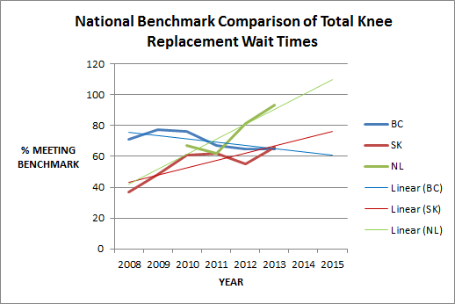
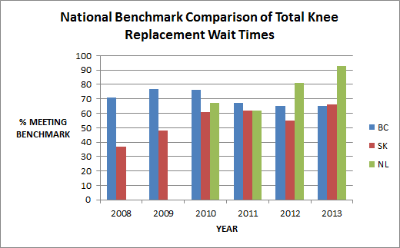

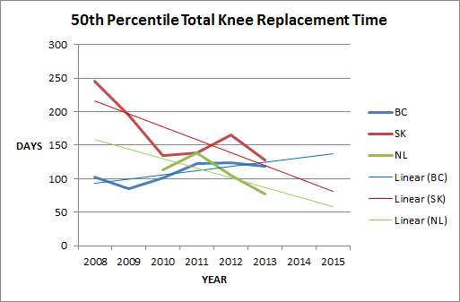
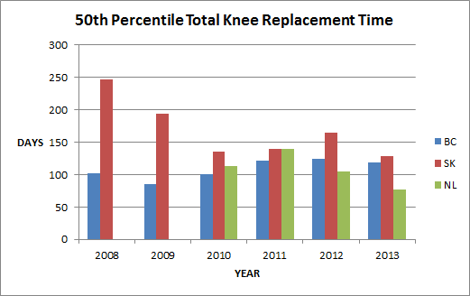

NOTE: 50th percentile represents the number of days in which half of the patients received treatment and half did not.
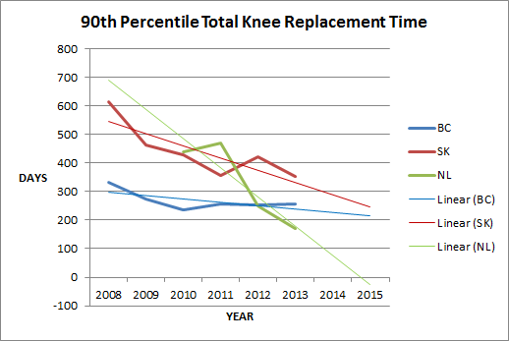
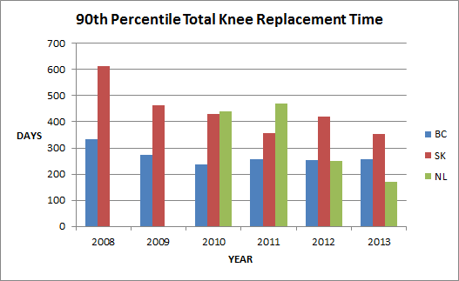

NOTE: 90th percentile represents the number of days in which 90% received treatment and 10% did not.

