Follow the steps below to register for the course materials offered by the Open Learning Initiative.
- Go to the Open Learning Initiative (OLI) website: http://oli.cmu.edu
- In the upper right hand corner of the site, click “Register” and fill out the form.
- On the “Confirm Your Account Information” page, review the account information you entered. If everything is correct, click the "Confirm Account" button. If not, click "Edit Account" to make your changes.
Important Note: the only account setting that can't be changed after you confirm your account is your Account ID.
- Read the statements in the “Online Consent Form” and select “I Agree” or “I Do Not Agree” then select “Submit.” Once you are registered, find Open and Free Courses on the home page:
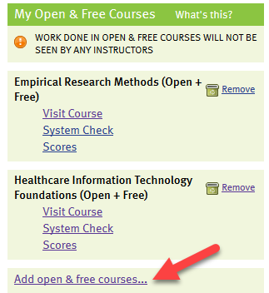
- Click on Add open & free courses and add Healthcare Information technology Foundations. Visit this course any time to use any of the course resources and learning activities to support your learning and assignments in NURS/MHST 602

