The Battle of Poitiers (1356)
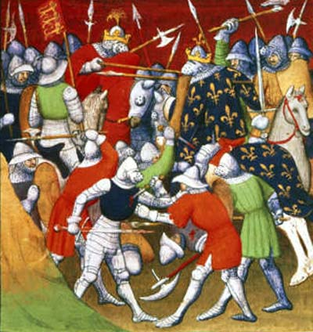

The son of King Edward III, namely Edward the Black Prince, defeated the army of the new French king John II near Poitiers. The French army was twice bigger than the English one, but they did not succeed in winning this battle as the English longbowmen were too strong. King John II and his son Philip Duke of Bourgogne were captured by the Black Prince.

