Genes to Cognition (G2C) Online workshop outlineDay 1 – Genes to Cognition (G2C) Online Content:
Genes to Cognition (G2C) Online – Workshop Material

www.g2conline.org

Contents |  | Page
 | G2C Online workshop schedule |  | 2
 | Useful information |  | 4
 | How to Download CmapTools… |  | 5
 | How to Run CmapTools… |  | 6
 | How to Share a Concept Map… |  | 9
 | G2C Online Workshop Jigsaw |  | 11
 | Model Organisms – Student Pages |  | 13
 | Genes for Memory - Student Pages |  | 18
© 2008, Cold Spring Harbor Laboratory. All rights reserved.

G2C Online workshop schedule:

- Pre-workshop survey: www.g2conline.org/survey

- Introduction to the G2C Online Internet site:
- Neuroscience in 2008 (not 1998!)
- Exploring the site
- Fostering meta-cognition
- Putting the systems in systems-biology

- Introduction to Teacher Feature
- Meet your teachers
- Is neuroscience relevant to biology and psychology curricula? Creating lessons that reference AP curricula and national standards

- The neurobiology of Learning and Memory

- SAP102 knockout mice
- Morris water maze and learning impairments
- Ethics and other relevant concepts

- How is a gene “knocked out?”
- How do we interpret gene knockouts – the future of medicine?

- Chromosome map
- How to search for genes
- Linking to research sites (NCBI)
- Mapping research

- The NMDA receptor
- What is NMDA? Search!
- Interview with Seth Grant
- How do genes relate to biochemistry and brain function?

- Molecules for Memory
- Introduction to the glutamate neurotransmitter
- What is long-term memory (LTM)?
- How do we understand LTM across levels (genes, neuroanatomy, and beyond)?

LUNCH

- Fly School
- More lesson plans
- Evidence from (unpublished) pharmaceutical trials – creating mice with photographic memories – time for an ethics debate?

- Revise the Learning and Memory “story”
- The final element of the story is the 3-D G2C Brain (awaiting development).

- Another “story”” autism
- Reading Faces

- Autism from a systems-level perspective
- Genes for autism
- Biochemicals and autism
- Autism and cells
- The neuroanatomy of autism
- Experiencing autism
- The environment and autism

- Independent group work: schizophrenia
- The jigsaw

- Group presentations

- Brief feedback

DAY 2 – G2C Online and Concept Mapping

- Basic principles and construction of concept maps.

- Theoretical underpinnings and classroom-related uses.

- Workshop activity: Construct and compare concept maps.

- Computer-generated maps: CmapTools and DNALC Simple Mapper

- Post-workshop feedback

Useful information:

Genes to Cognition (G2C) Online homepage: www.g2conline.org

- DNALC computer login details: Simply click on the “Workshop” username.

- The Dolan DNA Learning Center: www.dnalc.org

- G2C Online pre-workshop survey: www.g2conline.org/survey

- To run G2C Online, your browser needs to run Flash Player 9. If it is not already installed, it can be downloaded for free from www.adobe.com (click on Get ADOBE FLASH PLAYER).

- G2C Online is produced by John Connolly at the Dolan DNA Learning Center – email: connolly@cshl.edu; tel. 516-367-5179.

- The site is funded by the Dana Foundation (www.dana.org) and the William and Flora Hewlett Foundation (www.hewlett.org).

- CmapTools can be downloaded from the Institute for Machine and Human Cognition at the following address: http://cmap.ihmc.us/conceptmap.html. Further instructions are given below.

How to Download CmapTools onto your computer:

NOTE: Before you can install anything on your computer, you need to make sure you have administrative privileges. If you are using a computer from your affiliate institute, you may need to contact your technical staff. If you are using a personal computer, this should not be a problem.

- Go to the following address: http://cmap.ihmc.us/conceptmap.html

- The page is displayed as a concept map. The concept at the top of the map says “IHMC CmapTools.” At the bottom of this concept are two small boxes.

  - On the “IHMC CmapTools” concept, click on the small box on the left-hand side.
  - This gives you a menu of four items – choose the top one, “CmapTools Download Information and Forms” (see the screenshot below).


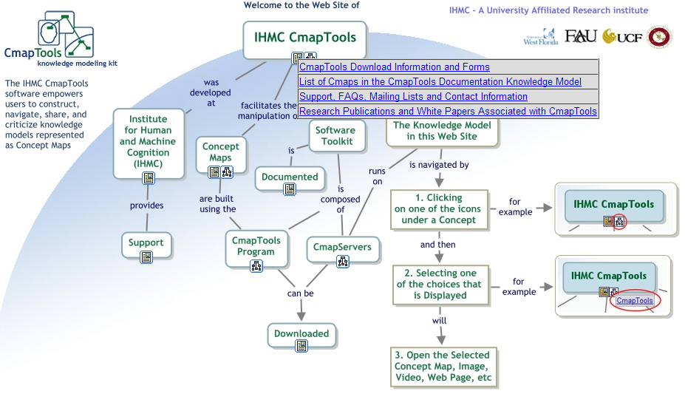

- This will take you to a new download screen – select your platform (Windows (PC), Mac, Linux, or Solaris).

- Click Download.

- You will be prompted to fill in some personal information, which is required for registration (the IHMC is a non-profit organization, and can be presumably trusted not to use your email address erroneously).

- Click Submit.

- Again, hit Download and proceed to save the file to an appropriate location.

How to Run CmapTools and create a Cmap:

    - Click the Start menu in the bottom-left of the screen.

    - Choose the All Programs option.

    - Find the “IHMC CmapTools” folder. It is probably close to the bottom of the programs menu.

    - When you rollover the folder, you will have see a “CmapTools” option. Click on it. Note: If you are prompted for a username/password, “workshop” will work for both.

    - By default, CmapTools typically opens two windows – the Views window and a window called “Untitled 1”, which is the concept map window. If you see both of these windows, proceed to number 8.

Views window
Concept Map window (“Untitled 1”)

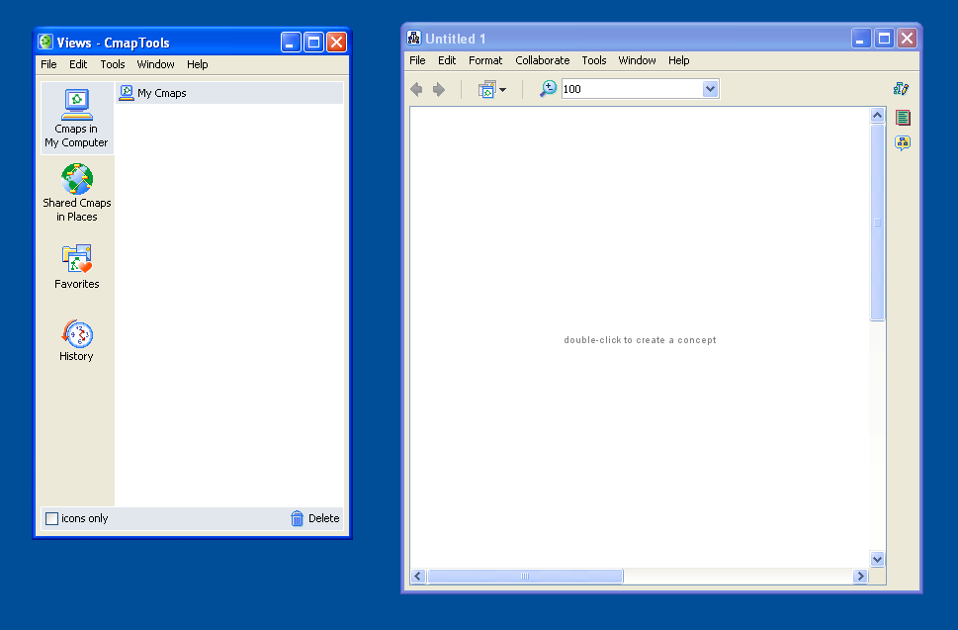
My Cmaps

    - If the Views window does not open, all you need to do is click on Window and choose the first option Show Views.

    - If the concept map window does not open, proceed as follows:

      - In the Views window, click on the File.

      - Your first option will be to create New Cmap. Click it.

      - This will open a blank window called “Untitled 1.” This is the space where you can draw you new concept map. But first you need to save your map!

    - The “Untitled 1” window is an empty concept map. This is where you will create your new map. The first thing you need to do is give your map a name:

          - Click on “Untitled 1” to select that window.

          - Click on File. Under File, your third option will be to Save Cmap. Click Save Cmap.

          - You will be prompted to name your file. There are some other options to include extra information. This information is not essential to creating your map.

          - Once you click Save, you will see your concept map appear under “My Cmaps”.

    - You are now ready to create your own map:

      - Double-click in the blank workspace of your recently saved map.

      - This will create a concept with the default name “????”. You can identify concepts because they have a box around them.

      - Name your concept and then click in the blank workspace – you should see the name change from “????” to whatever you called you concept.

    - Now, return your mouse to your newly created concept and click once. You will see a small box appear above the concept with two downward-pointing arrows.

    - Move you mouse up to the box with arrows. Click and do not release in the space just beneath the point where the arrows meet.

    - Drag you mouse out. This will do things:

          - It will create a new concept, titled “????”. Click on this concept once to give it a new name (as with number 4, above).

          - It will also create the all-important link word. Again, the default name for the link-word is “????”. Just as with the concepts, just click the link-word once to rename it.

          - Note: You can tell concepts and link-words apart quite easily. Concepts have a box around them, link-words do not.

    - You can proceed in this way to draw out your map.

    - Once you become familiar with CmapTools, you can use more sophisticate Style options to change the look of you map:

          - Click on Format at the top of the page.

          - Choose the Styles option.

          - In the Styles window, you have various options to format font, object (i.e. the concept or link-word you have selected), line, or the entire Cmap.

          - You have a number of options to change the design of your map. We will not go into them here, but once you become familiar with the tool, you can begin to experiment.

    - You also have the option of adding hyperlinks to your concepts:

      - Right click on one of the concepts you have created.

      - One option is to Add Web Address. Click it.

      - Under Resource Name, you can name your hyperlink (e.g. “G2C website”)

      - Under Web Address, type the full url (e.g. http://www.g2conline.org)

      - Click OK.

    - You can also search for maps in the public folders. There are often hundreds of maps (of varying quality) available.

      - Click on Tools at the top of the page.

      - Choose Search. You have the option to search for other CMaps in the various public folders.

      - Note: There is no quality control on these maps – some are very good and some are truly awful.

    - Another option is to add images or other resources:

      - Right click on one of the concepts you have created.

      - One option is to Add & Edit Links to Resources… Click it.

      - Locate the resource you’d like to add (e.g. a PDF or an image) and select it with your mouse.

      - Click Add to List and click Update.
How to Share a Concept Map using CmapTools:

Note: This is a little tricky but well worth the effort.

- When you save a concept map using CmapTools, the default is to save the map locally in your computer. Another option is to save your map in a public folder, where Cmaps can be shared with other users.

- If you followed the steps on how to run CmapTools (above), you will have saved your map in Cmaps in My Computer workspace (see below). The option immediately below is Shared Cmaps in Places. Select this option by clicking it once.

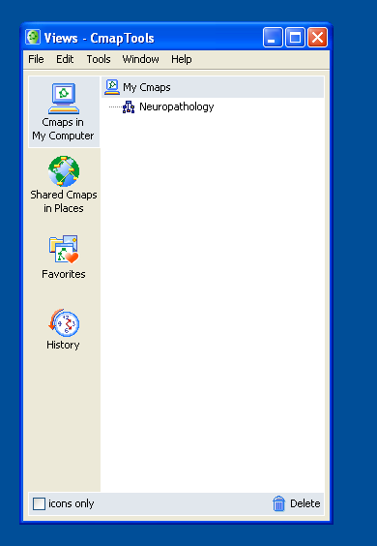
My Cmaps
Shared Cmaps

- You should be given the option of choosing from one of four folders. Select the IHMC Public Cmaps (2) option by clicking the “+” to the left, which you can see in the image below.

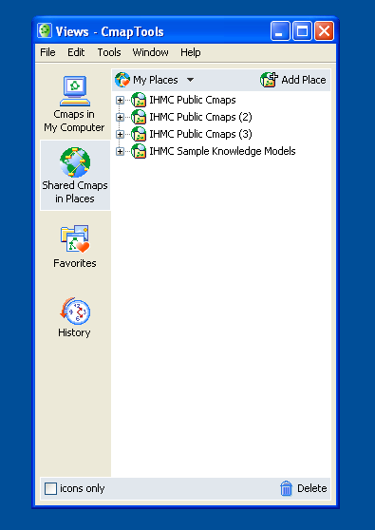
Click Here

- After a short pause, you should see a number of folders opening up. These are folders that other CmapTools users have created in order to share Cmaps. The DNALC has created a folder called “G_2C”, which is where we share some maps. In order to find this folder, scroll down through the list of folders until you find the “G_2C” folder.

- Double-click on the G_2C folder. NOTE: You may require a username and/or password. The username AND password for the G_2C folder is “workshop.”

- The folder should open and you will see some other Cmaps and sub-folders. If you see a sub-folder with the name of your workshop, double-click that to enter. The next part is tricky…

- You are now ready to share your Cmap:

  - Leave the G_2C folder open.

  - Go back to the Views window.

  - In the Views window, select Cmaps in My Computer. You should see the concept map you created earlier.

  - Click to select the map you created and drag the map to the G_2C folder.

  - You can now share your map with the world!

- Note: You can also create your own folders in IHMC Public Cmaps. You can create folders for students to work in, where they can create maps, collaborate, etc.

- Note: Rather than having the bother of finding the G_2C folder every time, you can add it as a shortcut. To do this:

  - When you navigate to the G_2C folder through IHMC Public Cmaps, instead of left-clicking to enter the folder, you can right-click.

  - This will bring up a menu. One option is to Add to Favorites. Select this option.

  - From the Views window, the third option (after Cmaps in My Computer and Cmaps in Places) is Favorites. An easy-to-access shortcut will be saved in the Favorites; it will take you directly to the folder.

G2C Online Workshop Jigsaw:

You will be assigned a number corresponding to a specific level on the G2C continuum (genes are 1, biochemicals are 2, etc.) Your task has three parts:

- Find out as much information as you can about schizophrenia in terms of research specific to that level (e.g. if you are number 2, find out as much as you can about the biochemistry of schizophrenia).
- Once you have that information, try to integrate this information with the levels immediately above and below yours (e.g. if you are looking at biochemistry, try to integrate this with cellular and genetic approaches).
- Come together as a group and pool your knowledge to construct a “story” about schizophrenia that relates all these levels. You will be asked to present your results.

Number 1:
Information about Genes
⬆
Interactions of Genes and Biochemicals
⬇
Number 2:
Information about Biochemicals
⬆
Interactions of Biochemicals and Cells
⬇
Number 3:
Information about Cells
⬆
Interactions of Cells and Brain Anatomy

⬇
Number 4:
Information about Brain Anatomy
⬆
Interactions of Brain Anatomy and Cognition

⬇
Number 5:
Information about Cognition
(Behavior/
Symptoms)
⬆
Interactions of Cognition and Environment
⬇
Number 6:
Information about the Environment

Student pages: Model Organisms – Fly School

Model organisms are particular species of animal that can substitute for humans. With model organisms, answers to scientific questions can usually be obtained faster and without many of the ethical dilemmas caused by using human subjects. Discoveries made using model organisms provide insight into the workings of other organisms, including humans.

This activity examines learning and memory in the common fruit fly, Drosophila melanogaster. Fruit flies are easy to breed, reach maturity in days, and have many of the same genes that humans have. As a result of their popularity as a model organism, much is known about their genes and the role of the environment in the expression of these genes.

In this activity, the genes responsible for learning and memory in humans are examined in the fruit fly. Investigations of the genes involved in these processes may lead to treatments for disorders of learning and memory such as Alzheimer’s disease.

Fruit flies are sensitive to a wide variety of odors. By conducting a series of experiments online, it is your task to determine the conditions in which fruit flies learn to avoid a specific odor. Once the flies have learned which odor to avoid, you will want them to remember for as long as possible.

A simple T-maze training chamber allows your flies to move to the right or the left. By manipulating a number of variables such as fly-type, odor, number of training sessions, or whether to administer an electric shock, you can design the experiment you would like to conduct.

Begin your task by accessing the Internet site Genes to Cognition Online, at http://www.g2conline.org. Access Fly School, found under the Model Systems research approach, and read the introduction. Use a separate piece of paper to record your responses to the questions on the accompanying worksheets.

Model Organisms – Fly School Part 1:

- Rollover the wild type flies icon to read about this particular fly strain. After reading the information, explain why your first round of experiments should be done with wild type flies and not with a variant.

- Click on the wild type fly icon to load your flies in the training device. They are now ready to learn.

- Select the number of training sessions. To begin with, select 1 time. Do you think the flies will learn better and remember longer if they go through the training process one time or ten times?

- Your flies will be exposed to two different odors during the training. One of the odors must be associated with electrical shock and the other not. Attempt to train the flies to avoid the odor associated with shock. Select OCT and Shock for training session 1 and click continue. For training session 2, select MCH and No Shock. Continue.

- Remember, the goal is to train your flies to learn to avoid a specific odor and to remember to avoid it for as long as possible. First, choose the 30 minutes time option.

- Now the moment of truth! Did you train your flies? Do they remember which odor is associated with the electrical shock? Click on Results. Were you successful? Explain.

- Many variables are to be considered during your investigations. Work through Experiments 1-3 using the Fly Training Matrix. NOTE: Rolling over any of the icons will give you more information on the relevant variable.

- What do the results of this series of experiments indicate about the ability of the wild type fruit flies to remember what they have learned?

- Repeat the complete exercise. This time, check to see if the flies remember their training after 1 day (experiments 4-7). Use the Fly Training Matrix to guide and record your results.

- The flies were learning to avoid a specific odor because it was associated with receiving an electrical shock. What variable(s) directly influence the formation of long-term memory? Support your answer with evidence from this series of experiments.

- What does Exp. 7 tell you about the CREB A fly strain?

- If learning in fruit flies and humans is similar, describe what this experiment indicates about the ideal combination of variables when studying for a science test, learning a new dance step, or memorizing lines for a play?

Fly Training Matrix - After 30 minutes

Experiment | Exp. 1 | Exp. 2 | Exp. 3
Fly variant | wild type | wild type | wild type
No. of training sessions | 1 | 10 | 10
Type of training | - | massed | spaced
Training session 1 | OCT & shock | OCT &  shock | OCT &  shock
Training session 2 | MCH &  No shock | MCH &  No shock | MCH &  No shock
When to test | After 30 minutes | After 30 minutes | After 30 minutes
Results

Fly Training Matrix- After 1 day

Experiment | Exp. 4 | Exp. 5 | Exp. 6 | Exp. 7
Fly variant | wild type | wild type | wild type | CREB A
No. of training sessions | 1 | 10 | 10 | 1
Type of training | - | massed | spaced | -
Training session 1 | OCT &  shock | OCT &  shock | OCT &  shock | OCT &  shock
Training session 2 | MCH &  No shock | MCH &  No shock | MCH &  No shock | MCH &  No shock
When to test | After 1 day | After 1 day | After 1 day | After 1 day
Results

Model Organisms – Fly School Part 2:
Your research lab is investigating long-term memory formation in fruit flies. The hope is to learn more about the genes that directly affect the ability of people to retain information. From your work, you will observe distinct differences in the learning abilities of CREB A, CREB B, rutabaga (rut), shibire, and wild type fruit flies.
- Access Genes to Cognition Online, at http://www.g2conline.org. Locate Fly School, found under the Model Systems research approach, and read the introduction. Read about each type of fruit fly variant by rolling over the relevant icon.
- Formulate a hypothesis about the ability of one of the variants to learn as compared to wild type flies. Record your hypothesis.
- Design and conduct a series of experiments to test your hypothesis. Construct a data table to organize and record your work. Do the results of your experiment support your hypothesis? Explain.
Model Organisms – Fly School Part 3:
In the quest for more information about how people learn, your lab is ready to expand its research to other model organisms. However, you are not sure which would be the best for what you want investigate.

- Use the Model Center (GENES content section of Model Systems) and read the introduction.

- Close the introduction by clicking in circle the top-left corner. You will be prompted to ‘choose a gene’ from a drop-down menu. Several genes are listed. The creb1 and rut genes are both important in your research. Click on the creb1 gene. All of the organisms for which creb1 data is available will be highlighted.

- Click on the organisms you wish to compare. You can read about each organism by clicking on the red “i” in the top right of each icon.

- A table, which is relevant only to the gene you have selected (in this case, creb1), will appear. The table allows you to see the similarities in the creb1 gene in each of the organisms you have selected. It does this by ‘aligning’ the respective amino acid sequence of creb1 from each organism.
Creb1 is highly conserved, which is means that the amino acid sequence is very similar across species. An asterisk (*) under the sequences indicates that they are the same in every organism selected.

- Next, click on % Protein the same. You will see that although the amino acid sequences may not have been identical, the organisms generally have a very high proportion of proteins that are the same.

- Explain why knowing the proportion of protein that is common across species would be important in selecting new model organisms for your research.

- Based on your observation, which 3 species would you select to research the role of the creb1 gene in human learning and long-term memory formation?

- Now, you can only select one! For each of the 3 you selected, list two positives and 2 negatives that would influence your final decision. Indicate which species you would recommend for use.

- Would the same species be the best model organism to use when you investigate the influence of the rut gene on learning and memory formation in humans? Explain why or why not.

Student pages: Genes for Memory Part 1
Mice are model organisms that researchers study in order to further understanding of human behaviors. In this activity, you are going to conduct an online experiment in which mice are being tested for their ability to learn.

You will observe two groups of mice – wild-type mice and knockout mice. Wild-type mice are typical, normal mice. Knockout mice have had one of their genes removed, in this case a gene known as SAP102.

Both groups of mice have been trained to remember the location of a platform in an apparatus know as the Morris water maze (basically a large circular water tank). In the first part of the experiment you will compare two groups of mice when the platform is hidden. In the second part, you will compare the mice when the platform is visible.

Your task is to determine whether the SAP102 knockout mice show any differences in navigating the water maze and to relate your observations to the biology of memory. Follow the instructions below.

- Access SAP102 Swimming Mice (a COGNITION content section of Learning & Memory) and read the introduction about mouse behavior. Click Start to begin the experiment. Record the swim times for each of the mice in the space below.

SAP102 Swimming Mice – Record time (seconds)
 | Hidden platform | Visible platform
SAP102 mouse #1
SAP102 mouse #2
SAP102 mouse #3
SAP102 mouse #4
Wild Type mouse #1
Wild Type mouse #2
Wild Type mouse #3
Wild Type mouse #4

One a separate sheet, record your answers to the following questions…

- What conclusions can you draw regarding the behavior of the two types of mice when the platform was hidden?

- What conclusions can you draw regarding the behavior of the two types of mice when the platform was visible?

- Other than the time taken to find the platform, what other measure could researchers use to compare the two groups?

- What other conditions must be controlled by the experimenters when doing this type of experiment. Think of at least three.
Genes for Memory Part 2:

There are other genes in mice associated with learning and memory. One gene, known as PSD-95, encodes for a protein that is expressed in the synaptic space between neurons. PSD-95 mice as well as wild type mice were studied using a Morris water maze.

Mice were placed in the water maze and expected to locate a platform. In the first experiment, the platform was hidden and in the second, the platform was visible. The data was recorded in the data table below.

Hidden Platform
Trial # Path length (meters)
Wild Type PSD-95
1 | 6 | 8
2 | 7 | 12
3 | 4 | 13
4 | 5 | 9
5 | 5 | 9
6 | 3 | 6
7 | 4 | 5
8 | 5 | 8
9 | 6 | 9
10 | 6 | 8
11 | 4 | 6
12 | 6 | 9
13 | 4 | 12
14 | 3 | 11
15 | 3 | 9
16 | 4 | 10

- Create a graph of this data. Use red to indicate the wild type points and black for the PSD-95 mice. Connect your data points with the appropriate color. Remember to label properly and use other known rules for graphing.

- What do you conclude, regarding the behavior of the two types of mice, when the platform was hidden?

- Examine the graph below. What do you conclude, regarding the behavior of the two types of mice, when the platform was visible?

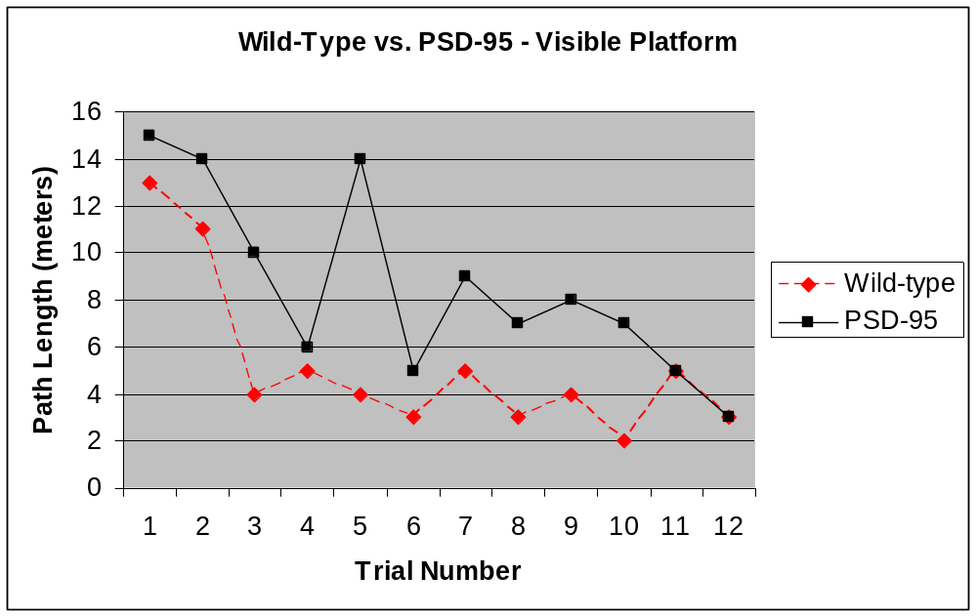

4. In Part 1, we learned that although SAP102 mice have impairments in finding the hidden platform, they are not impaired in finding a visible platform. Using the above results what do you conclude about the differences between these two sets of knockout mice in terms of learning?

5. Access the COGNITION section of Learning & Memory and again click on SAP102 Swimming Mice. In the related items, click on SAP102 - Sanger Institute Research. Read the press release from the Wellcome Trust Sanger Institute and answer the following questions.

- According to the article, what did investigators conclude when they compared the SAP102 mice and wild type mice?

- Was this conclusion similar to your own? Explain.

- Why do the investigators believe that genetic change in these SAP102 mice can be overcome?

- What surprising data resulted when the mice were tested in a different kind of learning task and not one that required spatial skills?

- How does Dr. Grant compare behavioral changes observed in mice to children with Asperger syndrome, a type of autism?

- What is the proposed explanation of his findings?

6. Why did the scientists choose the SAP102 gene and the PSD-95 genes as the ones they chose to knockout and study?

Notes:

