The Circular-Flow Info

This circular flow diagram shows us how the economy flows between Households, Government and Firms. The economy consists of people from the household that engage in many activities around the world. This is what we call a macroeconomic environment.

The activities that govern macroeconomic are the buying, saleing, working, hiring, manufacturing and so on, that is done on a global basis.

The circular flow chart that we just viewed presents a visual model of the economy. In this model you can view how Household, Firms and Government interact with each other on a Macroeconomic level

The economy is simplified to include only two types of decision-such as labor, land and capital (buildings and machines). These inputs are called the factors of production. Household own the factors of production and consume all the goods and services that the firm produce.
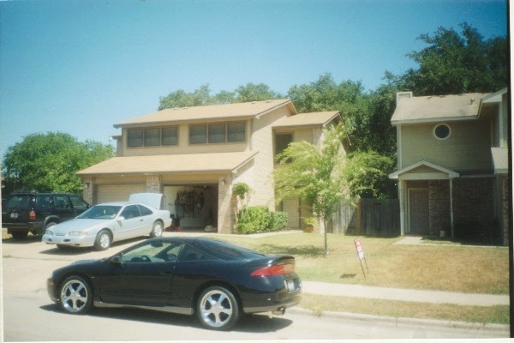
Household

