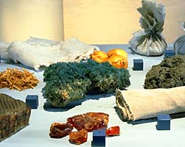 | 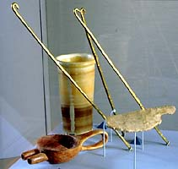
Materials used in mummification:  linen  - sawdust  - lichen  - beeswax  - resin  - natron  - onion  - Nile mud  - linen pads  - frankincense | Mummification tools:  Brain hooks  (replicas based on examples from the Rijksmuseum, Leiden)  Oil jar  (Royal Ontario Museum 948.1.17)  Funnel  (replica)  Embalmer's knife  (Smithsonian Institution 221.389)

