Keya Driver
Examples of Design Elements

Image | Source (URL) |  | Design Element(s) | Principles
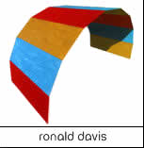 |  | http://www.abstract-art.com/a00_index_folder/a10_artist_list.html | Lines, Color and Shape | The colors have a pattern which repeats itself throughout the design.
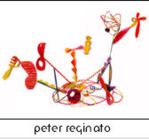 | http://www.abstract-art.com/a00_index_folder/a10_artist_list.html |  | Lines | Lines are used to create an untraditional design
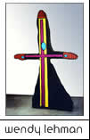 | http://www.abstract-art.com/a00_index_folder/a10_artist_list.html |  | Lines | The lines are straight and intersect with each other to create a cross figure
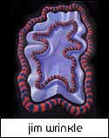 | http://www.abstract-art.com/a00_index_folder/a10_artist_list.html |  | Lines and Color | The lines and color area cohesive unit in this picture. Both are combined to create a curvy substance.

