Chapter 2, Designing and Planning Technology Enhanced Instruction

Effective Learning Environments, Dunn and Dunn - (Duffy-Lever, p. 35)

Rita and Kenneth Dunn → Learning Styles → Match Environment to Individual Learning Styles

When setting up the room → consider the following:

lighting
seating
physical accomodations

Suggestions include

Create well-lit reading areas
Arrange for areas to be warmer and cooler than normal
Establish areas of the room where students can work individually, in pairs, or groups
(Examples, beanbag chair or a couch)
Establish quiet places for students who need quiet
Arrange an area with a cassette recorder and headphones for students who need music to study or for text to speech, etc.

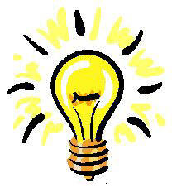

Years ago I attended a Marie Carbo reading workshop: She suggested placing stationery bicycles in classrooms for bodily kinesthetic learners. Students could ride the bicycle as they listened to books on tape. Update: Use this idea as students read /and listening to e-books on pda’s or listening to podcasts.

