Hello!
My name is Francesca.
I’m a young girl and I’m 10 years old.
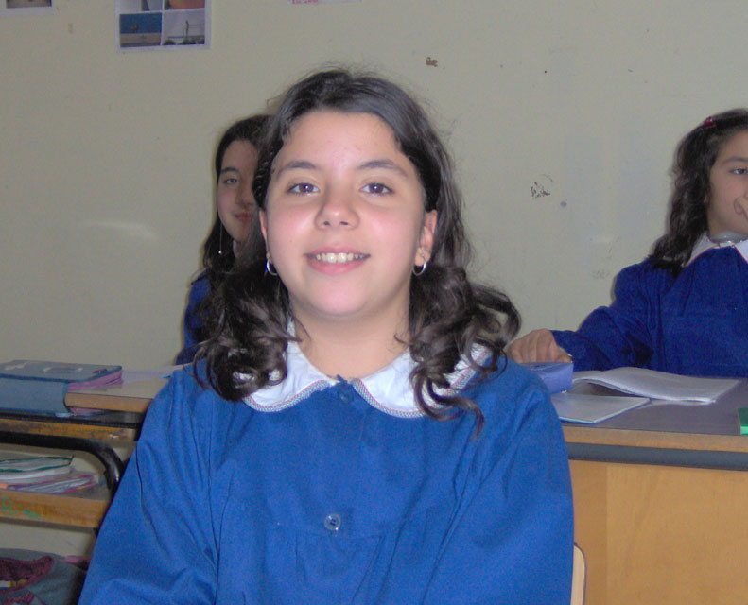
I live in Bernalda (ITALY).My favourite color is violet.I’m thin and tall;I’ve got brown hair and brown eyes.
I have a brother and a two sisters.
I have a two dogs, two parrots, a pony, rabbitts and doves.
I like fish, I don’t like pasta and peas . I like the school subjet italian. I don’t like a science. I like riding and I don’t like to lay the table. I play the piano.
My favourite singer is Gigi D’Alessio; my best friend is Serena .My favourite actor is Giulia Robertz.

I say goodbye.

P.S. Write me soon.

By Francesca

