Nunzia
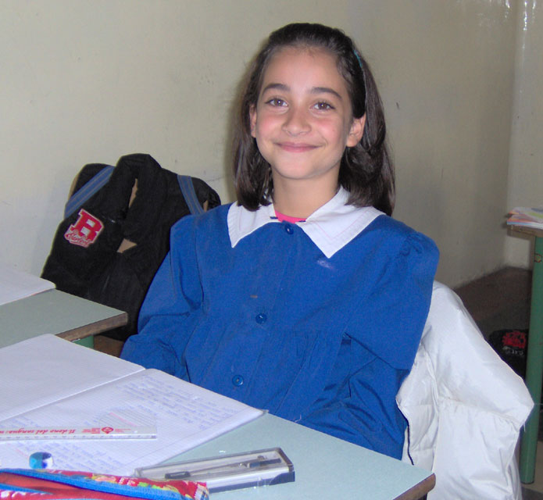
Hi! My name is Nunzia.
I’m a girl and I’m a ten years old.
I live in Bernalda and my birthday is on the 25 of September . I go to school on foot .My favourite colour is blue. My favourite number is 32. My favourite toy is ball .
My favourite pet is dog.
My best friend is Marco.
I like pizza , but I don’t like fish. I can swing , but I cannot play golf.

Write me soon.
Nunzia

