IT8100 Winter Powerpoint Presentation by Tim Boileau, Ola Lebedovych, Stacey Schepens, Elizabeth Rager & Hillary Andrei

Current Applications of Systems Theory
Tim Boileau, Ola Lebedovych,
Stacey Schepens, Elizabeth Rager &
Hillary Andrei

- HPT in the K-12 Environment (Elizabeth)
What is HPT?
- A set of methods and processes for solving problems—or realizing opportunities—related to the performance of people
(Rosenberg 1990)

- Systematic approach to analyzing improving and managing performance in the workplace through use of appropriate and varied interventions
(ASTD, 1992)

- An engineering approach to attaining desired accomplishments from human performers
(Population Leadership Program, n.d.)

HPT and Systems Theory
- Clear predictable purpose
- Steps
- Order
- Data drives activity
- Relationships b/w actions
- Output of one step serves as input for the next
(Rossett, 1992)

Human Performance Technology Model
Attributes of HPT
- Systematic
- methodical manner
- Systemic
- gaps as elements of the system
- Scientific theory base
- achieve results using ways established in science
- Focus
- achievement that human performance and the system value
- Open to all means/methods

(Population Leadership Program, n.d.)

Focus of HPT
- Problems:
- indication of clear gap b/w desired and actual performance
- Opportunities:
- when performance standards are met but there is chance to improve by 20%
- New situations:
- intro of new services or organizations
(Population Leadership Program, n.d.)

Who’s Who in HPT
- Gilbert:
- Father of HPT,
- “Human Competence: Engineering Worthy Performance”
- Harless:
- coined “front end analysis”
- past president of ISPI
- Job aid workshops
- Rummler:
- “Improving Performance: How to manage the white space on the organizational chart”
- “Human performance systems”
- Stolovich & Keeps:
- “Handbook of Human Performance Technology
(ISPI, n.d.)

Similarities between IT and HPT
- Adherence to systems approach
- Reliance on analysis for decisions
- Share antecedents in theory and literatures e.g. communications and psych
- Attention to causes of performance problems
- Anticipating obstacles
(Rossett, 1992)

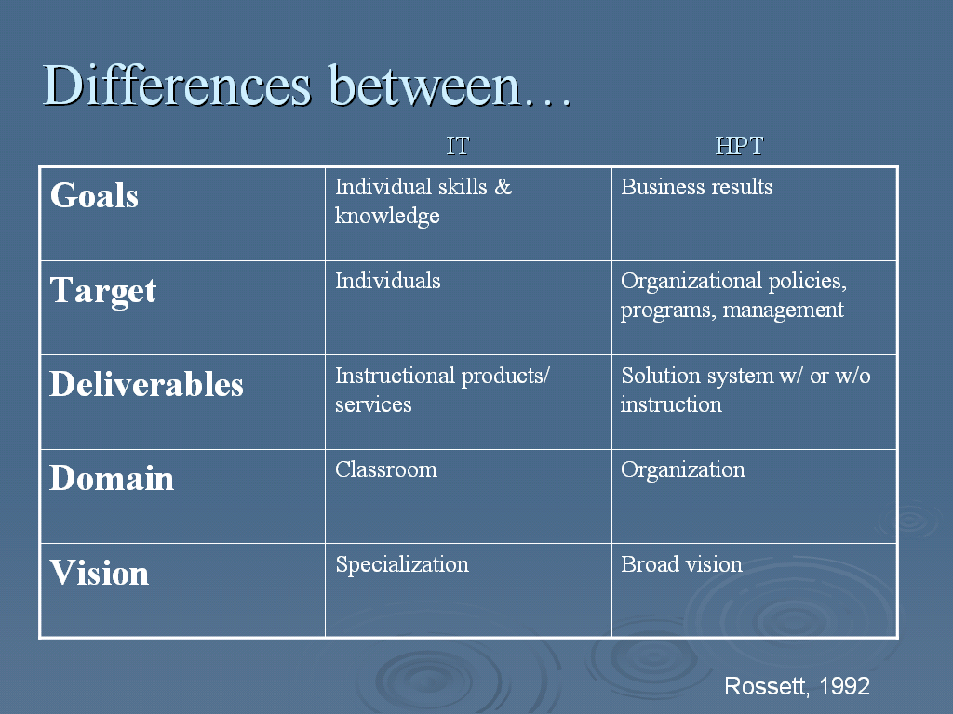Mager: Techniques, procedures, & approaches to solve problems in human performance (1999, p. xii)
Gilbert: Behavior vs accomplishment (1992, p. xxxi)

HPT: Aims to improve human performance
Perceived as
- An applied field of practice
- Evolving
- Outpacing its research & theoretical foundations
Stolovitch & Keeps (1999)

What is HPT?
- Maximizes valued achievement of people
- Denotes a quantified result
- Improvement / ↑ productivity, effectiveness, efficiency
- Brings major changes to a system
Stolovitch & Keeps (1999)

The Origins of HPT
- Systems
- Behaviorism
Suitable interventions to improve &
to meet required level of measurable performance

- Cognitivism
Workers do mental tasks & activities

In HPT, need higher awareness of cognitive operations
Stolovitch & Keeps (1999)

Other influences on HPT
- Motivational aspect
- Focus on internal beliefs & expectations
of groups/individuals
- Empowerment of individuals/groups
- Internal consequences of external events
- Neuroscience
- Handling information/storage & retrieval
- Economics
- Human/intellectual capital
- Value-added features
Stolovitch & Keeps (1999)

HPT’S Relevance to Organizations
- Systems approach
- Seeks optimal solutions
- More CAUSE conscious than solution oriented
- Bottom-line orientation/cost of not overcoming gap (Gilbert, 1996)
- Measurable benefits
- Related to IT…but not necessarily looking for training solutions, which can be costly

Stolovitch & Keeps (1999)

A Human Performance System
Conceptual Model
- External & internal environment
- Analysis of system

Organizational Model
- Engineers solution
- Identifies business & performance
requirements

Stolovitch & Keeps (1999)
Engineering Effective Performance
- HPT specifies current performance:
- Exemplary
- Deficient
- Related
- Defines performance gaps
- Specifies performance gap factors
Stolovitch & Keeps (1999)

Engineering Effective Performance (cont’d)
- HPT is results driven, though not with management bias.
- HPT overall goal is achievement & accomplishments valued by every one in the system.
- In sum, HPT takes objective approach, cost consideration, & system determines the returns.

Relationship of PT to IT?
- PT is a subset of IT. IT does not have to be PT first. (Misa)
- PT is more comprehensive [than IT]. (Stephanie P.)

- PT is the extended role played by IT. (Misa)
- PT is subset of IT. To be an effective PT, need to understand ISD. (Deborah S.)

- Is this another Clark-Kozma Debate? (Pasha, Vicki)
- It is an offshoot of PT. (Pasha)
- PT is subset of IT. (Deborah)
- PT and IT, is it generalist vs specialist? (Tim, Elizabeth)

- IT helps make an effective PT. (Elizabeth)

- ISD is a subset of PT. HPT is the whole, and ISD is part of that system. (Deborah) * change in view
- IT is a subset of PI. PI deals with performance systems, and IT deals with learning, a subcomponent of that system. It appears to be true. (Rahat)
- All PTs have to be ITs, but not all ITs have to be PTs. (Tara)

- Question: What is the relationship between IT and PT?
Shifting from Training to Performance
- Results

- Behavior

- Learning

- Reaction

What is “Performance”?
- Rummler (2004): “performance equals results”
- Gilbert’s formulas
Worthy performance = Accomplishment
Costs of behavior
Behavior = Individual repertory + working environment
Thomas Gilbert’s BEM (1978)
Classes of Interventions
- Career development systems
- Communication systems
- Documentation & standards
- Ergonomics and human factors
- Feedback systems
- Financial systems
- Human development systems
- Industrial engineering
- Information systems
- Instructional systems

- Job & workflow design
- Labor relations systems
- Management practices
- Measurement & evaluation systems
- Organizational anthropology
- Organizational development
- Quality improvement systems
- Resource systems
- Reward and recognition systems
- Selection systems

Is it possible to enhance performance w/o promoting learning, to create expertise w/o creating an expert?
- Examples given:
- CPR course, Drivers education course, Training a dog to sit, extracting tactic knowledge embedded in employees
- Other comments:
- If the problem is not lack of knowledge then learning and training are not the solutions
- Hard to apply to an educational setting when all the goals are based on learning
- PT’s are consulting roles and are more long-term
- PT’s rarely take the reins of actual performance and are generally consultants
- Healthcare org. consultants- effective?
HPT: What’s in a name?
- ‘Instruction’ or ‘Learning’ vs. ‘Performance’
- ‘Technology’ vs. ‘Improvement’
- ‘Human’ vs. ‘_________’
- ‘Systems Approach’ vs. ‘System Approach’

Activity 2: Who leads PT
Does change always have to be systemic? Can it be conducted on a smaller scale and still be effective?
- The relative “ease” of systemic vs. housekeeping/piecemeal/kaizen change
- system complexity (Stephanie P.)
- human discomfort with change (Angelene)
- Change is typically not systemic (Stephanie W.)
- Stakeholders (Pasha)
- Duration/Sustainability of each type of change
- Inter-relatedness
- Intended and unintended consequences
- Occupational health example (Stacey S.)
- Parts, subsystems, the “whole”
- What motivates systemic change?
- Money (Stephanie W. & Mike)
- Survival (Debbie S.)
- Where do you initiate change and obtain the most meaningful results?

HPT in K-12?
- The discussion group question took a micro-view look at this question

- The readings took a macro-view look at this question (more in the realm of change, but in the realm of systems change which is what HPT is all about)
HPT in K-12 Discussion Group Summary
Ultimately, HPT is a viable tool in the K-12 Environment:
- HPT could be employed in K-12 environments to improve teacher performance (Angelene)
- HPT could be employed to improve student performance (Angelene)
- HPT is a good tool for school teachers, administrators, and community members to improve the learning environment (Vicki)
- HPT solves problems in human performance and the techniques are applicable in any industry (K-12: Improving students’ overall academic achievement, improving students’ bad attitudes, improving students’ bad behaviors, improving employee’s (teachers, admin) morale (Vicki)
HPT in K-12 Discussion Group Summary
Questions still remain: What performance measurements do you use? And, Is it IT anyway?
- Teacher’s performance should not be measured by student grades or MEAP scores but by a comprehensive course evaluation (Mike)
- Educational Systems are complex systems but ultimately we are looking to have teachers and students perform to their maximum potential. Is this IT or PT? (Ola)

So final question to the class…With all these HPT applications in the K-12 arena, should an HPT class be a requirement for the K-12 IT Graduate program?
“The Imperative for Systemic Change”
(In education) parentheses mine by Charles M. Reigeluth
- Two Kinds of Change
- Piecemeal Change: Tinkering, Fixing a Part
- Systemic Change: Paradigm shift, Replacing the Whole Thing
- Comprehensive
- Change in one aspect, requires change in other aspects to be successful
- All levels
“The Imperative for Systemic Change”
(In education) parentheses mine by Charles M. Reigeluth
- But changing the whole thing?!
- Radical
- Difficult
- Risky

Do we really need “systemic” change?
“The Imperative for Systemic Change”
(In education) parentheses mine by Charles M. Reigeluth
Reigeluth contends
- Society has shifted paradigmatically
- Education is part of society’s system
- So…education needs to shift paradigmatically as well…
“The Imperative for Systemic Change”
(In education) parentheses mine by Charles M. Reigeluth
“The Imperative for Systemic Change”
(In education) parentheses mine by Charles M. Reigeluth
Look at the changes, conditions needed to keep up with an information society…
“The Imperative for Systemic Change”
(In education) parentheses mine by Charles M. Reigeluth
Implications for new system…
Different Educational Systems View
Caine and Caine in “Education on the Edge of Possibility” (1997)
“Education is losing control of its commodity: Information is available everywhere”
- Information is overwhelming traditional channels
- The core elements of the educational system are consequently being changed
- Traditional sources of information are fundamentally inappropriate as they become obsolete
- Even teachers can only keep pace with a small fragment of what is becoming available
Different Educational Systems View
Caine and Caine in “Education on the Edge of Possibility (1997)
- Why have the variety of reforms not worked?
- The paradigm of beliefs and values has not changed:
- Only experts create knowledge
- Teachers deliver knowledge in the form of information
- Children are graded on how much of the information hey have stored
Different Educational Systems View
Caine and Caine in “Education on the Edge of Possibility (1997)
- What would happen if the core relationships, beliefs and values were as follows?
- Dynamical knowledge requires individual meaning making based on multiple sources of information
- The role of educators is to facilitate the making of dynamical knowledge
- Dynamical knowledge is revealed through real-world performance

Association for Educational Communications & Technology (AECT)
Created a Division on Systemic Change
- Information age “necessitate a comprehensive redesign of our educational system”
- Manage the change process using “educational sound applications of technology”
- Facilitate use of instructional systems

The Division on Systemic Change (AECT)
- Traditional school reform has focused on changing the parts of a system and basically left the core system in tact
- Short-lived change
- The changed parts not compatible
- Early advocates of systemic change wanted to discard old system entirely and design a new one
- Not practical
- Ignored political reality
- What about sub-systems that worked?
The Division on Systemic Change (AECT)
- Current reform/change movement advocates that change/reform…
- Must by systemic in that it reflects interrelationships (does not have to change whole system at once) but must include:
- The nature of the learning experiences
- The instructional system that implements those learning experiences
- The administrative system that supports the instructional system
- The governance system that governs the whole educational system
The Division on Systemic Change (AECT)
- Current reform/change movement advocates that change/reform…(Continued)
- Must ensure that old and new components reinforce one another rather than undermine one another
- Use systems theory as a strategy aided by “change” research
But keep in mind….

“A reverence for uncertainty is one of the unrecognized implications of systems thinking.”
Peter Senge

(So what is really happening in the K-12 realm…on to the next topic!)

