Initial Database 5/2/2006
I was able to understand the procedure of creating a database from our lab session two weeks ago in Korman. For information that is often repeated, I wanted to create separate tables, and thus, also separate queries to call the entries from these tables. By creating separate tables, I’d also be able to organize the queries that would call information from a combination of the tables. You can see from my CMap, which I started in class two weeks ago in Korman, the logic that I used. I assume that building managers who regularly check and use data from sensors may want to see the information organized in this way. They would want to see the data collected by sensors viewed:

- By building system: HVAC, water, or fire protection
- By room number
- By sensor

For instance, by looking at the "By BuildingSystem" query first, building managers would be able to see at a glance if all the systems are operating properly. If any data seems out of line, then they will pinpoint the room and the exact sensor. By looking at the "By RoomNo" query first, building managers would be able so see data from rooms that may have received complaints, observe out of the ordinary fluctuations, identify the sensor(s), and remedy the situation. By looking at the "By Sensors" query first, building managers would be able to see if any sensor is malfunctioning or not functioning. These are only a few of the possibilities and assistance that having queries organized in this fashion may help building managers.

The only difficulty I had with Access was adding entries to one query and not seeing the entry in another query. After speaking with Prof Mitchell, I understand the problem. Access has three options from which to choose when defining the "Join Properties" of the relationships between tables/queries. They are shown in the figure below:

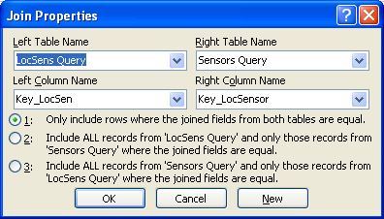

By default, I have all of the relationships defined by option #1, only include rows where the joined fields from both tables are equal. I had queries which called all of the information from each of the respective tables (I’ll call them query_level1). I then had queries, organized by the logic in the CMap, that called only some of the entries from each of the respective tables (query_level2). Therefore, if I entered data in one of these latter queries (query_level2), all of the fields would not be complete and the new entry may not show up in other query_level2 queries. To reconcile this, I created a query_level2 query called "New entries" which included all of the fields from the appropriate query_level1 queries.

