1.0 Final Database
Databases are a powerful, the most widely used, method of organizing and recalling large amounts of data. Many of the computer tools used daily have a database behind them, programs such as AutoCAD and websites such as Amazon. For this assignment, a database of sensors is created. The type, size, measured parameter, and other characteristics of selected sensors are organized in tables, then, the data entries are collected and recalled in queries. Below are descriptions of the database and also of the sensors in the database.

1.1 Tables
Five tables are set up in Microsoft Access; they are: for the building systems chosen; the data simulated; the mounting location of the sensor; room information; and the sensors themselves. Any information which is repeated can be set up in a table; however, for the purposes of this assignment, only the information above is organized into tables.

1.1.1 BuildingSystem
Sensors for three major building systems are chosen: HVAC, plumbing (in database, called "water"), and fire protection. As discussed in class, there are many more building systems which can be monitored, and even some that are not as conventional, such as "rooms". Information on sensors for these building systems is more easily available on the internet.

1.1.2. Data
Simulated data collected by each sensor is organized here. "Data_1" is data collected at the first time step and "Data_2" at the second time step. Depending on the response time of a sensor, the time interval between readings varies. Slow response sensors may only be able to respond to changes every few minutes, whereas fast response sensors every few seconds.

1.1.3 LocSens
The mounting location of the sensor is organized here; they are: wall, duct, pipe, or submersed. It is important to know where to find the sensor once the room number is determined. Because the mounting location affects readings, the exact location of the sensor would need to be known. For instance, a temperature sensor near a diffuser or entry way will be affected by fast moving currents and may thus report lower temperature readings than what is felt inside the room. However, for the purposes of this assignment, only a general sensor mounting location is given.

1.1.4 RoomNo
Two offices and two mechanical rooms are simulated for this assignment. The table gives the physical location of the room (NE, E, NW, SW; see also Figure 1) for easier navigation through the building. This information would prove to be even more useful in a more complex building.

1.1.5 Sensors
Information from the sensor manufacturer is organized here. The fields are: name; manufacturer; parameter measured; model number; size; weight; power; installation location (which is linked to the LocSens information); operating range (min); operating range (max); operating range units; tolerance; accuracy; network type; output frequency; website; room number where sensor is located (which is linked to the RoomNo information); comments.

Not all manufacturers provide all of the information. Interestingly enough, I did not find any information on output frequency. As discussed in class, manufacturers keep the technical information private for several reasons, including keep a competitive edge and wanting interested customers to inquire by phone. For this assignment, it was not imperative that every sensor characteristic is found; however, for design, all the characteristics must be known in order to make wise design decisions.

1.2 Queries
Queries were created for all fields in the tables above, call them query_level1. Then, queries were created using selected fields in the query_level1 queries. It may be beneficial and helpful for building managers, who regularly check and use data from sensors, to see the information organized one of three ways: by building system; protection; by room number; or by sensor.

For instance, by looking at the "By BuildingSystem" query first, building managers would be able to see, at a glance, if all the systems are operating properly. If any data seemed out of line, then they could pinpoint the room and the sensor for further investigation. Or, by looking at the "By RoomNo" query first, building managers would be able to see data from rooms that may have received complaints, observe out of the ordinary fluctuations, identify the sensor(s), and remedy the situation. Finally, by looking at the "By Sensors" query first, building managers would be able to see if any sensor is malfunctioning or not functioning. These are only a few of the possible advantages for organizing data in this fashion.

In order to ensure that entries in one query would be visible in all other queries, a query called "New Entries" was created. This query included all of the fields from the queries that could have new data entered, like the queries called "Sensors" and "Data". The other queries would not have additional data entered.

2.0 Sensors
For clarity, below is a schematic of the simulated building.

Office 1
N
Office 2
Mechanical
Room 1
Mechanical
Room 2
Corridor

Figure 1. Schematic of simulated building.

2.1 The offices
Both offices are monitored with respect to two building systems: HVAC (heating ventilation and air conditioning) and fire protection. They each have a thermometer (slow response), temperature sensor (fast response), pressure sensor, contaminant sensor, smoke alarm, and carbon monoxide sensor. The mechanical rooms are only monitored for the plumbing system in terms of water temperature, flow, and leakage.

2.1.1 The Offices - HVAC
The thermometer in Office 1 is a wall hung mercury thermometer manufactured by Smith & Hawken (Figure 2a). It reads 68ºF both at the first and second time step. On the other hand, the temperature sensor (Figure 2b) reads 68ºF and 70ºF. If the temperature changed just before the second time step, the thermometer may not have been able to respond. If this were a temperature-sensitive space, then the difference would be significant and important to monitor accurately. However, for an office application, a fast-response temperature sensor may not be necessary. The temperature sensor in Figure 2b is able to be networked to a control system while the thermometer is not; therefore, the readings for the thermometer may also be limited to the number of personnel available to read the temperature off the thermometer. The ability to network sensors is important for the control of central air conditioning systems. The thermometer in Office 2 is digital but is also slow response; the fast response model is very similar to the one in Office 1. Therefore, they are not show for brevity.

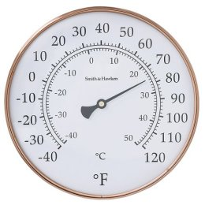 | 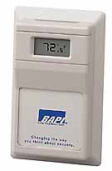
(a) Smith & Hawken | (b) BAPI
Figure 2. (a) Thermometer and (b) temperature sensor.

The pressure sensors for Office 1 and 2 are both mounted on the duct (Figure 3a) and both contaminant sensors on the wall (Figure 3b). Only one of each is shown. The pressure sensor may be used to monitor the pressure difference across a filter; once the pressure difference is greater than a set limit, the filter will need replacement. If the pressure sensor were located near the door, it could monitor the pressure difference between the hallway and the room. This type of monitoring is usually for pressure-sensitive rooms, such as operating rooms, laboratories, or clean rooms. The contaminant sensor records the concentration (in units of percent of air or ppm). This information can be fed to the controls of the central ventilation system in order to regulate fresh outdoor intake.

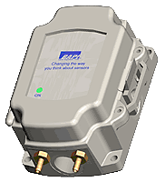 | 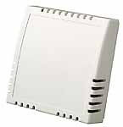
(a) BAPI | (b) BAPI
Figure 3. (a) Pressure and (b) contaminant sensor.

2.1.2 The Offices – Fire Protection
Office 2 has the addressable smoke alarm (Figure 4b), which is networked to an alarm system that can notify the entire building of fire. In contrast, the one in Office 1 is stand-alone (Figure 4a) and relies on the occupant to alert the building of fire. One could argue that the addressable smoke alarm is the fast response one because it sends a signal directly to the main controller, which then activates the alarm system and alerts the building through the public announcement system. However, an occupant in Office 1 may respond more rapidly to the stand-alone smoke alarm, in less time than it takes a signal to be sent to the main controller and a signal sent out to the alarm system.

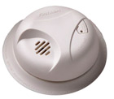 | 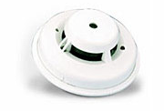
(a) First Alert | (b) Honeywell
Figure 4. (a) Stand-alone and (b) addressable smoke alarm.

The carbon monoxide sensors in both offices, though from different manufacturers (Figure 5), are similar in operation. They warn occupants when a certain level of carbon monoxide is detected in the air; the sensitivity (or minimum detection value) of the sensor is not listed on either manufacturer’s site. These sensors are important in areas where high emissions of carbon monoxide are possible, such as near loading docks or large machinery which emit fumes. Perhaps inside the offices the risk may not be very high for carbon monoxide poisoning.

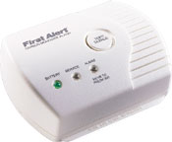 | 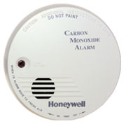
(a) First Alert | (b) Honeywell
Figure 5. Carbon monoxide sensors.

2.2 The mechanical rooms
The plumbing system is monitored; its sensors are located in the mechanical rooms, and they monitor water temperature, water flow, and leakage.

2.2.1 The mechanical rooms – Temperature
The water temperature sensor shown below is submersible. If the building used a well for its cold water supply, sensors such as those shown in Figure 6 (though of various functions, the exterior housing is similar) could be used to monitor temperature and water quality. This would ensure that water pumps used in the operation, both above and below ground, would continue to run properly and without obstruction. The beauty of this sensor is that while the sensing mechanism is submersed in the water source, the reading can be read on a monitor accessible above ground.

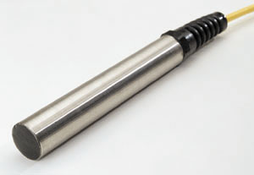
Figure 6. Water systems sensor (temperature, water quality).

2.2.2 The mechanical rooms – Water Flow
Both flow meters in the mechanical rooms are electromagnetic (Figure 7) which means that there are no probes into the pipe; the flow is calculated by measuring the voltage across a magnetic field, which changes with the flow. This sort of sensor is found in applications where the water should not be contaminated by probes, such as water for cleanrooms (ultra-purewater). Though not appropriate for offices, inclusion of such devices in the database is merely an exercise.

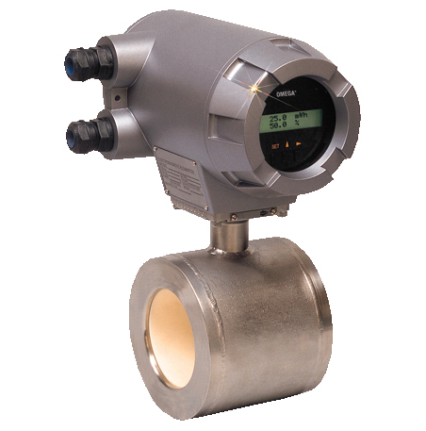 | 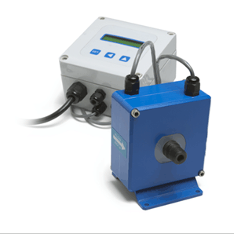
(a) Omega | (b) Microflux
Figure 7. Electromagnetic flow meters.

2.2.3 The mechanical rooms – Leakage
It is important to monitor leaks in a plumbing system, as leaks result in water pressure loss, damage to the building, and is a waste of water. The sensor shown in Figure 8 is suitable for residential use; a similar device made by another manufacturer for commercial or industrial use could have been selected for inclusion in the database.

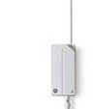
Figure 8. Wireless leakage sensor.

2.3 Sensor characteristics
As discussed above, manufacturers do not provide complete lists of sensor characteristics available on their website. However, the manufacturers seem to agree to exclude the same type of information. Out of the 16 sensors included in the database, only three had accuracy information. Although only one value is shown, manufacturers will have graphs of accuracy over the operating range. Perhaps one reason manufacturers cannot provide all of the information customers may be looking for is the sensor performance varies given the situation. Based on personal experience, however, manufacturers are willing to give the information if you call.

3.0 CONCLUSION
Sensors monitor the HVAC, plumbing, and fire protection system in a simulated building for this assignment. All of the sensors may not be entirely appropriate for an office application; however, they were included in order to demonstrate the usefulness of a relational database to organize information. The selection of slow- and fast-response sensors depends on the application. The cost of purchasing and storing data from a fast-response temperature sensor may not be warranted in an office because it is not a temperature-sensitive space. On the other hand, the cost may be justified for a space such as an archival facility. In conclusion, there are no one-size fits all sensors; one must consider the application and perform an economic analysis before choosing the appropriate sensors.

