Joe Monahan
AE-790 Intelligent Buildings
Final Assignment
30 May 2006
6 June 2006 Revised

As we move forward into the 21st century, one of the primary areas of concern is energy use and conservation. This is an everyday issue that we must all deal with currently in things such as fuel costs in the automobiles we drive, to the energy used to heat, cool, and power our buildings.
Every time that you go to the pump to fill up your car I am sure that you want the car makers to figure a way to reduce the cost of operating, be it by increasing the mileage that cars get so that we require less gas, or by changing to an alternate fuel, one less dependant on foreign resources (oil). The following chart by Syracuse University’s Maxwell School (http://wilcoxen.cp.maxwell.syr.edu/pages/804.html) shows what a large portion of people outside of the A/E field are unaware of, that our buildings use far more energy than all transportation currently does. (69 to 27 quadrillion BTU per year)
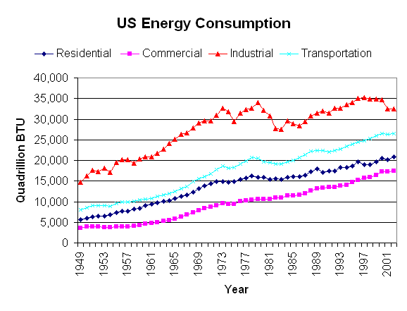
One of the methods of reducing the amount of energy consumed by buildings is the evolution of Intelligent Buildings. The definition of an Intelligent Building is still somewhat of a moving target, due to the relatively new concept of building in this method. A generally accepted definition is similar to;
Intelligent building - Most intelligent buildings sense or manage several variables, or manage more than one building system, extracting greater performance than several disconnected building systems could achieve. Some form of network, or integrated information system seems to be required for a building to be called "intelligent." Simple thermostats are not considered intelligent, and neither are quite complex HVAC, and cogeneration systems.

Initially I defined an Intelligent Building as one that can be designed and built so that it becomes more than a stagnant object, but rather one that can learn and adapt to how it is used. When asked to revise this definition at the completion of this class I felt as my general concept remained and that an Intelligent Building is one that through various methods of design, construction and monitoring can better perform the tasks required of it by its end users. I am very interested in how we can use Intelligence in the design process as was discussed in class. The most realistic use currently is the implementation of sustainability or “Green Design”.

Green building is the practice of increasing the efficiency with which buildings and their sites use and harvest energy, water, and materials, and reducing building impacts on human health and the environment, through better siting, design, construction, operation, maintenance, and removal — the complete building life cycle. In addition to sustainability, another common goal of green building is aesthetic harmony between a structure and the surrounding natural area. Green Building is also sometimes known as "sustainable building" or "environmental building," and it can lead to benefits including reduced operating costs (e.g., by using less energy and water), improved occupant health (due to improved indoor air quality), and improved environmental impacts (e.g., by lessening storm water runoff and the heat island effect)1

One question that was raised was, “Are all Intelligent Buildings Green buildings, or are all Green Buildings Intelligent Buildings?” I feel that in order for a building to be Green it needs to be Intelligent, however the reverse does not hold true, one can have an Intelligent building that is not environmentally friendly.

For my senior thesis I developed An Environmental Education Center, I decided to reevaluate my project to see how some of the topics that we covered in class could be implemented into my building. Some of the key elements are:
- Green Roofs
- Nano-solar Technology
- Passive Lighting
- River Power
- Passive HVAC systems
*Green Roofs
A green roof is a roof of a building which is partially or completely covered with plants. It may be a tended roof garden or a more self-maintaining ecology like a living wall or breathing wall. An earth structure often has such a roof, as plants simply grow naturally over it, making a hill that may be indistinguishable from a natural one from some angles. Perhaps I could have sensors to determine how much water the grass and plants have received and what temperature the surface of the roof is as well as inside of the structure below the green roof. This could be used to determine if the moisture content of the grass affects how much heat the roof can contain.
*Nano-solar technology
Nanotechnology comprises technological developments on the nanometer(nm) scale, usually 0.1 to 100 nm (1/1,000 µm, or 1/1,000,000 mm). This is about ten thousand times smaller than the width of a hair. The term solar power is used to describe a number of methods of harnessing energy from the light of the Sun. It has been present in many traditional building methods for centuries, but has become of increasing interest in developed countries as the environmental costs and limited supply of other power sources such as fossil fuels are realized. It is already in widespread use where other power supplies are absent, such as in remote locations and in space. 1 Together these create a very interesting opportunity that would allow us to disperse solar cells at a microscopic size into things such as paint, and roofing. This would allow the collection of solar power without the less than desirable look of large solar arrays. This technology will also collect inferred solar power, which means that as long as it is daytime, the system would collect power regardless of sun or cloud coverage, a major breakthrough. Sensors could determine how much power is being generated by the system during different lighting conditions (sunny or cloudy). http://news.nationalgeographic.com/news/2005/01/0114_050114_solarplastic.html
*Passive lighting
By orienting a building with a large amount of the windows with a north/south orientation you would be able to use as little artificial light as possible, however this would require a way to control this light so that there is not direct sunlight on say a computer monitor, or in a persons eyes. Sensors would be able to detect the amount of light entering a space and perhaps adjust sun control elements such as louvers, shades, light shelves, or even tint of the glass.
*River Power
Another thing that I learned a little about was the ability to harness power from the river. http://www.freeenergynews.com/Directory/River/ My project was located along West River Drive, so by using a turbine below the surface of the water with a current of just 3 to 4 knots we would be able to generate power that could be used by the building and even sold back to the power company. Sensors could be used to determine the speed of the river and when is the best time to activate the turbine. Perhaps it could determine how much power is being generated and how much is needed and automatically switch to the appropriate system so that power that is not needed could be sent to the power company
*Passive HVAC Systems
The orientation of my building is also part of the passive ability to heat the building making use of the sunlight and adjusting the light control devices so that we can maximize the solar heat gain.

These are some of the most readily available Intelligent Building systems, as you can see they are primarily MEP systems and this is do to the fact that most experts believe that an Intelligent Building must be tied to a computer network. The next step in Intelligent Buildings is that Architects must begin to think about how we can utilize this technology for the actual design and appearance of a building. Imagine a building that could sense when people are standing outside looking at it and change its material, color or even form to become more attractive, or sense when a room is empty and instead of just turning off lights or changing the temperature, but could actually move a window so that the buildings exterior appearance is different. This could truly change how Louis Sullivan would view a building….”form follows function indeed”

www.wikipedia.com

