Using Cmap Tools v3.4

I want to… | Procedure | Notes
Download Cmap Tools or Cmap Server software) | Download from the Institute for Human and Machine Cognition website: http://cmap.coginst.uwf.edu/  Cmap Tools can work as a standalone application.  Cmap Server is designed to work in a networked environment managed by an administrator. The Cmap server is required to utilize the collaboration features of Cmaps. Public servers are also available for use by registered users of Cmap Tools. | Cmap Tools and Cmap Server are free open source applications.  The user ID and password created during installation of Cmap Tools on your local machine will be used to provide access to other Cmaps located on Cmap servers.  For ease in providing access to Cmaps on the HTC server, it is recommended that you use your HTC user ID (password is your choice)
Set up Cmap work environment | - Remember User ID and password created during set up of Cmap Tools  - Determine how you want to access your Cmap files by specifying the default location to save Cmaps (local hard drive or other external location). Saving to the local hard drive requires always using the same computer to access your maps.  - Set general preferences for Cmap Tools. Refer to Set Properties section of this document for additional information.  - Sketch a rough draft of the concepts and phrases needed for the Cmap  - Make a list of and locate supporting files (resources) for the Cmap
New Cmap | - Open Cmap Tools v3.4  - From the VIEWS window select FILE>NEW Folder  - Type a name for the folder and click OK  - Double click the folder you just created and the My Cmaps window will display  - Select FILE>NEW CMAP  - Double click anywhere on the work area to create the first node  - Type the subject for the Cmap  - Add additional nodes and linking phrases as outlined in this document  - Select FILE>SAVE CMAP after you have entered your information | Creating a folder to organize maps by Domains of Knowledge or Knowledge Models (e.g. Radioactivity, Science, English 101) will facilitate exporting the Cmap and associated resources as a web page, publishing to a server, and setting permissions.  To designate a folder as a Knowledge Model right click the folder and select PROPERTIES. Check the SET AS KNOWLEDGE MODEL box.
Link nodes | - With a Cmap open, single click the node you want to link to (it will become active)  - Click and hold one of the arrows above the active node, drag to the desired location and release  - Two nodes will be created: one for the linking phrase and another for the related concept.  - Click each one of the nodes to enter information | Dragging the arrow above a highlighted concept node always creates 2 nodes (one for the linking phrase and one for the new concept).  A single concept node can be created by dragging an arrow from the linking phrase node (a new linking phrase node will not be created).
Format text | - With a Cmap open, select WINDOW>SHOW STYLES PALET  - Click the FONT tab located at the bottom of the STYLES window  - Select the node with the text to be formatted by clicking it once  - Click the desired format in the STYLES window. Choices include…  - Size  - Typeface  - Color  - Bold  - Italic  - Justification  - Alignment within node  - Margins within node | Formatting is applied to all of the text in the node.
Node attributes | - With a Cmap open, select WINDOW>SHOW STYLES PALET  - Click the OBJECT tab located at the bottom of the STYLES window  - Select the node to be formatted by clicking it once  - Click the desired attributes to be applied to the node. Choices include…  - Change shape  - Add color  - Add background image  - Add a shadow  - Stretch and/or align 2 or more nodes | In order to use the STRETCH and ALIGN features, two or more nodes must be selected. To select 2 or more nodes, click the first node, hold down the CTRL key and click other nodes.  The shapes of the nodes can be changed (oval, rectangle, or circle. However, the size of the node is dependent on the amount and size of text entered. You cannot manually adjust the size of a node.
Line attributes | - With a Cmap open, select WINDOW>SHOW STYLES PALET  - Click the LINE tab located at the bottom of the STYLES window  - Select the desired LINE by clicking it once  - Click the desired line style in the STYLES window. Choices include…  - Curved line, click and hold one of the Bezier points on the line and drag until the desired angle is achieved.  - Color  - Size  - Style  - Arrows
Cmap background | - With a Cmap open, select WINDOW>SHOW STYLES PALET  - Click the CMAP tab located at the bottom of the STYLES window  - Click the desired attribute in the STYLES window. Choices include…  - Background color  - Background image  - Scale image  - Remove image
Save a Cmap to My Cmaps | - Select FILE>SAVE CMAP  - The Cmap will be saved to the local hard drive or the user specified location (network, server, external drive, etc.) | Unless the default location is changed in the Properties dialogue window, all Cmaps are saved to MY CMAPS on the computer’s hard drive.  If more than one computer will be used to work on Cmaps, it is suggested that the default save location be changed to reflect a network folder, Cmap server folder or external high capacity drive/disk.  Cmaps can also be exported as XML, web pages, and life maps and re-imported to the Cmap application on another computer/server.
Save/Export a Cmap as a web page | - In order to keep all files (resources) associated with the Cmap together, first create a folder on the hard drive or other location to house the Cmap web page  - Open Cmap Tools v3.4  - In the VIEWS window, right click the folder containing the Cmap to be exported as a web page.  - Select EXPORT FOLDER AS A WEB PAGE from the pop up menu  - Navigate to the new folder created to house the web page  - Click OK to save  - The new folder will contain the web site as well as associated resources | This feature will allow creation of a web page to share with others. The functionality of the original Cmap will be preserved and can be opened and viewed in a web browser. The Cmap Tools application or connection to a Cmap server is not required to view the web page.  The Cmap web page can also be uploaded to other websites (e.g. Blackboard) if the entire folder containing the Cmap web page files is zipped prior to uploading. Select the .zip file just as you would any other document in Blackboard. You will be prompted to select the home page from the list of files.  Saving a Cmap, without a folder containing associated resources will result in a web page that simply contains an image of the Cmap. Clickable links will not be preserved.  Export as a web page can be performed locally (hard drive) or from a server.  Known Issues  - When a Cmap is opened in a web browser Icons representing the types of resources will be displayed as small boxes. However, clicking the box will display the linked resource  - Nested nodes can not be opened or closed  - Annotations and Discussion Threads cannot be opened  - Cmap cannot be edited
Save/Export a Cmap as an image | - Open a Cmap  - Select FILE>EXPORT CMAP AS>IMAGE FILE  - Select the image format (.bmp, .png, or .jpg)  - Click OK to save the image | This results in a basic image of the Cmap as it appears on screen.
Save/Export a Cmap as a Cmap outline | - Open a Cmap  - Select FILE>EXPORT CMAP AS>OUTLINE  - Select the image format (.bmp, .png, or .jpg)  - Click OK to save the text file | This outline can be re-imported into Cmap Tools. This is useful for moving a Cmap from a hard drive.
Save/Export a Cmap as an XML file | - Open a Cmap  - Select FILE>EXPORT CMAP AS>XML FILE  - Select the image format (.bmp, .png, or .jpg)  - Click OK to save the text file | This file can be re-imported into Cmap Tools. This is useful for moving a Cmap from a hard drive.
Save/Export a Cmap as a life map | - Open a Cmap  - Select FILE>EXPORT CMAP AS>LIFE MAP  - Select the image format (.bmp, .png, or .jpg)  - Click OK to save the text file | This file can be re-imported into Cmap Tools. This is useful for moving a Cmap from a hard drive.
Save/Export a Cmap Propositions as text | - Open a Cmap  - Select FILE>EXPORT CMAP AS>PROPOSITIONS AS TEXT  - Select the image format (.bmp, .png, or .jpg)  - Click OK to save the text file | Propositions are 2 concept nodes linked by one linking phrase. This file can be re-imported into Cmap Tools. This is useful for moving a Cmap from a hard drive.
Resources - add to a Cmap | Add a file (documents, images, audio, video, etc.)  Option 1 :  - Open a Cmap  - Drag and drop the file onto the desired node  - An icon representing the type of resource will appear at the bottom of the selected node  Option 2:  - Open Cmap Tools  - Locate the resources to be used with the Cmap  - Drag and drop each resource to the appropriate folder in the Tools window that contains the related Cmap  - Open the Cmap and drag and drop the desired resource on the appropriate node  - An icon representing the type of resource will appear at the bottom of the selected node  Option 3:  - Open a Cmap  - Right click the node related to the file to be added  - Select ADD & EDIT LINKS TO RESOURCES  - Locate the desired resource (hard drive, external drive, Tools window)  - Click ADD TO LIST button  - Click the UPDATE button  - An icon representing the type of resource will appear at the bottom of the selected node | Resources include Cmaps as well as associated documents and web pages.  Resources that do not “hang” from the lower edge of a node can not be clicked. This will occur if the shape of the node is a large circle.
External website (URL) – add as resource | - Open Cmap Tools  - Using the VIEWS window, select the folder containing the desired Cmap  - Select FILE>ADD WEB PAGE  - In the pop-up window for the web page, type a name for the web page and the URL  - Click OK  - An icon representing the web page will appear in the Views window  - Click and drag the web page to the desired node of the Cmap  - An icon representing the type of resource will appear at the bottom of the selected node
Nest nodes | - Open the desired Cmap  - Hold down the CTRL key and click each node, linking phrase, and line to be included in the nest  - From the menu bar select TOOLS>NESTED NODES>CREATE  - In the blank node that appears, type a name for the nest  - A double arrow will appear to the right side of the group of nodes.  - Click the double arrow to close and expand the nodes  - To remove a nested node, select the primary node  - From the menu bar select TOOKS>NESTED NODES>DETACH CHILDREN | This feature allows users to hide nodes within one node. Open and close the nested node by clicking on the double arrow attached to the node.
View Cmap as a web page | - Open a Cmap  - From the menu bar select FILE>VIEW WEB PAGE  - The Cmap will open in your web browser | Cmap MUST BE ON A SERVER  This is a view only page - changes can not be made.  The URL displayed in web page view can be copied and pasted into other applications (e.g. Blackboard, Word, PowerPoint) as a link.
Folder on a server (Places) | An internet connection must be available to access the HTC or other public servers (Places).  - Open Cmap Tools v3.4  - In the Tools Window, click the SHARED CMAPS IN PLACES icon  - The places window will display listing all available servers  - Navigate to the desired server (Huston-Tillotson College)  - Right click the server name and select NEW>FOLDER  - Type your name on the folder  - A new folder will be created for adding your Cmaps. Sub folders may be created within your folder as needed
Publish a Cmap to a server (Places) | An internet connection must be available to publish to a server. Refer to the instructions for creating a folder on a server before publishing the first time.  - Right click the folder containing the Cmap and associated resources to be published  - Select PUBLISH from the pop-up window  - From the Publish window click the NEW LOCATION button  - In the SELECT LOCATION window, navigate to the desired server {Huston-Tillotson College (USA)} and your folder  NOTE: If the HTC server is not visible, you will need to add it using this IP address: 172.16.0.5 (from the Views window select EDIT>PREFERENCES and click the DIRECTORY OF PLACES tab)  - Click OK  - Click the PUBLISH button  - The folder is now accessible from the HTC server | In order to ensure that the Cmap and all associated resources are uploaded to the server, upload the entire folder containing the Cmap and its resources. Otherwise, the Cmap and all associated resources must be uploaded individually.
Permissions for a Knowledge Model or folder | An internet connection is required to set permissions for folders on a server.  - Using the Views window, click the SHARED CMAPS IN PLACES ICON  - Navigate to the desired server  - Locate the folder that permissions will be granted  - Right click the folder and select PROPERTIES from the pop-up window  - In the Edit Folder Properties window, click the PERMISIONS button  - When the Permissions List for the folder displays, click the ADD USER button  NOTE: As users are assigned to the folder, their names are stored in the list and can be selected here rather than creating a new user.  - Type the user’s ID in the user ID field  - Assign and verify the password for the new user  - Check all applicable permissions  - Click OK | Cmap MUST BE ON A SERVER  Permissions are applied to Cmap folders.  Permissions are assigned at the folder level – not individual Cmaps. Permissions set at the root folder (first folder) applies to the sub folders)  By default, everyone has access to a folder loaded to the server.  Types of Permissions  Administrator: Creator of Cmap and resources; can assign permissions; folder can have more than one administrator  View Contents of folder: Grants a user view only rights.  Annotate resources: Allows user to annotate Cmaps and create/participate in Discussion Threads  Add, modify and delete resources: Allows user to add, modify, and delete resources as well as annotate Cmaps.  Add folders: User can add new folders and thereby becomes the administrator of the new folders  Modify and delete folders: User can delete or rename folders
Synchronous collaboration (text based chat) | Synchronous collaboration  - Administrator opens the desired Cmap and clicks the collaboration icon (located at the top right corner of the Cmap window) to allow synchronously collaboration  - Users logged in at the same time as the Cmap owner should click on the collaboration icon to send a request to the Cmap owner  - The owner of the Cmap will receive a pop-up window to select YES to begin the session or NO to indicate collaboration will not occur at this time  - Each user requesting the ability to chat will receive the on screen message (Yes or No)  - Users type text messages in the chat window and click the SEND button  - All users are able to make changes to the Cmap if the appropriate permissions have been assigned. | Cmap MUST BE ON A SERVER  The owner of the Cmap moderates the chat session through the Collaboration Chat window.  The session ends when all users have exited the session.  The user id of the person who modifies the Cmap are displayed next to the node  If a user is working on a particular concept and another user selects the same concept,, the 2nd user gains control of the node  Chat session are automatically saved and become a part of the resources associated with the Cmap?????  Check with Carl to make sure the Collaboration Services are configured (includes Collaboration module and Collaboration client).
Discussion thread | Discussion Threads are asynchronous text based threads. For synchronous collaboration, use the Chat feature.  - Open a Cmap  - Right click the concept (node) that will be discussed.  - Select ADD DISCUSSION THREAD from the pop-up menu  - Enter pertinent information in the pop-up window  - Click CREATE  - A Discussion Thread icon will be displayed on the selected node in the same manner as a resource.  - Users can click the Discussion Thread icon to enter information  - After several users have posted to the thread, simply click their name to read comments | Cmap MUST BE ON A SERVER  Discussion Threads must be associated with a concept (node) on the Cmap.
Annotate a Cmap | - Select TOOLS>ANNOTATE from the menu bar  - Enter text in pop-up window  - Close window  - A sticky not icon will display near the node | Right clicking the node or area near node does not appear to create an annotation. Must use TOOLS>ANNOTATE. Even this function works sporadically
View sample Cmaps | This example shows several Cmaps being used at the University of West Florida for a Managerial Decision Making course in the MBA program  http://cmap.coginst.uwf.edu/cmaps/MDM2/
Save styles | - Open a Cmap  - Modify a node with the desired attributes  - Select the node by left clicking once  - In the Styles window, click the ADD STYLE button  - Enter a name for the style, and check the Include Background Styles check box if you want the  current object's background to be included in the style.  - Click Ok to save the style.  To apply saved styles to other objects  - Click the arrow at the bottom left corner of the Styles window to see a list of all the named styles.  - Select a concept or linking phrase, then click on the style name to apply the style to the selected object. | Once you have customized the look of a concept or link, you can save that look as a style that can be applied to other objects in the Cmap.
Set Preferences | Before creating your first Cmap it is recommended that you set preferences for the application. Begin by opening CmapTools. When the Views – CmapTools window displays, select EDIT>PREFERENCES | 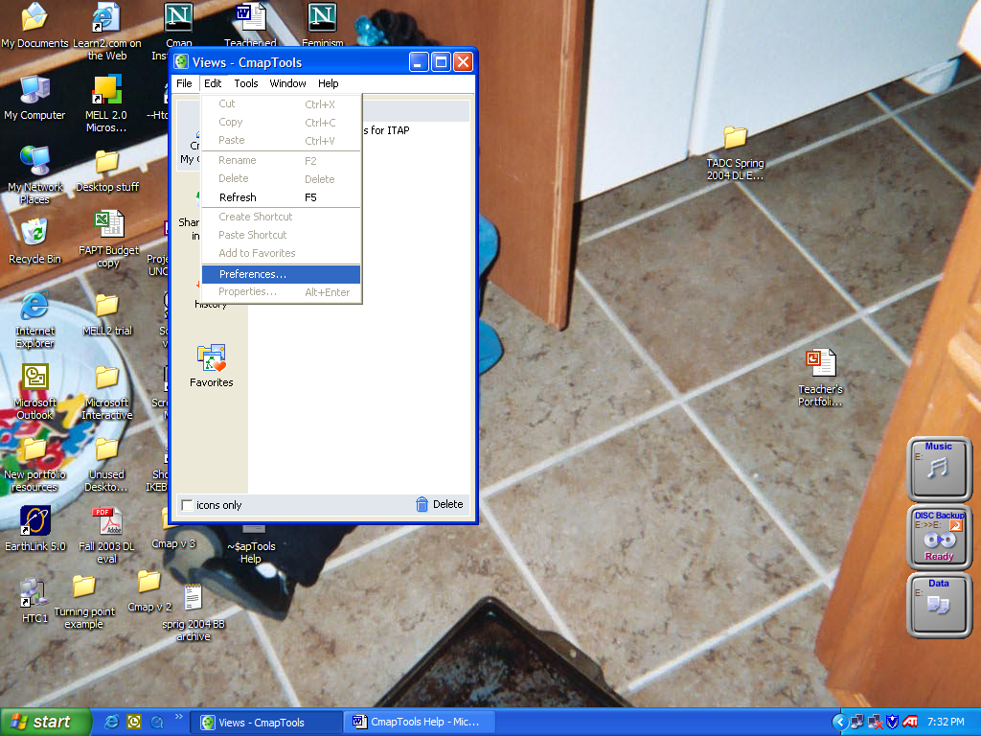
Set Preferences | The Edit Preferences window will display. Click on the desired tabs to set specific preferences for: • General • User info • Places (servers) • Directory of places • Discussion threads • Proxy configuration • Language | 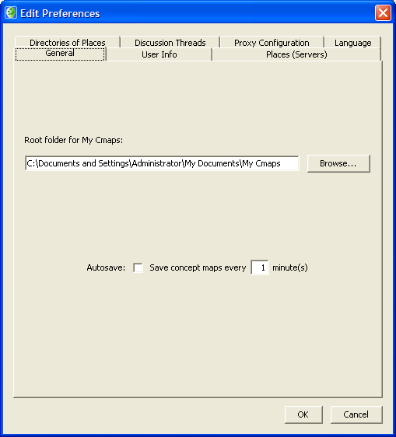
Set Preferences | General tab  • Set the default location to save your Cmaps. It may be helpful to specify a location other than the computer’s hard drive if you plan use different computers to create and work on Cmaps. External high capacity drives or network folders can be used as the default location. To open a Cmap, the CmapTools software must be loaded on the computer you are using.  • Specify the time interval to automatically save Cmaps during creation or modification. | 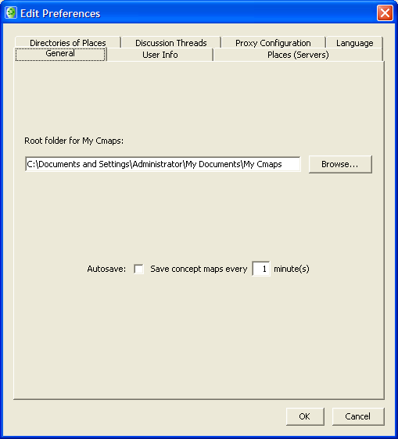
Set Preferences | User Info tab • Add and update personal information • Change user ID and password | 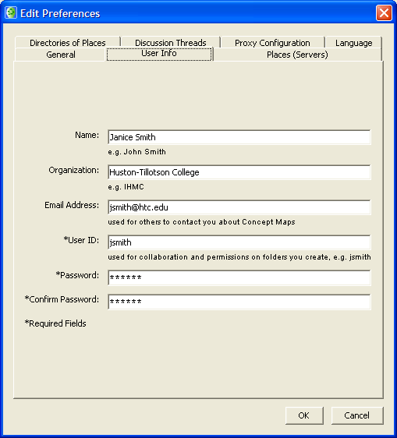
Set Preferences | Places (Servers) tab  • Provides status of public servers with option to hide selected servers.  • Ability to specify parameters to check for new Places and status of existing servers. | 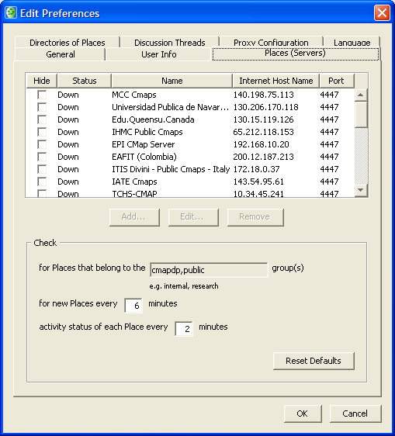
Set Preferences | Directories of Places tab  - Handles registrations from Cmap Servers. Monitors availability of servers to determine if it is up and running. Servers that are inactive for a period of time will be removed from the directory.  - The Huston-Tillotson College server is a private server. If you are prompted to enter an IP address during the publishing process, use 172.16.0.5 | 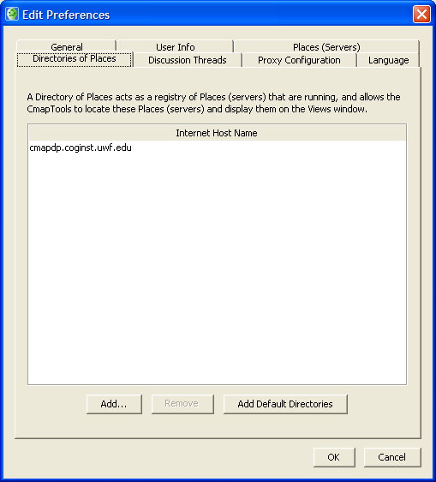
Set Preferences | Discussion Threads tab  - Set visibility of your user ID  - Specify frequency to check for new messages | 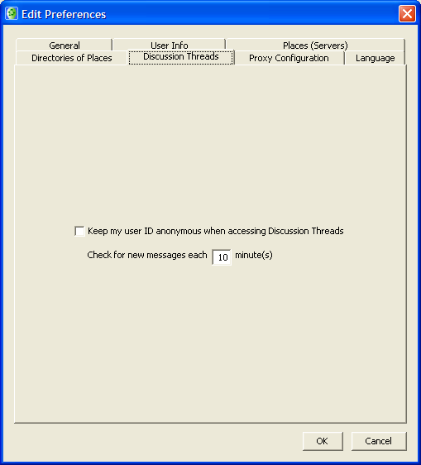
Set Preferences | Proxy Configuration tab • Settings for connection via a proxy server (authorized secondary server). NOTE: Consult the IT department before changing these settings | 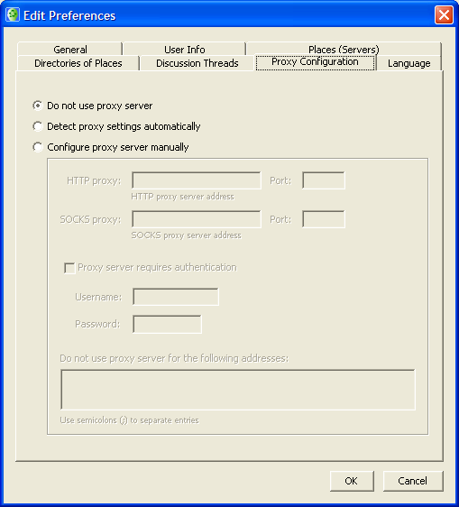
Set Preferences | Language tab  Available languages for menus and messages (as of June 2004)  - English  - Italian  - Portuguese  - Spanish | 