Huston Tillotson College
Presents
Seasonal Fashion Production
Black Fashion Designer Photos
African, Black and African-American Fashion Designers
TICKETS TO FASHION SHOWS
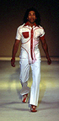  ANDRE MARTIN for LIFE  Spring 2003 | 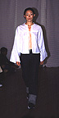  EXODUS  Spring 2001 | 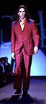  OZWALD BOATENG  Fall 2001
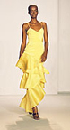  B MICHAEL  Fall 2004  Spring 2003  Fall 2001 | 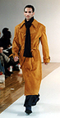  FRANCIS HENDY  Fall 2002  Spring 2002  Fall 2000 | 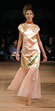  PATRICIA MILLS  Spring 2004
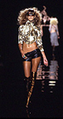  BABY PHAT  Fall 2004  Fall 2003  Spring 2003  Fall 2002 |   GERI BENOIT-PREVAL  Fall 2001 |   PATRICK ROBINSON  Fall 1999  Spring 1999  Fall 1998
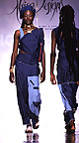  BONGA BHENGU  Spring 2001 | 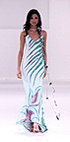  HEATHER JONES  Fall 2002  Fall 2000 |   PHAT FARM  Spring 2003  Fall 1999
  BONGIWE WALAZA  Spring 2001 |   JAMES MOORE  Fall 2000 |   ROCAWEAR  Spring 2000
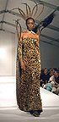  CALVIN SOUTHWELL  Fall 2000 | 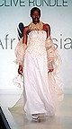  JULIAN  Spring 2003  Spring 2001 |   SABRE MOCHACHINO  Fall 2001  Spring 2001
  CARLOS ANTONIO REAVES  Fall 2004 | 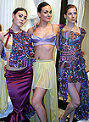  KENDRA FRANCIS  for FRANKE  Fall 2004 | 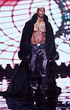  SEAN COMBS  for SEAN JOHN  Fall 2001  Fall 2000
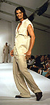  CLAUDIA PEGUS  Fall 2000 | 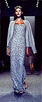  KEVAN HALL for HALSTON  Fall 1998 |   SISTER BUCKS  Spring 2003
  CHI CHI E for VINTIQUE  Fall 2004 | 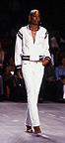  LADY ENYCE  Spring 2003 | 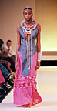  THULARE MONARENG  Spring 2003
  DAMAT & TWEEN  Spring 2003 | 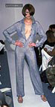  LAURITA SHIELDS  Fall 2001 |   TRACEY LEE  Spring 2001
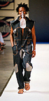  DIKETO  Spring 2003 | 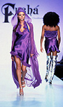  MARIE CLAUDINETTE JEAN for FUSHA  Fall 2003 |   TRACY REESE  Fall 2004  Fall 2002
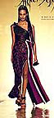  DEOLA SAGOE  Spring 2001 | 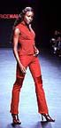  MAURICE MALONE  Fall 2000  Fall 1999 |   TULEH  Fall 2004  Spring 2001
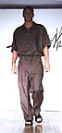  ERIC MALIK  Spring 2000 |   MICHE KIMSA  Spring 2001 | 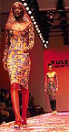  XULY BET  Spring 1999
  EVERETT HALL  Fall 2001  Spring 2001  Spring 2000  Fall 1999 | 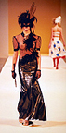  OLD BOY OOF  Spring 2003 | 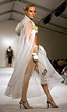  YOKO FUNG  Fall 2000  Produced By Glamour Creation Fashion Inc.  Mr. Edward Arnold

