The clay molding is of the back half of a lion on its two hind legs. It seems that it might be fighting with another animal or perhaps a human. It is thought that it could be an image of when Hearcles fought the Nemean Lion.

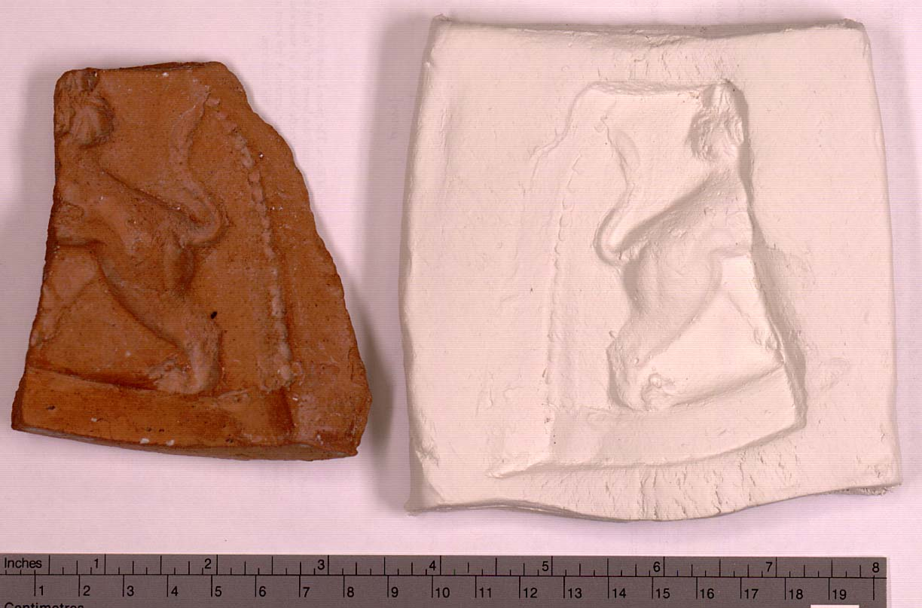

This image is part of the online exhibit Oxyrhynchus: A City and its Texts. Images and caption texts are © the Egypt Exploration Society

