The Tombs
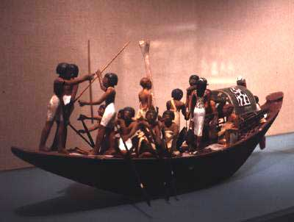
The tombs were created to provide the dead with the necessary supplies needed in the journey of the afterlife. The tomb would be equipped with every day items which the dead person would need, and was usually located on the west side of the Nile. Inside the tombs clothing, jewelry, food, and weapons were stored, all placed there as supplies for the afterlife. The tomb also often included a statue of the person along with detailed statues of servants, concubines and boats. These would help the spirit of the deseased in their travel in the afterlife.
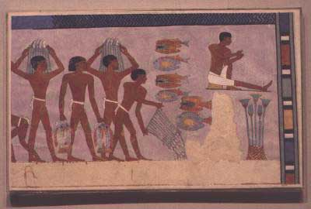
In addition to the material in the tomb, the walls of the tomb where painted with scenes from every day life. They believed that these paintings could be magically evoked to supply the spirits with their needs in eternity. The statue of the dececsed could act as a kind of substitute for the spirit in case the body was damaged or destroyed. The statues of the servants could all serve the dead person's spirit in the after life.
The dead were believed to have the same needs as the living. A man's heir was expected to bring food to the tomb daily to feed the dead person's "ka" or spirit. Often this duty was neglected the decedents. The heir may also hire a priest to take care of feeding the dead person's "ka." These priests became know as a Ka servant and would often be given large tracks of land to support their duties to the dead.
Bottom two pictures - Copyright 1997 - The Multimedia Library (http://www.multimedialibrary.com.)

