The first typewriter was invented in 1867 by American Christopher Latham Sholes. The first typewriter came without spacing, no shift keys, and other accessories that were added on to the newer models. Sholes went on the sell the patent to James Densmore who had it manufactured by the gun makers E. Remington & Sons.

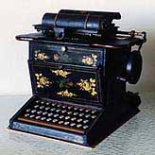

Picture: http://home.earthlink.net/~dcrehr/firsttw.html
Info: http://www.enchantedlearning.com/inventors/indext.shtml

