Design Elements Stephanie Lockett
Image | URL | Design Elements | Comments
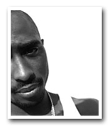 | http://wx10.registeredsite.com/user883521/miva/merchant.mv?Scree  n=CTGY&Store_Code=HI&Category_Code=Images | shape | Black and white portrait, the theme of this portrait could be the fact that it is off centered just like the artist, since Tupac’s facial features are very defined this could be the shapes of this portrait
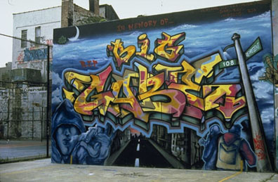 | http://photoarts.com/cooper/image089.html | Color  Texture  Lines | Lines are used to create name in untraditional script. There’s also a portrait created by lines  Blue is the dominant color  Red, Orange &Yellow are bold colors used in order to make the name Big Gabe more distinct.
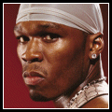 | http://allhiphop.com/ | Color  Lines | The color red, in a way matches his skin tone the silver head wrap matches all of his jewelry.
 | http://www.rapindustry.com/music.htm | Color, shape, texture, lines | The blue in this portrait is dominating, because it is in the center, I like the use of shapes

