Giuseppe

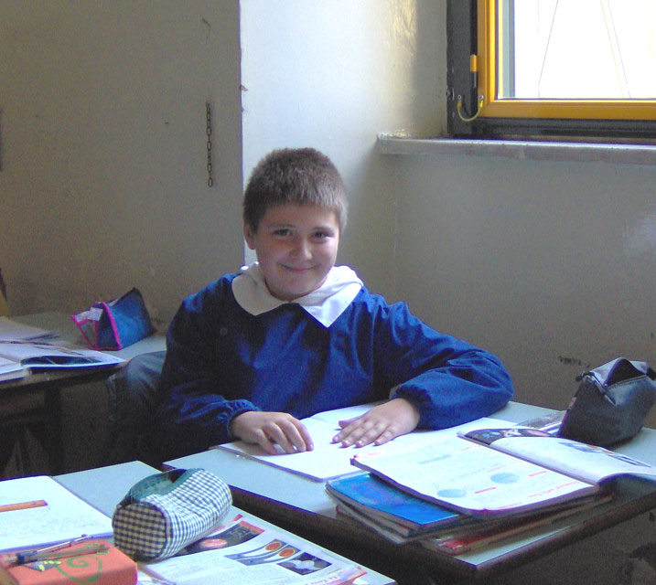
Hi! My name is Giuseppe. I live in Bernalda. I'm ten years old. I'm toll and roust.
My oyes har brown. My hair har blond.
My favourite group it's Blue. My favourite actor it's Breed Peet.
My favourite actres it's Julya Roerts.
My favourite sport it's basketboll. My favourite colour it's blue.
My favourite toy it's Playtation 2. My favourite sabjet it's Enghles.
I like bread and meet, but I don' t like cheese.
I have a brother, but I haven’t got a sister.
My best friend is Giuseppe F.
P.S
Write me soon.
Love Giuseppe

