Name_______________________________________________Date________________

- Where should the medication tray be placed for the pharmacist to access the drugs in it during a code blue emergency?
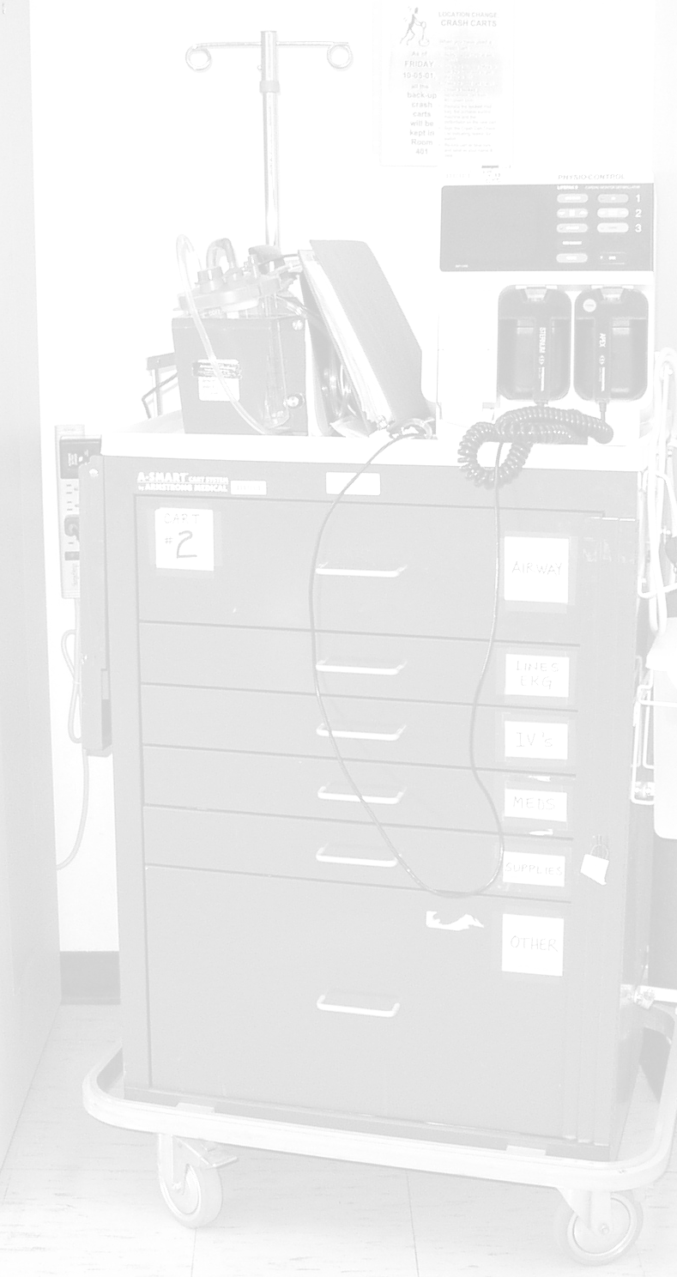

- What two medications should be assembled at the beginning of a code blue emergency?

- When the physician requests a medication, what does the pharmacist in conjunction with passing the medication to the physician or nurse who will be administering it?

- If an IVPB of isoproterenol is requested, where are the instructions regarding what concentration to make?

- What do you do with the empty syringe boxes as the code progresses? Why?

- Which IVPB medication should NOT be given in the same line as an alkaline IV solution?

- What do you do when the code has ended?

- Name two pieces of equipment found on the outside of the crash cart.

- What is an Ambu Bag™ used for?

- Name one item in the crash cart used for personal protection of the healthcare worker?

