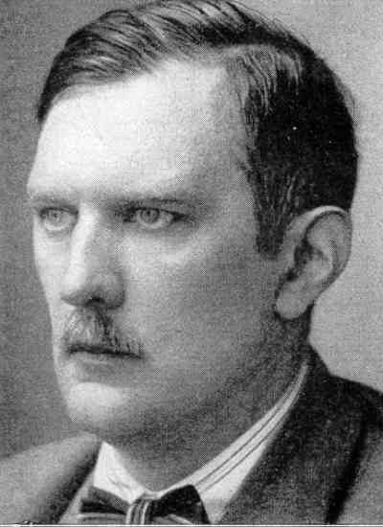
- Arthur Moeller van der Bruck
He was born in 1876 and he was the leader of the young revolutionary conservatives of the Weimar. He inspired the violent Hitler’s ideology and he was the teacher of the national socialism. Two years later the publication of his masterpiece, Das dritte Reich (the third kingdom) in 1925, because of a depression due to personal and ideological reasons, he killed himself in Berlin.

- Franco Cardini
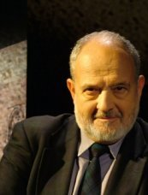
He is an archivist and a Honorary Professor of History Medieval Studies in different universities: Florence, Harvard, Paris, Bari, Vermont, Berlin, Saint Marino, Vatican City and Naples.
He became the Italian Historian for the Middle Ages and in 1986 he became a member of the National University Council.

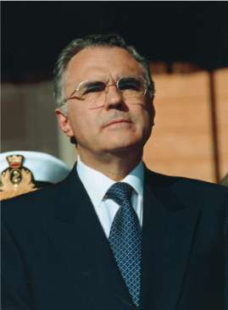

- Domenico Fisichella
He has been vice-president of the Senate in 1996 and in 2001 and Minister for Cultural and Environmental too.
He also is a professor of Doctrine of the State and Political Science at the Universities of Florence and "La Sapienza" in Rome.

- Luciano Canfora
He is a Professor of Greek and Latin Philology for Bari's University. He has studied problems of Ancient History, Greek and Roman literature, History of the tradition, History of the Classical Studies, Politics and Culture of the XX century in different universities: Pisa, Rome, Boston, Santiago in Spain.

- Sabino Acquaviva
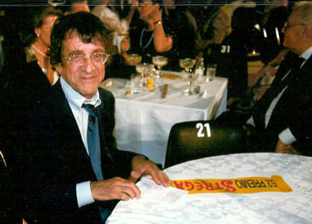
Professor of sociology at the Faculty of Political Sciences of the university at Padua. He belongs to the “Conseil de Perfectionement” of the Faculty of Law and Economy of the university of Nice. He has also been "Visiting Fellow" at Oxford.

- Tiziano Terzani
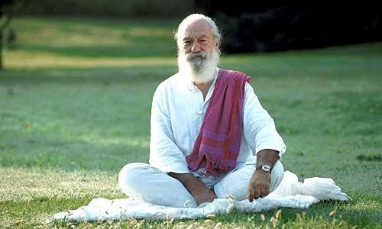
1961. He graduated with praise in Law at the Physician-Juridical College of Pisa. He was in Japan to hold some business courses.
1969. He achieved a Master in International Business Studies at to Columbia University in New York following courses of history and Chinese language.
1975. He was one of the few journalists to remain in Saigon (Vietnam): so he could witness to the taking of power from the communists.
1998.His experience accredited him to international level among the top experts of the Asian continent.
2002. He began the "pilgrimage of peace" through schools and public meetings supporting the cause of Emergency.

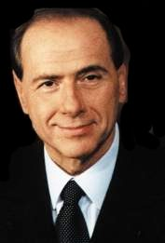
- Silvio Berlusconi
He is an tycoon (=imprenditore) and an Italian politician. Italian Prime Minister in 1994 and from 2001 to 2006. According to Forbes he is the richest man in Italy and the 37th richest in the world today, with an esteemed fortune in 2005 of 12 million dollars. Leader of Forza Italia, the political movement founded by him and Premier of the council from 2001 to 2006.

- Dick Cheney
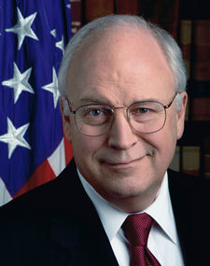
Richard Bruce Cheney, known as Dick Cheney, is the present Deputy President of the United States of America. Graduated at the University of Wyoming he began his public career in 1969.
In 1977 he was chosen to the Chamber and re-elected for five times.
In 2001 he became Vice president of the United States under the presidency of George W. Bush.

- Condoleezza Rice
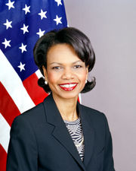
She is the second secretary of State of the United States of the George W. Bush administration.
She enters university at fifteen. She graduates in Political Sciences at the University of Denver at twenty. In 1975, she attends a master course at the University of Notre Dame (Indiana).
In 1981 she began the Academic career at the University of Stanford as a Professor of Political Sciences.
In 2000 she began adviser for the national safety of George W. Bush, she is the first woman to cover this charge.

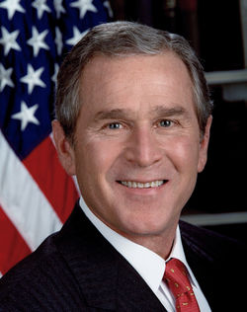
- George W. Bush
George Walker Bush is the 43rd and current President of the United States and former governor of Texas. He is currently in his second term as president, serving until January 20, 2009.
He is the son of the 41st president, George H.W. Bush, brother of the current governor of Florida, Jeb Bush, and grandson of former U.S. Senator Prescott Bush. He is only the second president to be the son of a former United States president.
A member of the Republican Party, Bush was elected the 46th governor of Texas in 1994, then re-elected in 1998. He ultimately defeated Democratic Vice President Al Gore in a close, disputed election which ended in a Supreme Court decision.
Bush's presidency has been defined by the War on Terrorism following the September 11, 2001 attacks. After the attacks, Bush and the United States Congress created the Department of Homeland Security and increased the powers of law enforcement agencies. In 2003, the United States and a multinational force took military action in Iraq, overthrowing and eventually capturing Iraqi President Saddam Hussein. A central theme in Bush's continuing policy in Iraq has been the creation of a democracy and free elections in Iraq.

