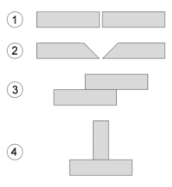

Common welding joint types – (1) Square butt joint, (2) Single-V preparation joint, (3) Lap joint, (4) T-joint.



The cross-section of a welded butt joint, with the darkest gray representing the weld or fusion zone, the medium gray the heat-affected zone, and the lightest gray the base material.
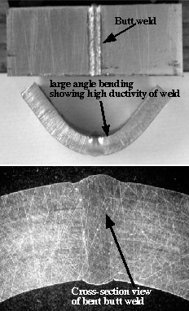

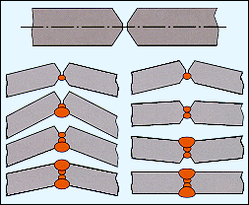
this is vee / double vee welding and the angle of welding
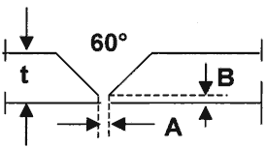
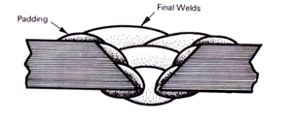

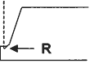
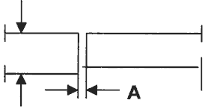
This is the J fillet welding joint.

This is Vee fillet

Below is a representation of a convex fillet weld without discontinuities. www.weldingengineer.com/ Discontinuities_.htm
