TOPIC: AFT END ARRANGEMENT

Learning Objectives :

At the end of the lesson the student should be able to do the following:

9. Understand the design of the aft end structure with respect to local loads and stresses.

9.1 List the loads that occur at the aft end structure and, with the aid of sketches, explain how the aft end is structurally strengthened to counter these loads.

9.2 Briefly describe the construction of a rudder.

9.3 With the aid of a simple sketch, show the various propeller clearances which are significant to proper ship functioning.

9.4 Briefly describe the construction of a stern frame which should include references to its attachment to the hull.
Aft End Construction
The aft end of the ship refers to the stern part of the ship within 0.25 length from the aft perpendicular. The aft end includes the main hull and superstructure including the poop. There are basically two types of stern construction, namely:

(a) the cruiser stern
(b) the transom stern

Cruiser stern presents a pleasant profile and reduces resistance probably because of the increase in waterline length but at a penalty of a longer overhang. It is likely to be subject to a greater slamming force than the transom stern.

Associated with cruiser stern are cant frames. Cant frames are frames constructed at an angle to the centre line of he ship so that the entire area of the stern plating can be stiffened at regular intervals. Where the span of the frame is 1ong, horizontal stringers or girders are fitted to reduce the span and therefore the size of the frames.

Transom stern provides for easier construction. Transom stern also provides for a greater deck area. Most merchant ships are fitted with transom stern because it is easier to fabricate.

Aft Peak Tank
The aft peak tank is the after-most tank on the main hull structure. It is normally used for the storage of fresh water or ballast and it provides a degree of protection to all spaces forward of the aft peak bulkhead.

The following members are normally found in the aft-peak tank construction:

(1) Stern frame: The shell plating at the aft end is terminated by the stern frame. This is usually a casting, but fabrications and forgings are sometimes used. The shape of the stern frame depends on the design of the stern, the propeller and the rudder arrangement. In single screw ships, the stern frame has a boss on the centreline for the tailshaft to pass through and an adequate aperture is provided for the propeller to operate in. The lower part of the stern frame may provide a support for the rudder post or an overhang section may provide gudgeons for the rudder pintles.

Various sections of the stern frame, particularly above the arch, provide connecting points to the individual floors of the aft end construction. The transom post and the vibration post are two particular connections. Sound connections at these points ensure that propeller-induced vibrations are kept to a minimum. For ships with more than one tail shaft the bossing arrangement will be different. Twin screw ships have a stern frame which is only required to support the rudder pintles and is thus much reduced in size.

(2) Solid floor is located at every frame space for a stern with a transverse framing system.

(3) Centreline longitudinal wash bulkhead is normally fitted to reduce the free surface effects. The centreline wash bulkhead is stiffened by vertical stiffeners and girders as necessary.

(4) Rudder trunk is a section which is found in the stern for the entry of the rudder stock into the steering gear room. The lower part. of the rudder trunk is open to the sea, but usually provided with an inspection manhole for viewing. The trunking above this is then constructed to be watertight, penetrated only by the rudder stock.

(5) Stern tube is also housed in the aft peak tank. It houses the propeller shaft and bearings. The tailshaft within the stern tube is either oil lubricated or water lubricated. For oil lubrication the bearings are made of white metal, an alloy of tin. Oil seals are required for the inboard and outboard ends of the stern tube. Oil seals have mostly replaced water-lubricated ones due to increased loadings on the bearings due to slow-speed shafts and heavier propellers on modern ships.

For water lubricated stern tube, the bearings are made from lignum vitae (a type of wood) or synthetic materials. In this case the outboard end of the stern tube is not watertight to allow circulation of sea water within the stern tube but the inboard end of the stern tube must be watertight so that the engine room can be kept dry.

Rudders
It is an underwater appendage the surface of which is used to generate sufficient force to steer the ship when it is in motion. A single rudder is fitted in ships with single tail shaft or single propeller. Twin rudders, i.e. two rudders, are fitted on ships with twin screws or twin propeller arrangement.

Construction of a typical rudder for merchant ships:

- Normally made from standard streamlined profiles.

- A typical rudder will be constructed of plates stiffened by horizontal and vertical webs.

- A coupling palm is normally provided at the top of the rudder for attachment to the rudder stock.

- Lifting eyes are provided for lifting and dismantling of the rudder.

- A drain plug at the top and another at the bottom are provided for drainage, coating and testing purposes.

- A closing plate is fitted on one side of the rudder. This closing plate is the last piece of plate to be fitted after carrying out internal weldings of the rudder. Since only the cut edges of the closing plate can be welded from the outside, additional slots or plugs must be cut on the closing plate so that welding to the horizontal and vertical webs can be effected.

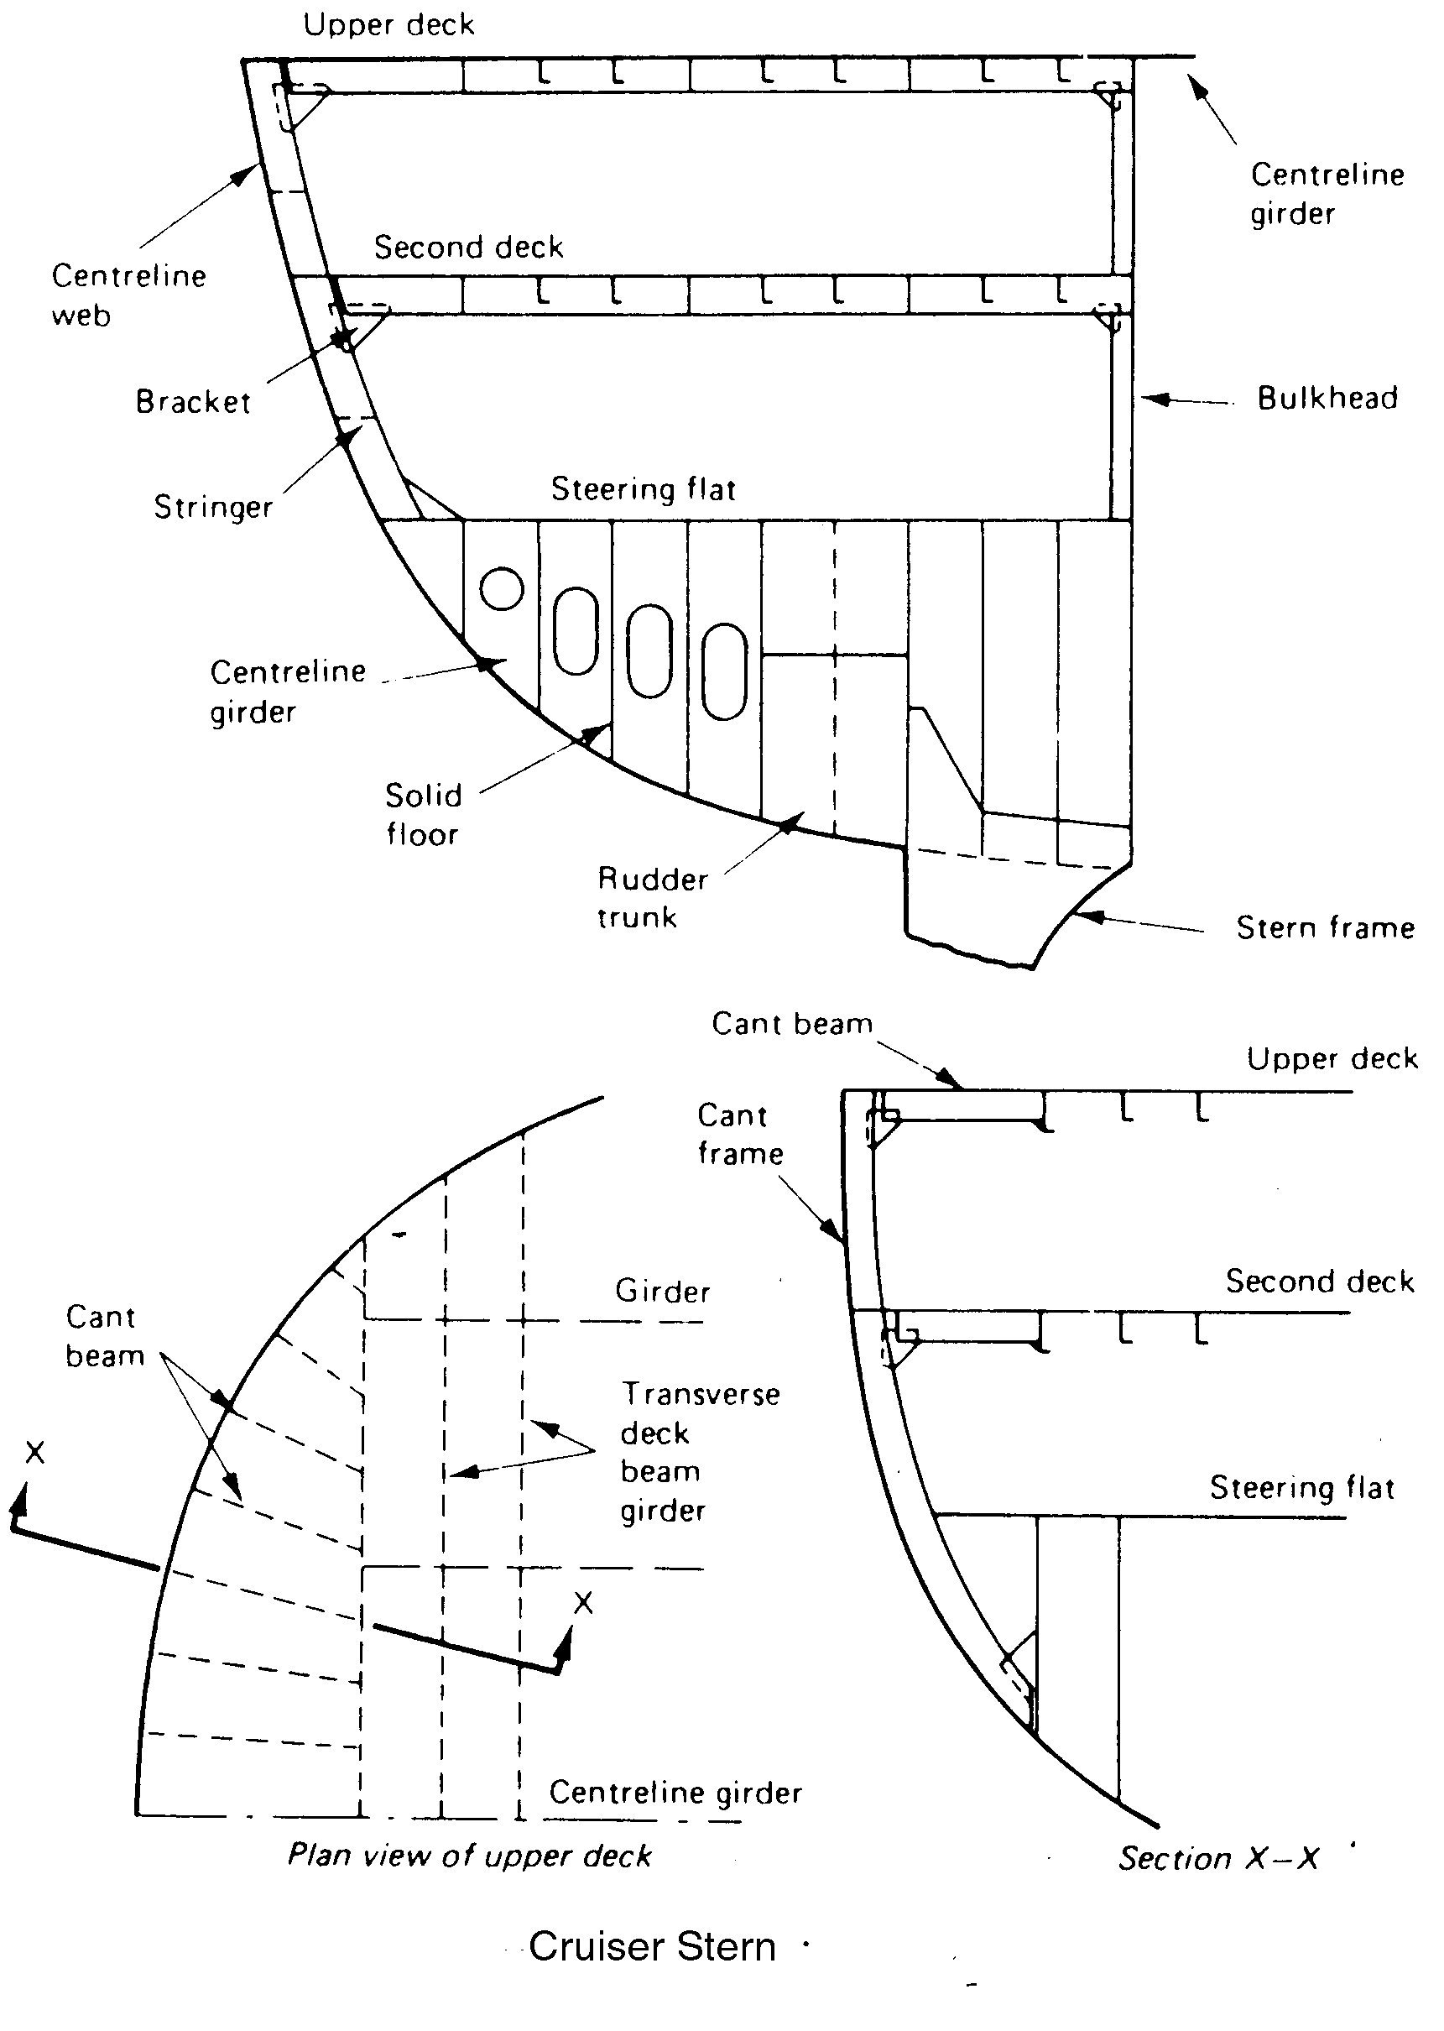

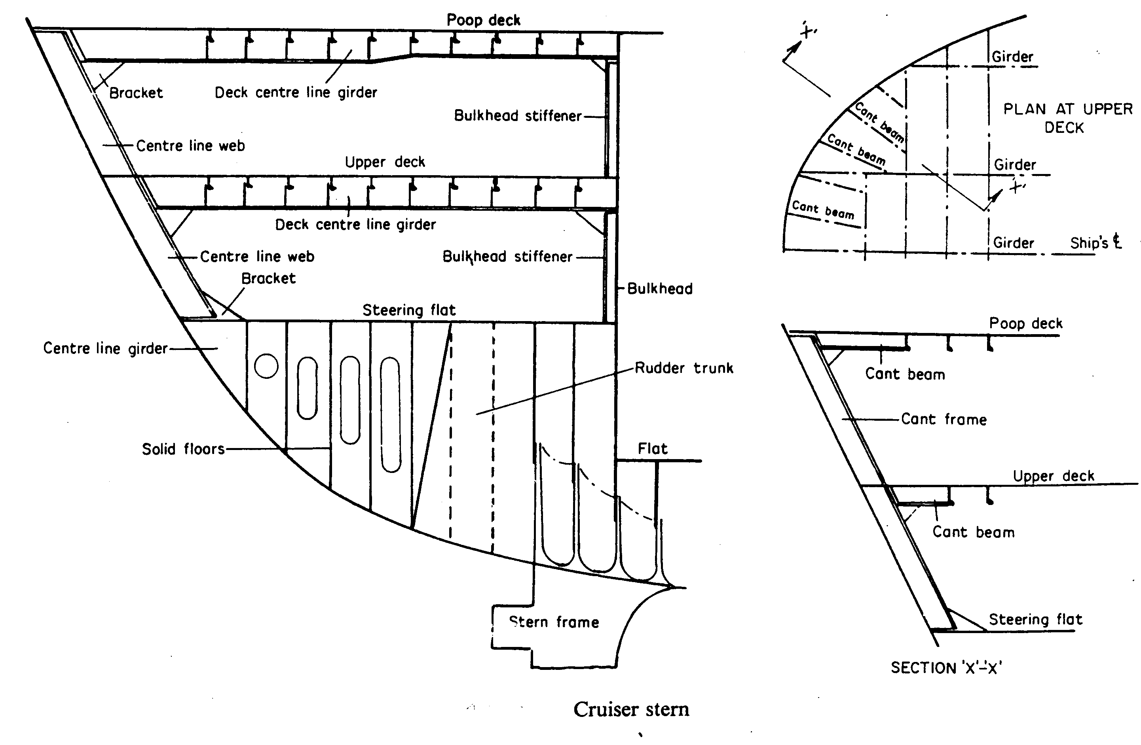
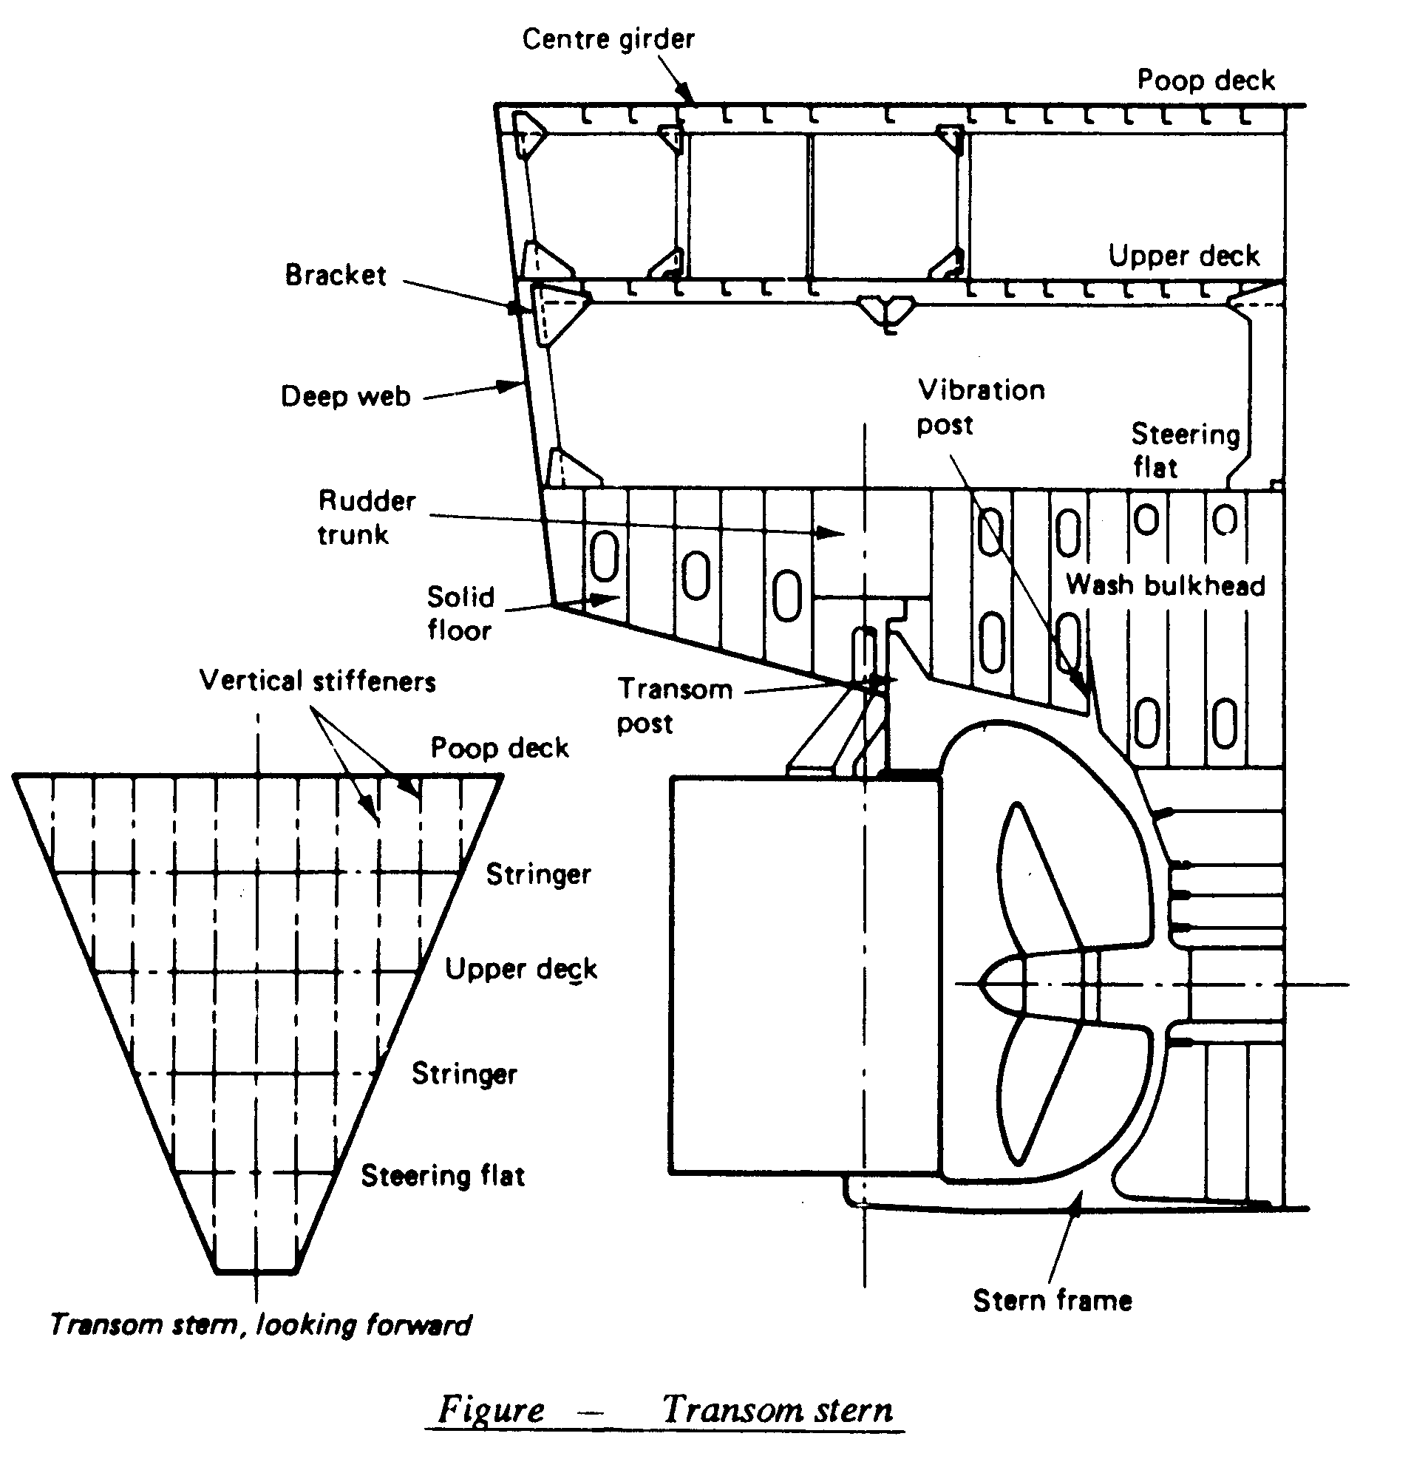

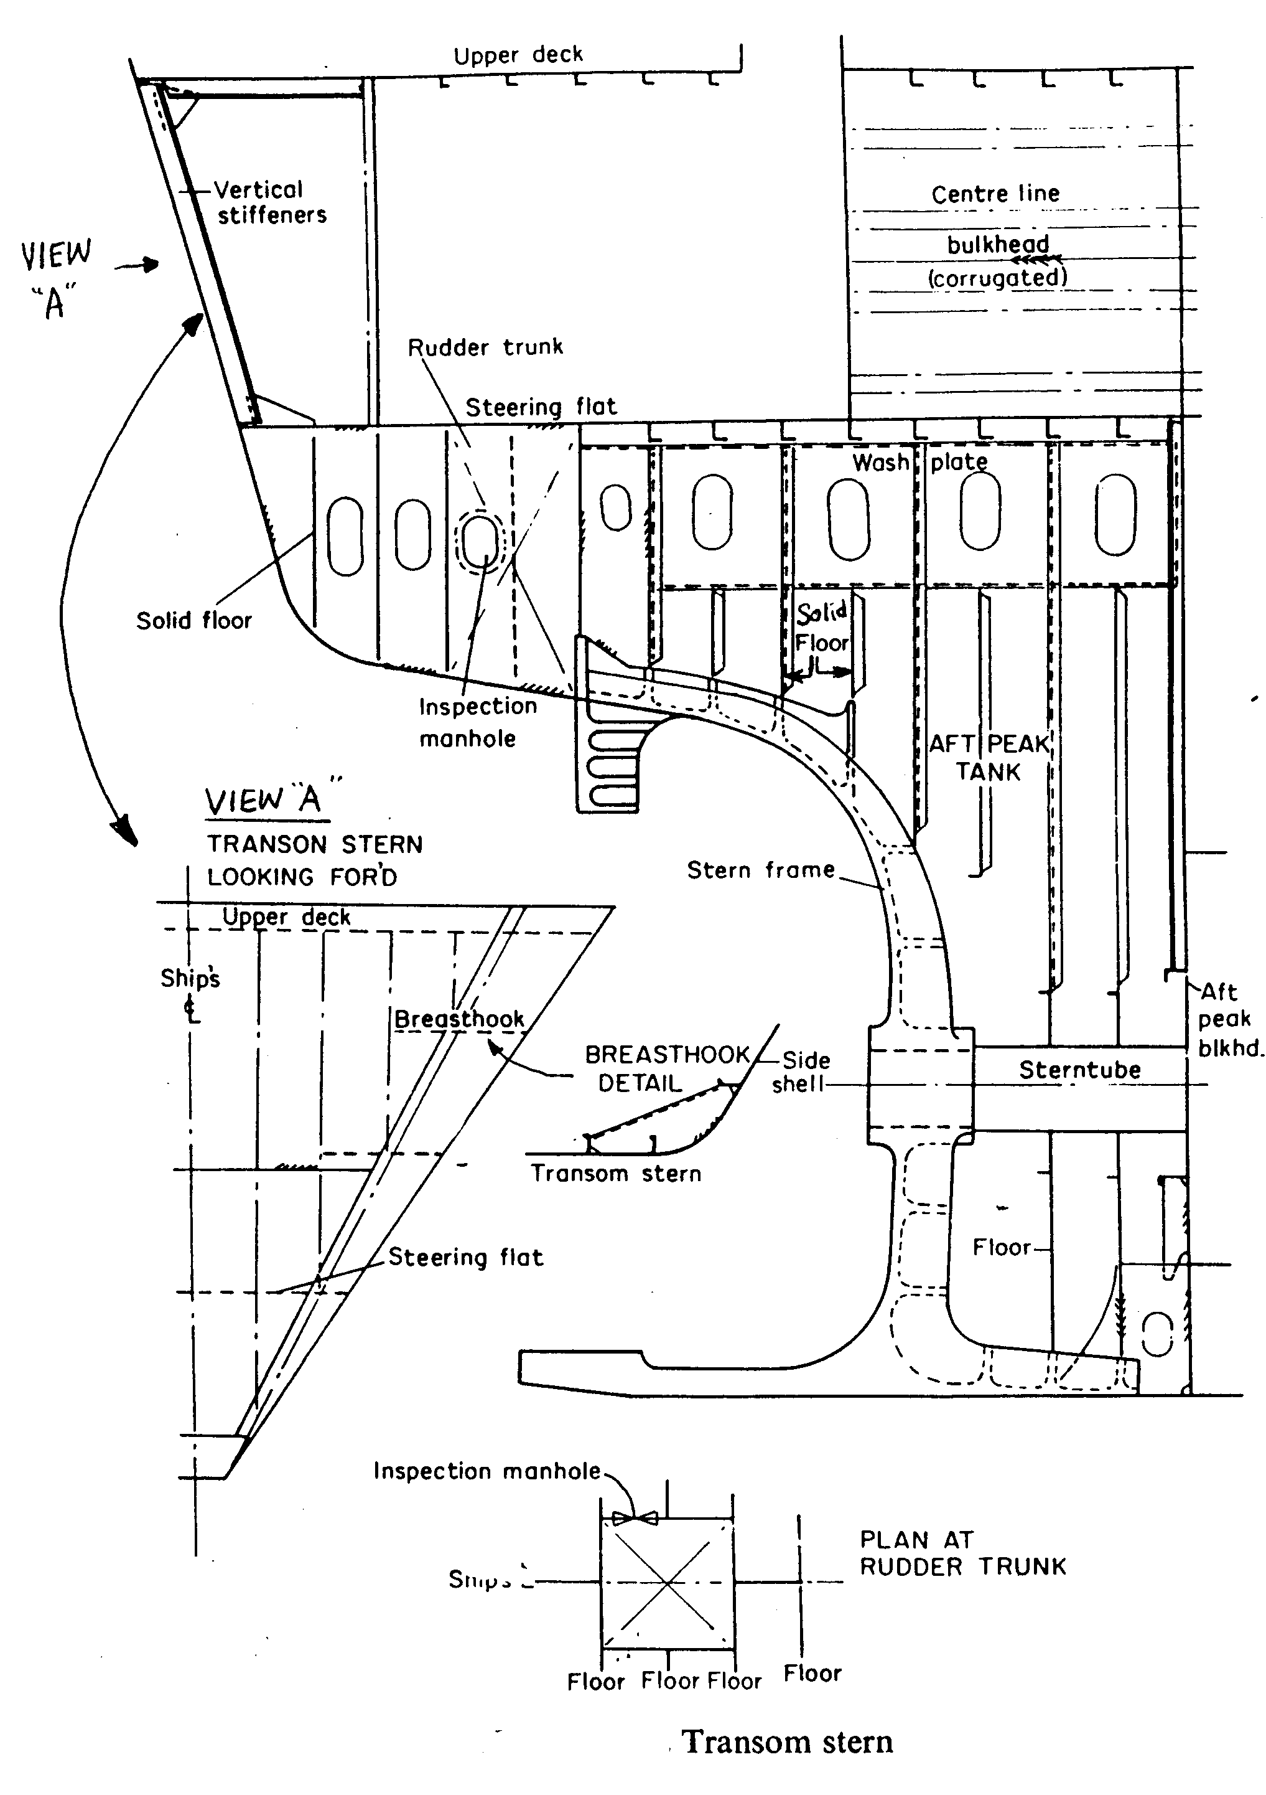

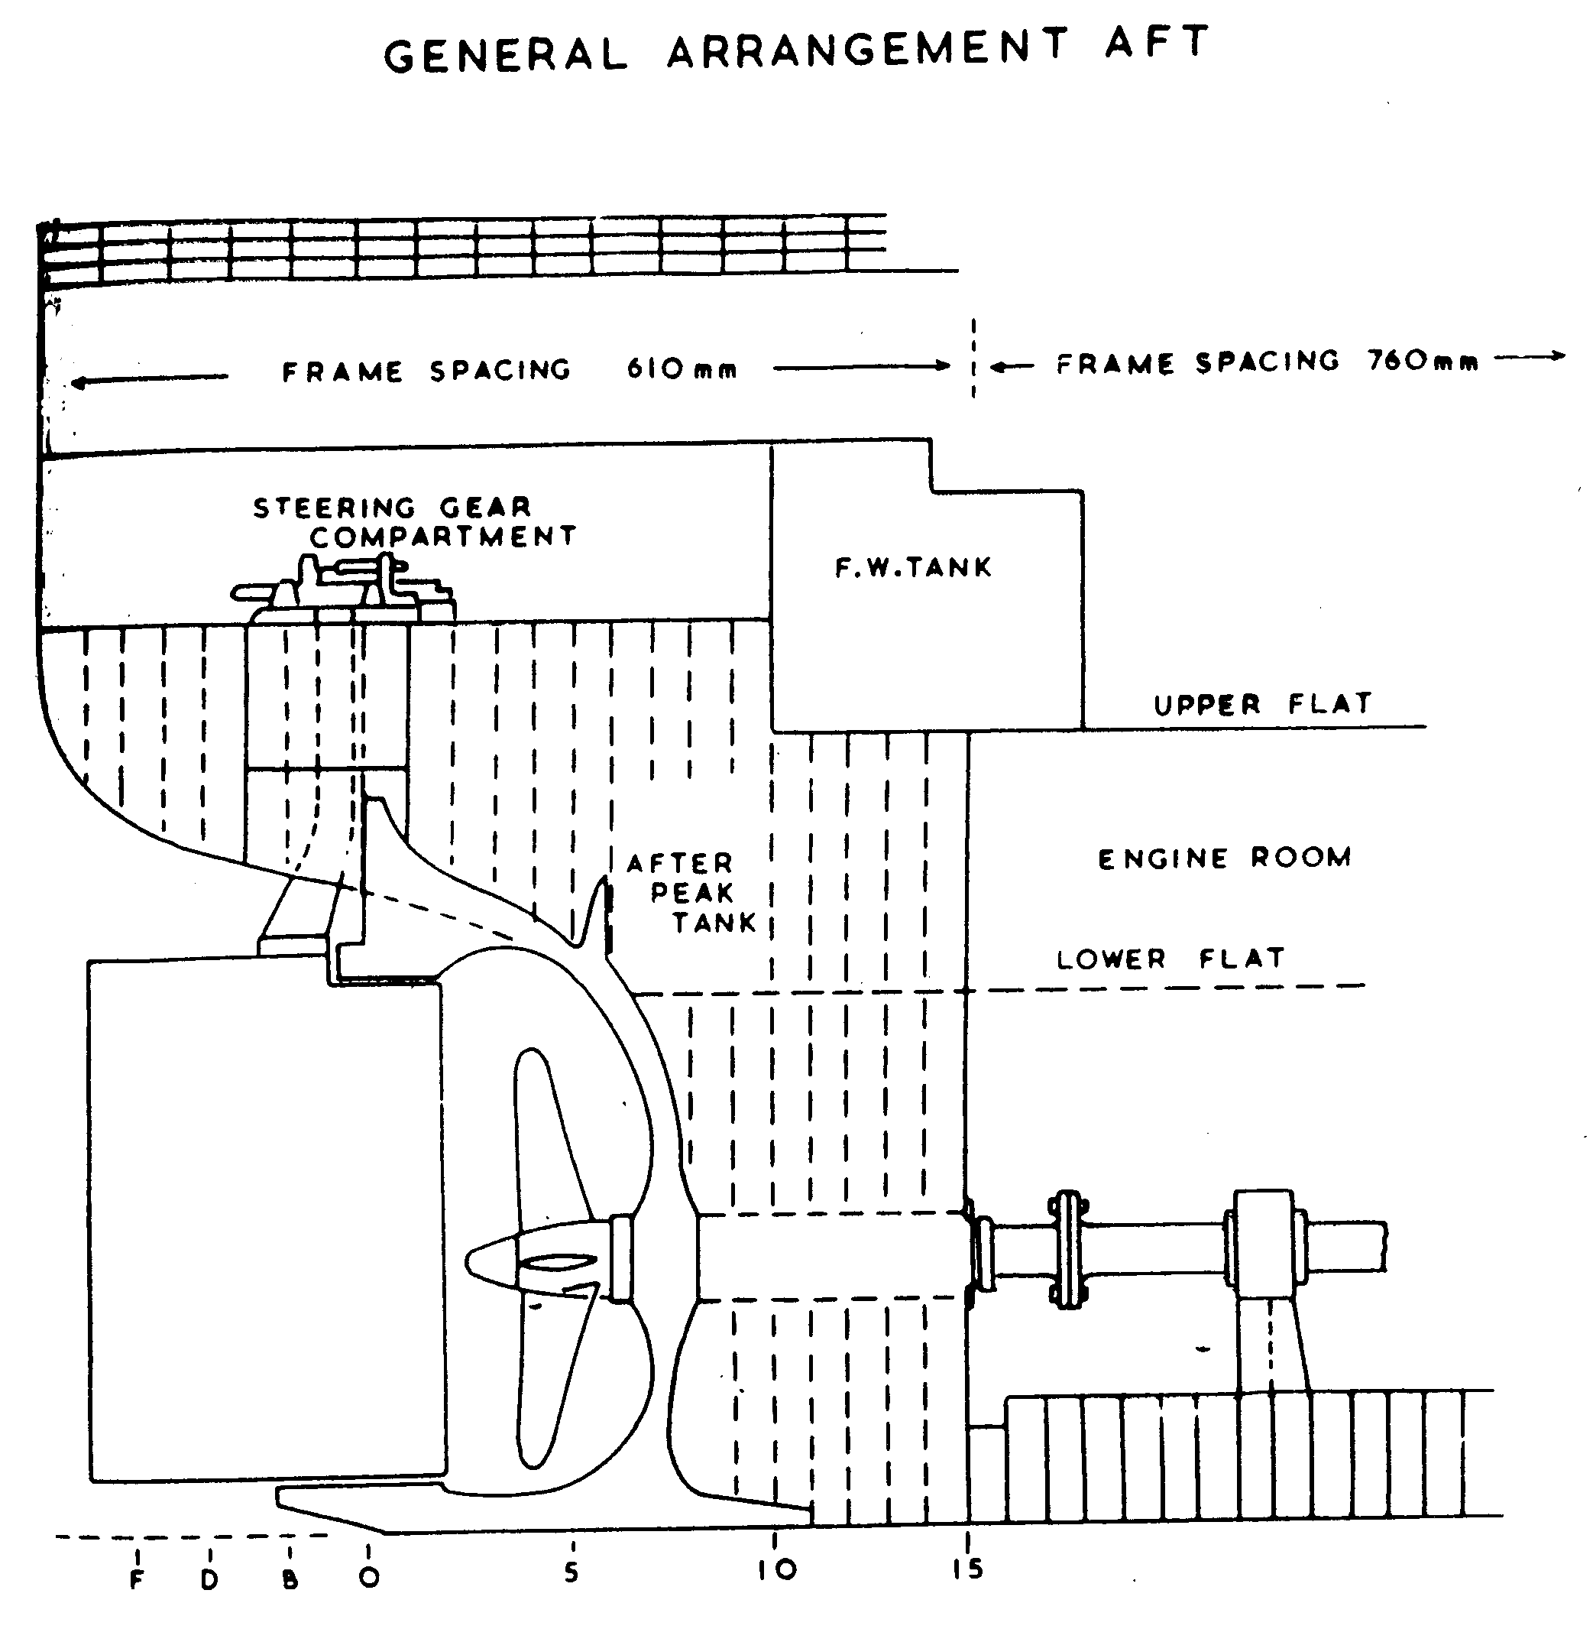

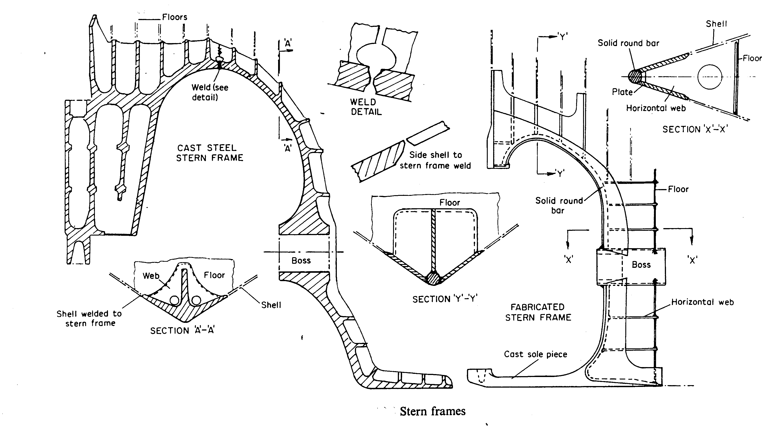

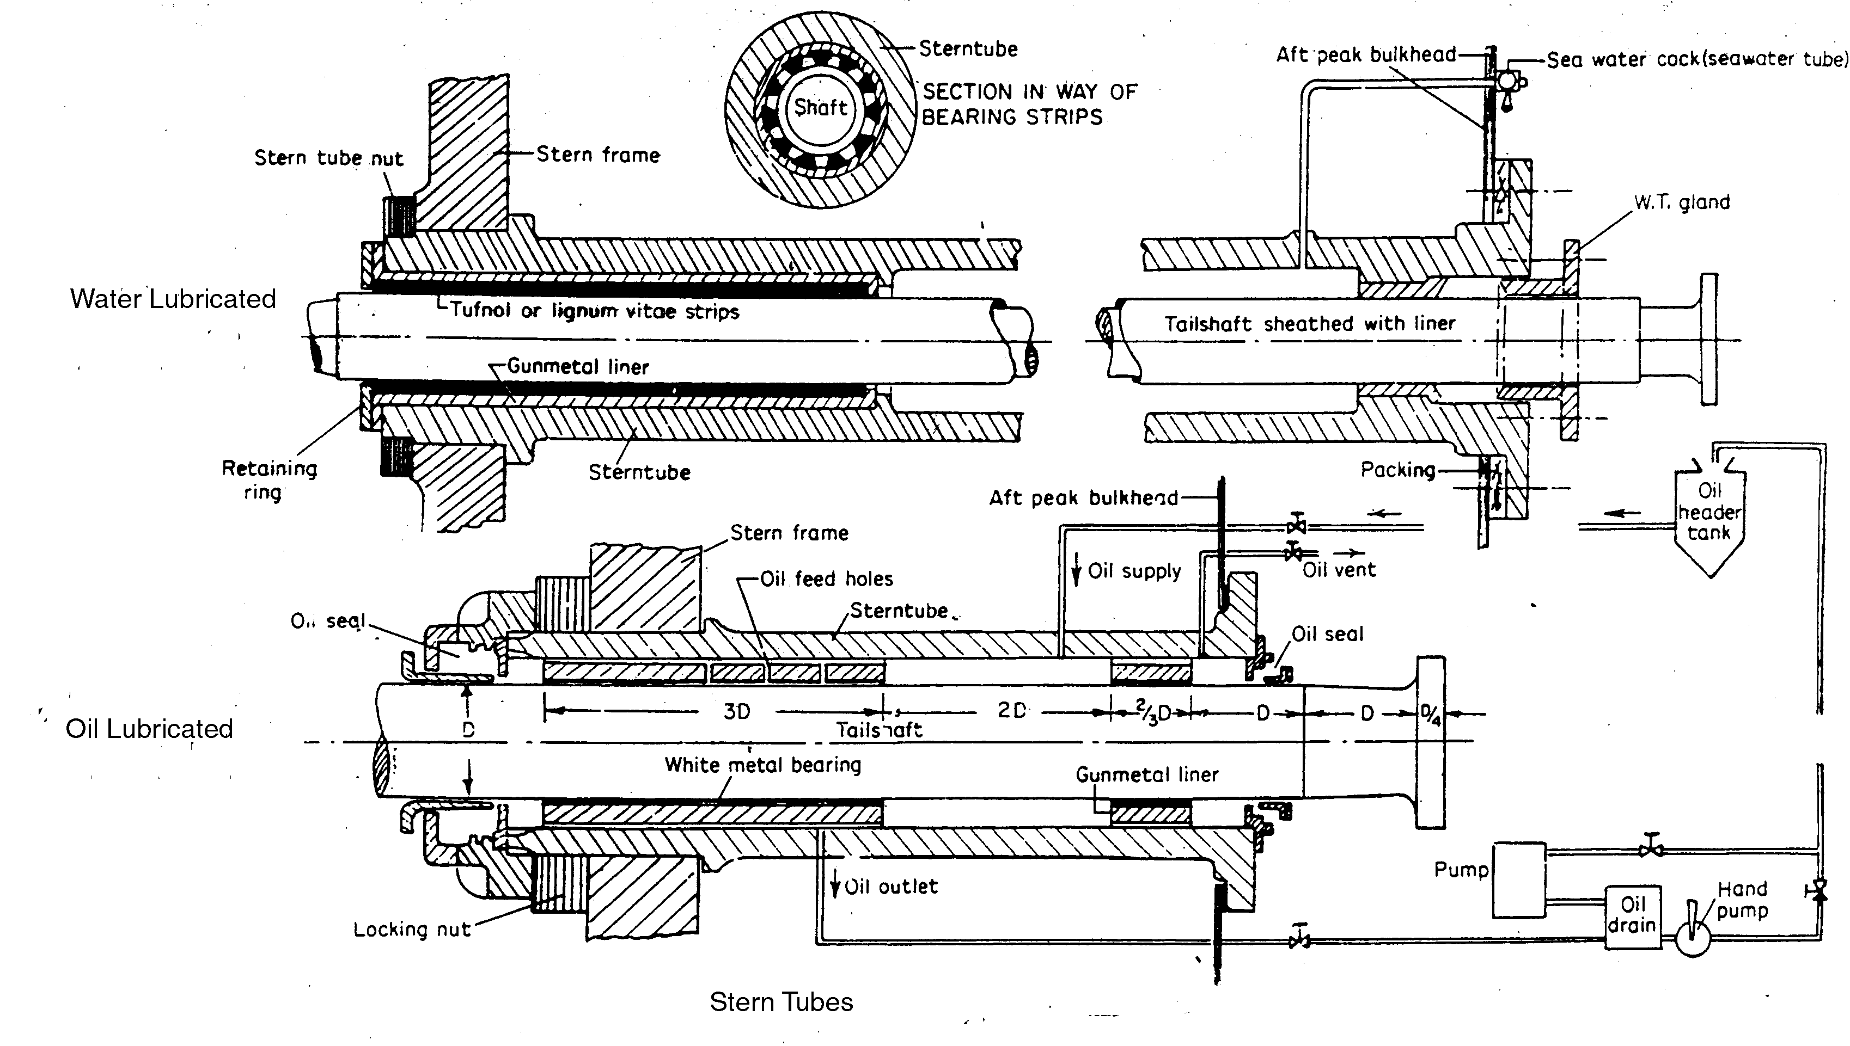

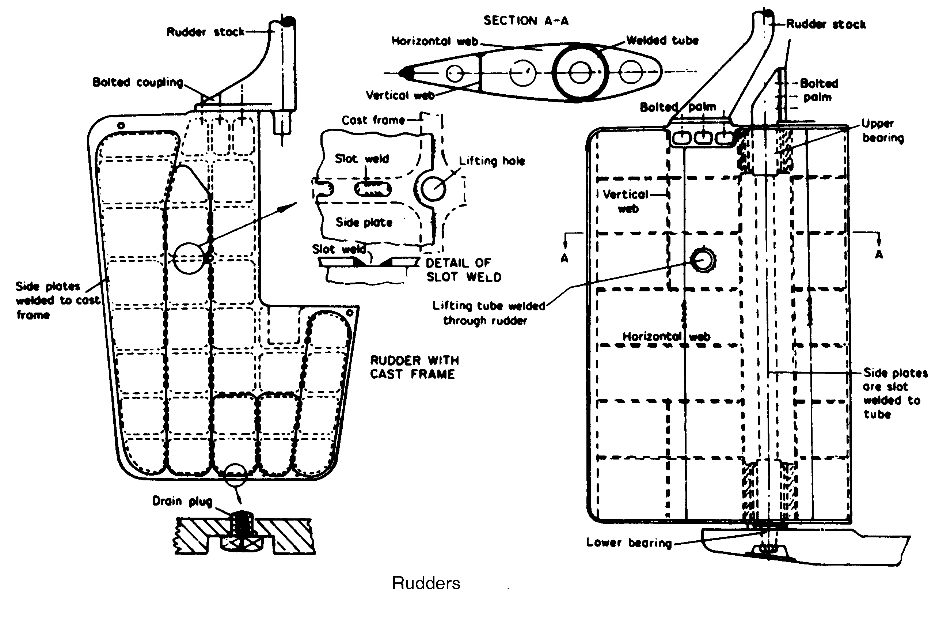

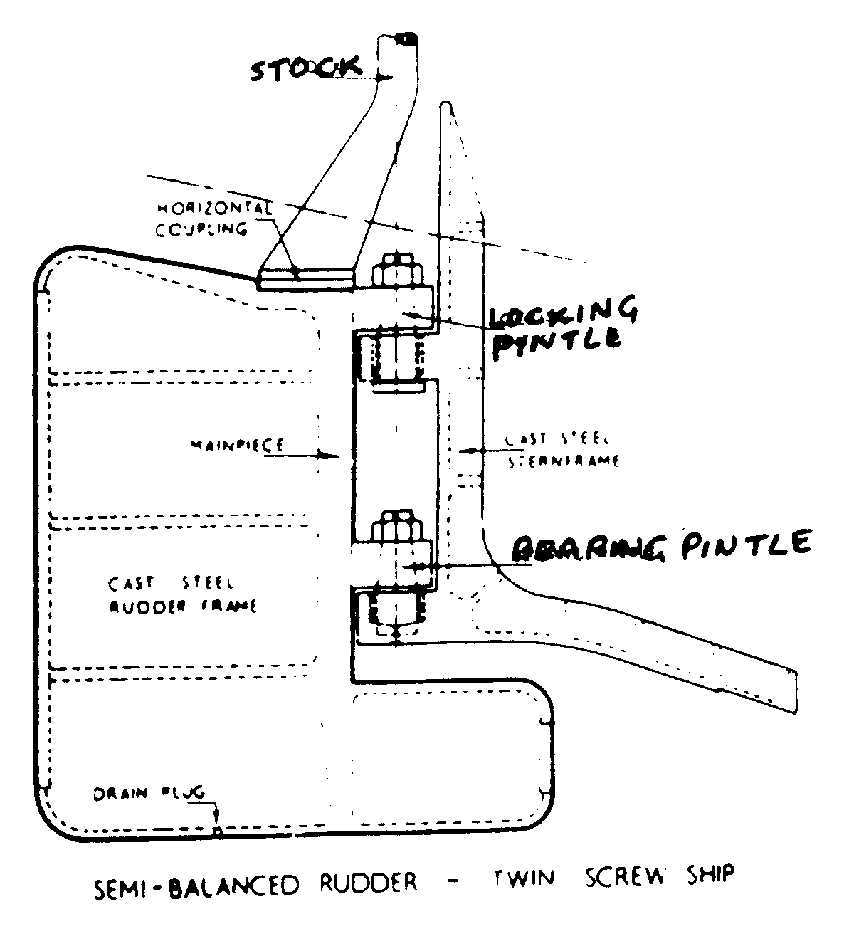

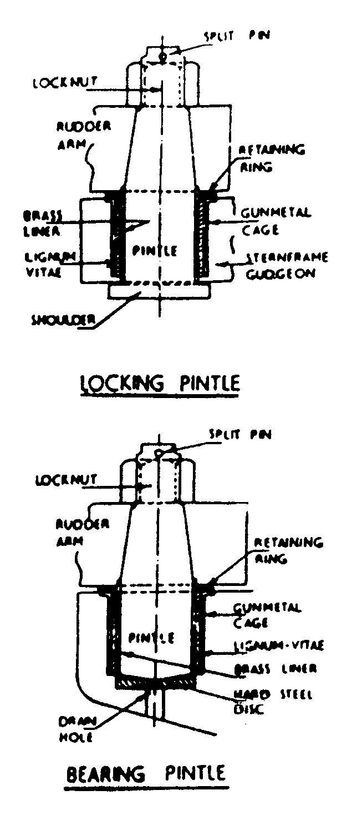

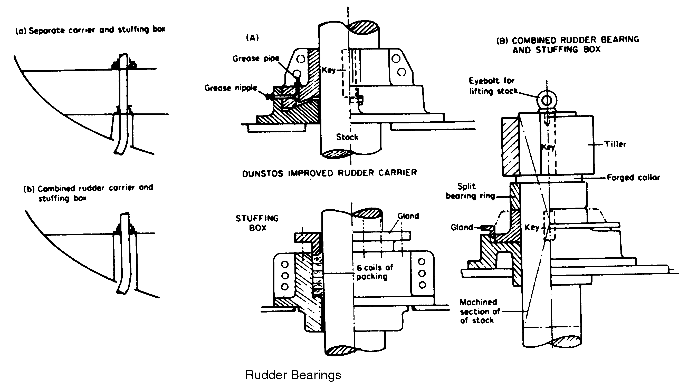

---The End of Chapter---

