U6A3: Alternative Assessment and Scoring

- Concept mapping is the alternative assessment tool that I applied most extensively.
- The question I addressed was: Does the Big Backyard Program align with the Massachusetts State Frameworks.
- The procedure for demonstrating the alignment of the Big Backyard Program with the Massachusetts State Life Science Framework was as follows:
1) A State concept list retaining as much of the explicit and implied propositional linkages and hierarchy as possible was derived from the Massachusetts Elementary Life Science Framework. The Massachusetts science standards are listed in a table format indicating learning standards, ideas for developing investigations and learning experiences, and suggestions for extensions to learning in technology/engineering. The framework is divided into conceptual clusters. The Grades PreK-2 standards (p.39-40) are clustered into: characteristics of living things; heredity; evolution and biodiversity; living things and their environment. The Grades 3-5 (p. 41-44) life science standards are divided into major conceptual clusters: characteristics of plants and animals; plant structures and functions; adaptations of living things; energy and living things.
2) . Using CmapTools, the state concept list was used to create a template framework concept map. The template map includes a core map (Figure 1) and three submaps, which can be viewed by clicking on the icons of attachments on three of the concepts: ‘Living Things,’ ‘Food Chains,’ and ‘Plants.’ (http://cursa.ihmc.us:80/servlet/SBReadResourceServlet?rid=1143727786182_1913844725_6339&partName=htmltext) To view the State concept list, click the icon at the bottom of the ‘Environment’ concept.

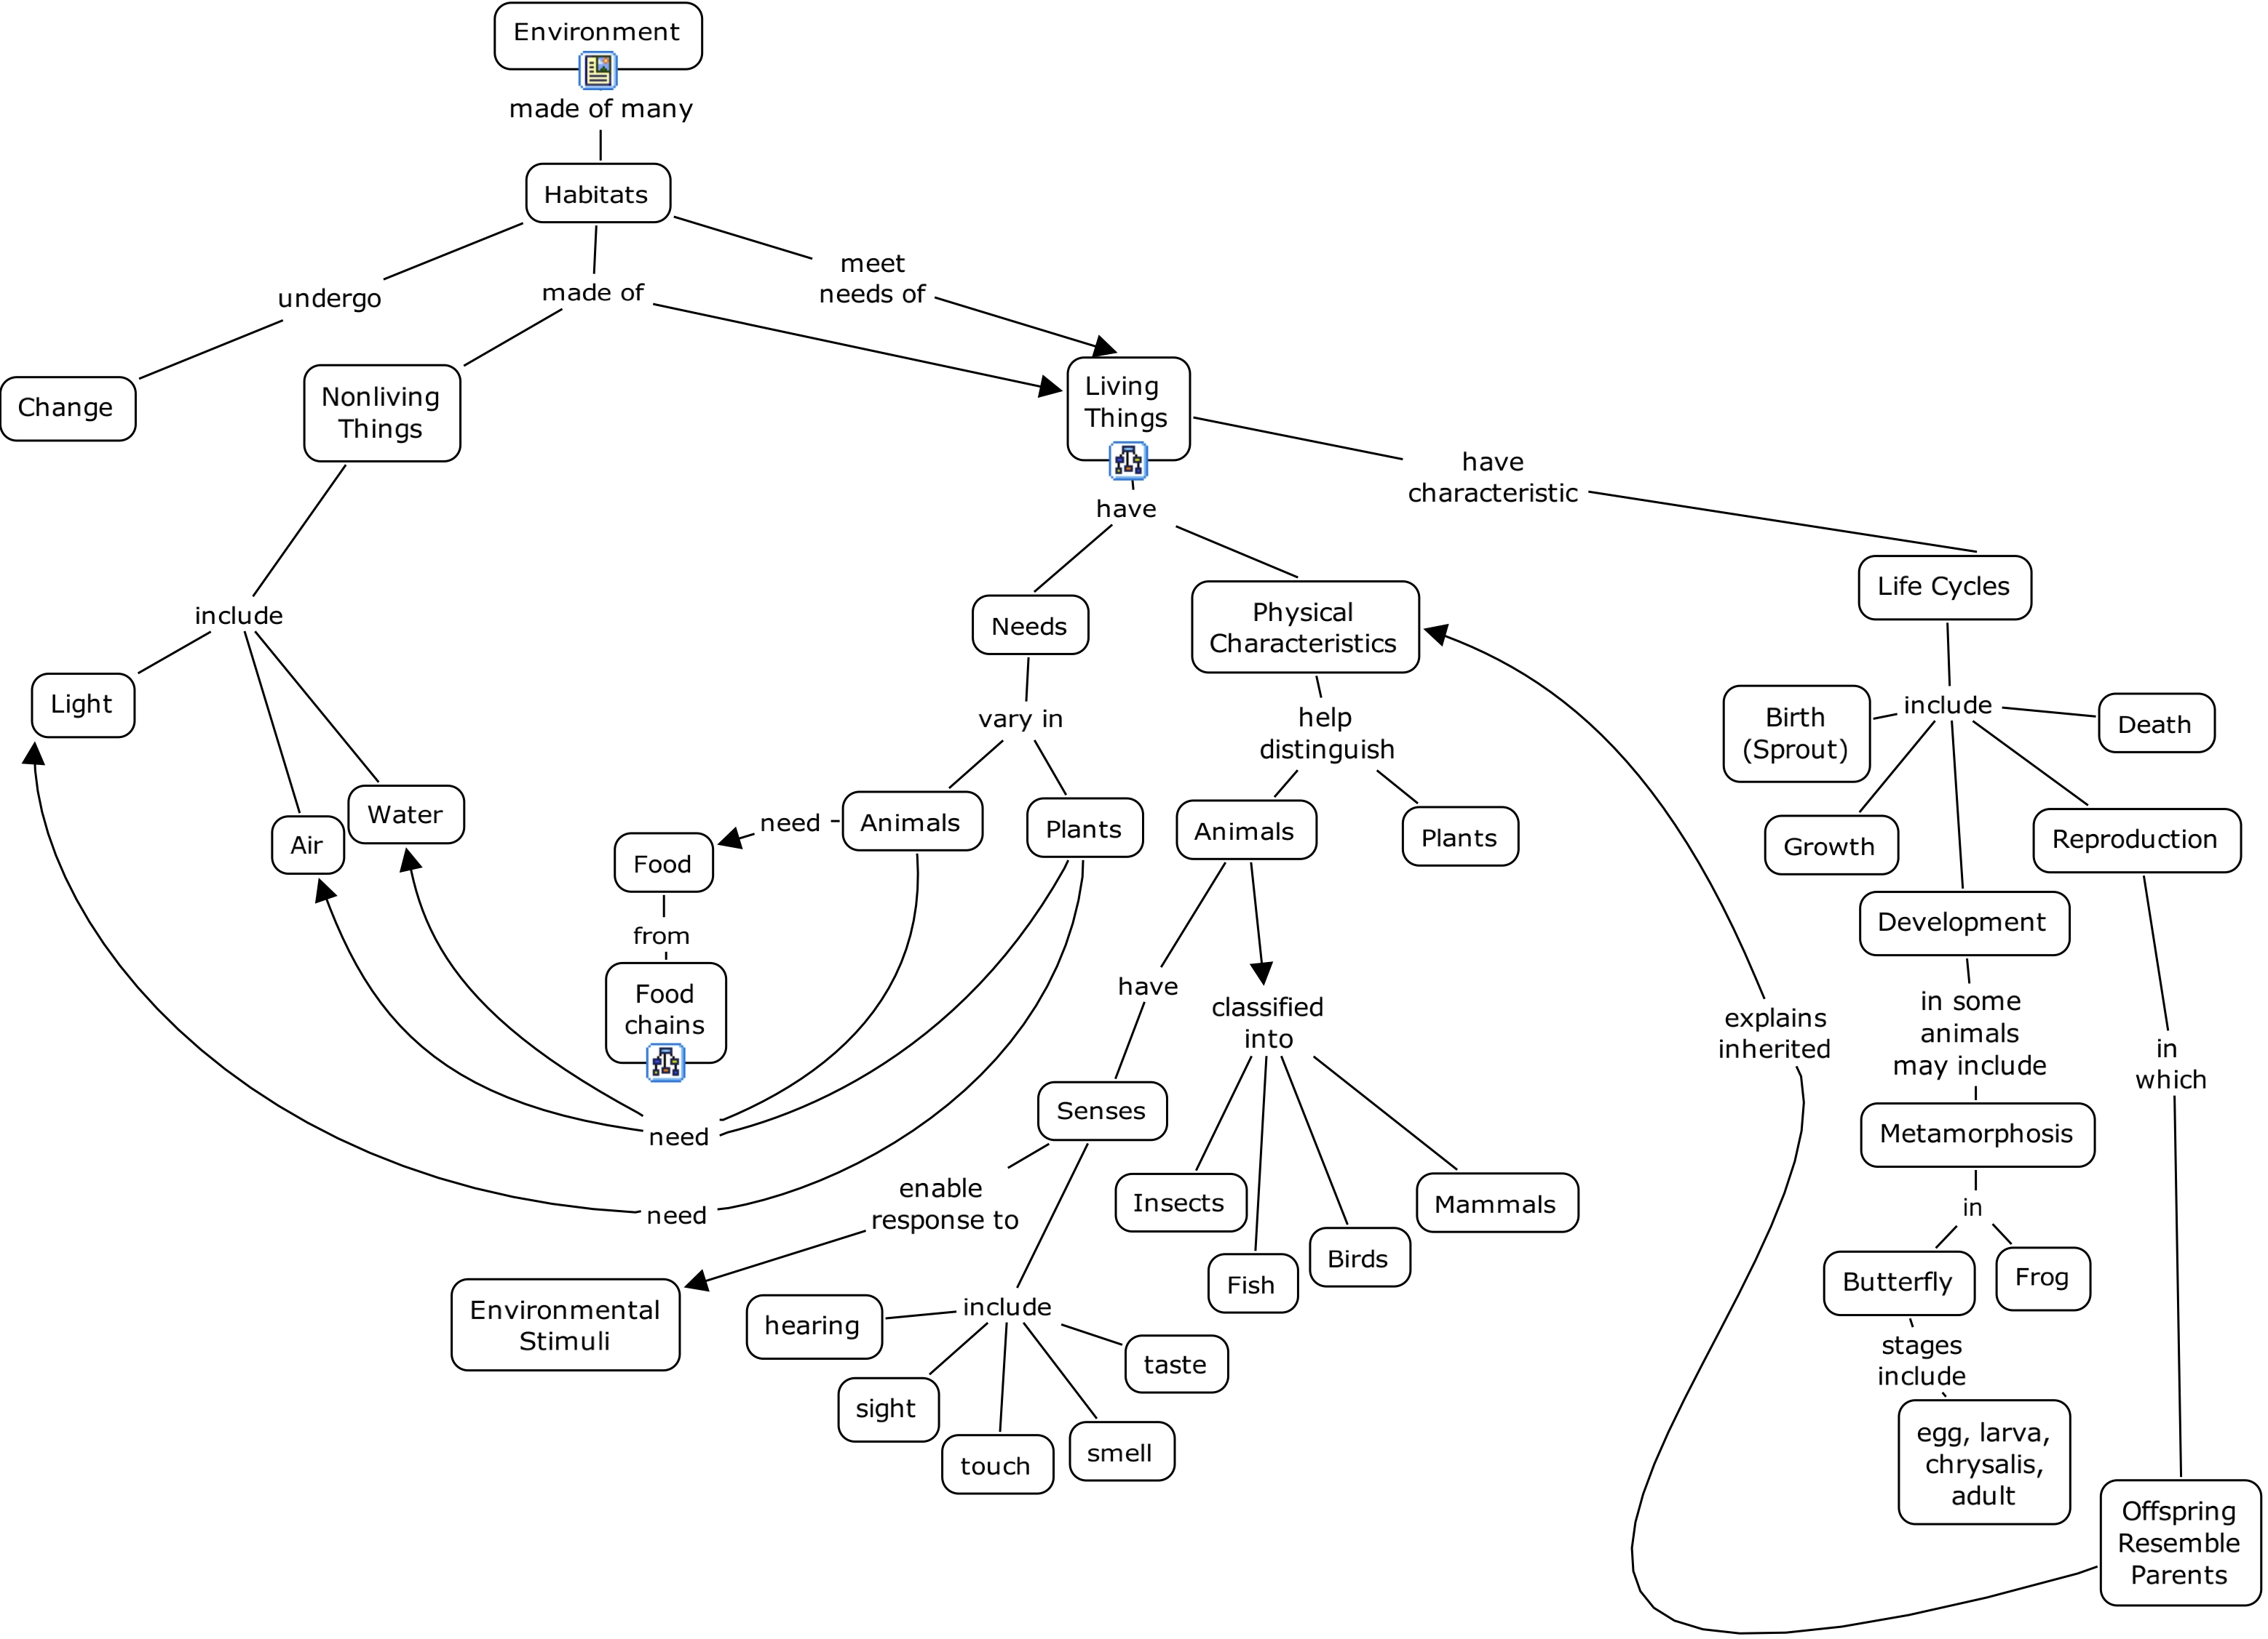
Figure 1. Massachusetts Framework ‘Core’ Concept Map

3) A Big Backyard concept list was derived from the stated objectives of the original hard-copy of the K-5 walks and the objectives listed in the “Grade Overview” and “Teacher” documents available at the Big Backyard website.
4) Concepts on the state template concept map were color-coded: ‘green’ for concepts found in both the framework and the local Big Backyard Program (BBY); ‘red’ for concepts found in the framework, but not the BBY; and ‘yellow’ for concepts found in the local BBY, but not in the framework. Note, this map has an additional submap located by clicking on the “Habitat” concept. (Figure 2) This alignment can be viewed in color and with submaps on the web at: http://cursa.ihmc.us:80/servlet/SBReadResourceServlet?rid=1143727786182_1921903453_6343&partName=htmltext To view the Big Backyard concept list, click the icon at the bottom of the ‘Environment’ concept.
For an alternative route to observe the alignment concept maps on the web Go to [ http://cursa.ihmc.us/ ]. Then open the folder titled " JHFry CMaps, MA" (Scroll down. . . It’s alphabetical order.) Then " 1 Elementary School" Then "MA Elem Life Sci Framework" Select the cmap titled " Lex Life Science Framework K-5." (Repeat for the BBY folders.)

Figure 2. Alignment of Lexington Big Backyard Program’s life science objectives with the Massachusetts Frameworks

This assessment was already performed by me over the time period of this course and is currently being submitted for presentation at the 2nd Annual International Conference in Concept Mapping.
In aligning to the standards, I simply reported the percentage of concepts that aligned and described the areas that were not addressed by the Big Backyard Program and should be addressed by other parts of the elementary science curriculum. Given that scoring of concept maps if often difficult and somewhat subjective, I thought I’d offer the course members a generic concept map scoring rubric which could be adapted for particular alternative assessment concept maps assigned to students to create. (See below.)

Generic Rubric to Score Concept Maps

 | 0 | 1 | 2 | 3 | 4
Hierarchy: layers of depth | Map shows no hierarchy: is web-like | Map shows some indication of broad concepts at the top and detail concepts toward the bottom | Map demonstrates hierarchy throughout | Map demonstrates the requested number of levels of hierarchy and they are clearly shown in the map | Map demonstrates more than the requested levels of hierarchy and they are clearly shown in the map
Concepts: | Words in ovals are not concepts | Words in ovals are appropriate concepts to the assignment | Words in ovals represent 75% or more of the requested concepts | Words in ovals represent all of the requested concepts | Words in ovals include 100% of the requested concepts and also appropriate concepts from the mapper’s own experience.
Linking Words: | No linking words included on lines connecting concepts | Less than half of linking words are present; meaning is unclear or a misconception | Half to ¾ of linking words are clear and appropriate | All linking words are clear and appropriate | More than the required linking words are present and appropriate
Crosslinks: | No links between concepts from different parts of the map | Line is drawn from one part of a map to another part, but linking word is inappropriate or a misconception | At least one clear crosslink with appropriate linking word is present | At least two clear crosslinks with appropriate linking words are present | At least two clear crosslinks with appropriate linking words are present and at least one of them is a truly powerful and creative, “out-of-the-box” connection derived from the mapper’s mind/experience
Attached Resources | no resources attached to map | one resource attached to one concept of the map | two or more resources of one type attached to the concept map | at least two resources of different types attached to two different concepts in the map | multiple resource types attached to multiple concepts in the map
Generic Rubric Development for Concept Maps

Hierarchy: layers of depth
0- Map shows no hierarchy: is web-like
1- Map shows some indication of broad concepts at the top and detail concepts toward the bottom
2- Map demonstrates hierarchy throughout
3 Map demonstrates the requested number of levels of hierarchy and they are clearly shown in the map
4 Map demonstrates more than the requested levels of hierarchy and they are clearly shown in the map

Concepts: Criterion is that the words are the requested concepts: such as “Concept map all the words in Bold in Chapter 5.” Or make a concept map of the vocabulary words from today’s outdoor activity.”
0- Words in ovals are not concepts
1- Words in ovals are appropriate concepts to the assignment
2- Words in ovals represent 75% or more of the requested concepts
3- Words in ovals represent all of the requested concepts
4- Words in ovals include 100% of the requested concepts and also appropriate concepts from the mapper’s own experience.

Linking Words: Linking words refer to the words on the lines that connect and describe the relationship between two concepts.
0- No linking words included on lines connecting concepts
1- Less than half of linking words; meaning is unclear or a misconception
2- Half to ¾ of linking words are clear and appropriate
3- All linking words are clear and appropriate
4- More than the required linking words are present and appropriate

Crosslinks: Crosslinks are connections between concepts in different parts of the map.
0-No links between concepts from different parts of the map
1-Line is drawn from one part of a map to another part, but linking word is inappropriate or a misconception
2-At least one clear crosslink with appropriate linking word is present
3-A least two clear crosslinks with appropriate linking words are present
4- At least two clear crosslinks with appropriate linking word are present and at least one of them is a truly powerful and creative, “out-of-the-box” connection derived from the mapper’s mind/experience

Attached Resources: Any digital resource can be added to a concept map. Such resources include MP3 tapes, photos, video clips, website addresses, detail concept maps, stories, data tables, laboratory experiments, problem-solving experiences; decision-making experiences.
0-no resources attached to map
1-one resource attached to one concept of the map
2-two or more resources of one type attached to the concept map
3-at least two resources of different types attached to two different concepts in the map
4-multiple resource types attached to multiple concepts in the map

