Timothy Moore
Intermediate Art World A: U1, L1 and 2 Landscape
30 August 2006
Score: 20/20, 100% (Scoring guidelines included)

WATERFALL
Waterfall was created using my free 30-day trial of Photoshop. I really love the tools in this program.

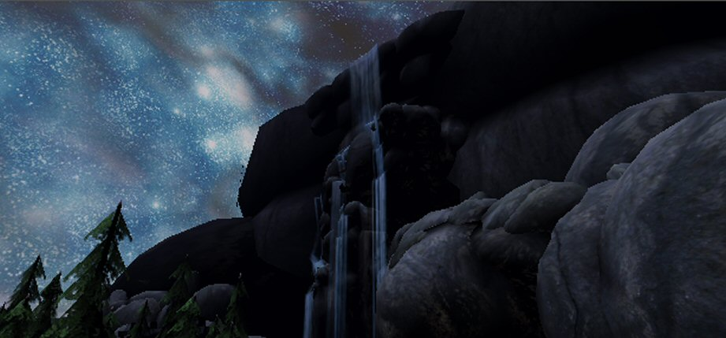

Scoring Guidelines:

10/10 points earned | 1. Did you make a landscape painting? Yes
10/10 points earned | 2. Does your landscape show the illusion of space? Yes

