Timothy Moore
World Art A; Unit 6, L3 to 6
06 to 21 November 2006
Score: 100%
My Own Gateway, Wall, and Building

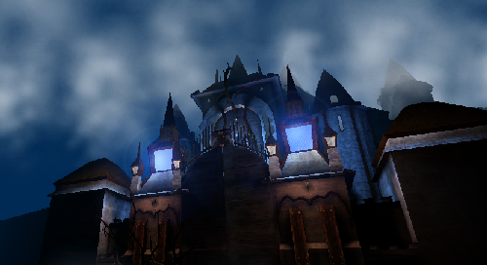

My design was inspired by the lesson on the Cathedral of Notre Dame. I spent two weeks of free time on this 3-D computer model including making the gate completely from scratch. It has a gate, wall, stone laid courtyard with a tree, and mansion. Once the building was completed, I worked on fog and lighting effects. I also designed an animated camera path and tried to desktop record a video of it to include here, but the computer's resources were so tied up with live rendering the scene that the video was too jumpy to use.

Everything I made can now be used in-game. That is one of the things I like about doing art projects using the computer. When you are done building it, you can feel like you are walking through it.

