APPLICATIONS OF CONCEPT MAPPING TO UNDERGRADUATE GENERAL EDUCATION SCIENCE COURSES

Jane Heinze-Fry, Ph.D., Science and Environmental Education Consultant Email: jahfry@rcn.com
Abstract. Constructivism and meaningful learning undergird the use of concept maps. Concept mapping was applied in undergraduate science courses in a small liberal arts college in Boston, Massachusetts, USA. Beginning with the first semester, the instructor used concept maps as advance organizers for lectures and handouts, and students created concept maps as culminating events for the course. In subsequent semesters, student individuals and teams also used concept maps as representations of their thinking about sections of the course; ways to view conceptual structure before and after research; and organizers for a student-created web site. While all applications were useful to some degree, the use of small-group concept mapping was found to particularly enhance use of concept mapping as a tool among the class as a whole and to balance concept mapping with other teaching/learning methods. A student-generated map to organize a class web site linking student research and projects was particularly innovative. While Inspiration software was often used in these applications to generate clear and creative concept maps, the new Cmaptools web site should be valuable in furthering integration of instruction and learning and in enhancing collaborative sharing of concept maps among the educational community.

1 Introduction: Context, Theory, and Practice

Emerson College is a small liberal arts college located in Boston, Massachusetts, USA. The students are particularly strong in communications. The general education requirements for undergraduates include one science course. Key objectives of all the introductory courses taught by Heinze-Fry at Emerson College between 1998 and 2002 were the development of conceptual structure, scientific inquiry skills, problem-solving strategies, and critical thinking (Table 1). In the Environment and Humankind class, an additional objective was the development of an historical perspective viewing the relationship between humans and the environment. Concept mapping was used with a variety of other teaching/learning methods including, among others, data collection on individual use of natural resources (Heinze-Fry, 1993), field work, problem-solving strategies (Heinze-Fry, 1996), forums (NAAEE, 1995), and critical thinking about research articles and web sites (Brooks/Cole web site).

Course/ Objective | Environment and  Humankind | Human Body | Personal Nutrition
Concept Development | Concept maps  Thought questions  Journals | Concept maps  Worksheets  Short essays  Interactive workbook | Concept maps  True/False queries about  typical misconceptions
Scientific Inquiry | Resource use analyses  Field work | Lab reports  Field trip reports | Personal scorecards  Websites: diet analyses
Problem Solving | Force field analyses  Tree diagrams  Forum | Case studies | Nutrition action  Choosing: “Savvy Diner”  tips
Critical Thinking | Research Paper/Project  Research article reviews  Web site reviews | Research paper  Research article reviews | Research article reviews  Web site reviews
Historical Perspective | Thought questions
Table 1. Teaching/ Learning Strategies Used to Meet Educational Objectives in Introductory Heinze-Fry Science Courses at Emerson College1998-2002
What theory drove this practice? The theoretical foundation of this case study rests upon the constructivist (in contrast to positivist) view of education and Ausubel’s theory of meaningful learning (in contrast to rote learning). Our constructed conceptual understanding of a subject helps to shape the world we observe, the questions we ask, our awareness of problems, and the areas of inquiry we wish to address. Therefore, by using concept mapping, the students learn a tool to further expand and examine the framework that guides their perceptions.

Concept maps were created to give visual representation to meaningful learning theory. They represent the conceptual linkages that people have in their minds. In Learning How to Learn (1984), Novak provides a generalized concept map illustrating the key features of concept maps. Concepts, or perceived regularities in objects and events, are enclosed in circles. Concepts are connected with lines, and these propositional linkages are labeled with words that describe the relationship between the connected concepts. The map is hierarchical with the most general concepts at the top, connected to progressively more specific concepts and, finally, in some cases, examples of concepts at the bottom of the map. Crosslinks are propositional linkages that connect different sections of the map and indicate integrated thinking. In this study, concept maps were the major instructional strategy utilized in promoting the development of conceptual structure. Over a period of 5 years in 19 classes (9 Environment and Humankind; 6 Human Body, and 4 Personal Nutrition), approximately 500 students created about 2,800 concept maps.
2 Methods of Concept Mapping Applications and Results
Concept mapping was used in a variety of ways by the instructor and the students (Table 2).

Course/ Semester | Environment and Humankind | Human Body | Personal Nutrition
S/98 | Lecture; full handouts  Culminating event
F/98 | Lecture; full handouts  Culminating event
S/99 | Lecture; full handouts  Culminating event
F/99 | Lecture; full handouts  Culminating event | Lecture; some handouts  8 chapter maps  Culminating event
S/00 | Lecture; 14 map-pack  7 team chapter maps  Culminating event | Lecture; some handouts  7 chapter maps  Culminating event
F/00 | Lecture; 14 map-pack  4 team cluster maps  Culminating event | Some handouts  7 chapter maps  Culminating event | Lecture; some handouts  7 chapter maps  Culminating event
S/01 | Lecture; 14 map-pack  5 team cluster maps  Culminating event | Some handouts  7 chapter maps  Culminating event | Lecture; some handouts  7 chapter maps  Culminating event
F/01 | Lecture; 14 map-pack  1 individual; 1 team map  Culminating event | Some handouts  7 chapter maps  Culminating event | Lecture; some handouts  7 chapter maps  Culminating event
S/02 | Lecture; 14 map-pack  4 individual detail; 4 team maps  Pre-/ post-analysis of research  Web site organizer  Culminating event | Some handouts  7 chapter maps  Culminating event | Lecture; some handouts  7 chapter maps  Culminating event
Table 2. Concept Mapping Applications in Introductory
Heinze-Fry Science Courses at Emerson College1998-2002
In Table 2, the first line in each box indicates how the instructor used concept maps. Generally, concept maps were used as advance organizers for lectures. From Fall, 2000 through Spring, 2002, however, the instructor used publisher-produced Powerpoint presentations for their conceptual and photographic visual clarity. Over the course of time, the instructor shifted from giving students full sets of published concept maps to “map-packs” and sample maps to serve as examples for the students. The remaining lines indicate how students created and used concept maps. Concept maps were assigned as part of the “culminating event” of each of the courses. Sometimes these maps were created individually, sometimes in groups. It became clear after the first 4 semesters that the desired quality of culminating concept map was not being created through guided lectures and distribution of the instructor’s published maps. Initially, mapping counted only 7% of the total course grade. Ultimately, having students individually or collectively create subunit maps during much of the course and counting the maps as about 1/4 to 1/3 of their total course grade resulted in higher quality culminating maps. This shift in emphasis is indicated in Figure 1.

Figure 1. Relative Weight Given to Concept Mapping in Final Grades Over Five Years

In the subsequent semesters, students were given a variety of concept-mapping assignments. In addition to the culminating event, students individually and collectively created maps of individual chapters, parts of chapters, and clusters of chapters. By the last semester, some students used pre- and post-maps to illustrate learning through research projects and one student created a map as a web site organizer showcasing student research papers and projects. Applications of concept mapping were emphasized to varying degrees. Each application varied somewhat in its intent and its outcomes.
2.1 Instructor’s Concept Maps as Advance Organizers and Handouts for Lectures
Concept mapping was viewed by the instructor as one of many teaching/learning tools to approach a student body and also as a strategy to integrate other instructional methods. Concept maps on overhead transparencies were used as advance organizers for lectures in all of the courses. In the Environment and Humankind class, the instructor used overview maps found in Tyler Miller’s textbook: Living in the Environment and in the accompanying Instructor’s Manual. Specialized chapter maps were used to introduce each new chapter. Throughout the course, new maps were connected to the original overview map. The projected maps provided a good roadmap for lectures. The complexity of these maps, however, often resulted in the projection of small images, which could be difficult to see from the back of the room and could cause “visual overload.” Students were given hard copy, on which they could take notes. However, “chunking” to smaller maps to project is probably a better idea. The instructor shifted from giving a complete set of concept maps to giving a 14-map pack to go with lectures (Table 2). Sample concept maps were handed out in the other two courses. Thus, students were encouraged to do more of their own thinking. In the Human Body class, the instructor switched to Powerpoint presentations to integrate visuals into lectures. Now Cmaptools offers capability to integrate any digitally-generated images into a clear conceptual structure.

2.2 Students’ Concept Maps as Culminating Events
In an effort to promote integration of the semester’s learning experiences, students were asked to create overarching concept maps as a culminating event. Most found this experience challenging and useful. The final concept map stimulated integrative thinking and thought about how to clearly represent ideas. It reduced the multiple and varied experiences of the semester to key understandings and connections. Much effort and individuality of expression went into this exercise. Overview maps were often shared the last day of class. Students and faculty enjoyed seeing these expressions of learning, commitment, and creativity.

Initially, students’ maps were created by hand. This process was time-consuming, leaving little time for revision of thinking. Legibility of some maps was also an issue. To allow maps to be more clearly represented and more easily edited, Emerson College bought a site license for Inspiration software. There is a “learning curve” in using new software tools. However, with the time invested in learning this new tool, maps generally increased in clarity. Not only was the text clearer, but students were able to reposition concepts to minimize overlapping linkage lines, which can cause visual confusion. Also, color pictoral representations could be added. While some students continued to create concept maps by hand, most found Inspiration software to be useful.

Anastasiya and Maria Kobrina, two sisters who worked synergistically, created a map that integrated text (Figure 2A) and photo collages. It was clear that they understood what the key concepts were and linked them together effectively through propositional linkages and hierarchy. (Figure 2B magnifies the central circle of superordinate concepts. Figure 2C magnifies the bottom circle indicating the subordinate concepts for “air resources.”) Crosslinks were clear. Color-coding and visuals were used creatively and effectively. Not only did this map showcase the depth of their knowledge and expression, but their work could be a very good learning tool for others approaching the subject.
2.3 Students’ Concept Maps to Communicate Understanding of Sections of the Course
In the more highly conceptually oriented chapters of the Human Body and Personal Nutrition classes, students were given frameworks with superordinate concepts that they were to complete with subordinate concepts. Thus, Human Body students mapped all the human body systems. And the Nutrition students mapped all of the macronutrients and micronutrients. The instructor wrote comments, graded, and returned the maps to individual students. Though this approach allowed for identification of insights and errors of individual students, it was very time-consuming for both students and faculty. Some individual maps were transferred to overheads, and, with student permission, the instructor pointed out qualities that made these maps especially meaningful. This instructional strategy somewhat enhanced communication, with students starting to understand clarity, depth of layers, and crosslinking.

In the Environment and Humankind class, where so many other experiences were required, individuals mapped parts of concept clusters, and then put together team “general multi-chapter cluster maps.” Teams worked collaboratively with Inspiration to create maps (Figure 3), sharing their conceptual knowledge, group process, organizational, and technological skills. When teams presented their results, the class discussed the strengths and weaknesses of their maps. Valued innovations such as color-coding, use of different shapes of polygons to indicate meaning, and the addition of visuals to maps were identified. This experience truly enhanced the diffusion of innovation. As students presented maps to the class, their confidence and communication skills also seemed to improve. It is particularly significant to note the enhanced learning that happens with shared maps among peers. Further, team-mapping reduced the time overload, and concept mapping was kept in balance with other teaching/learning strategies.
2.4 Students’ Concept Maps to Demonstrate How Research Changes Conceptual Structure
Students in the Environment and Humankind class were asked to graphically represent the results of their research papers. For this task, some students chose pre- and post- concept maps. While this strategy was not used extensively, its potential as one tool for authentic assessment was demonstrated.

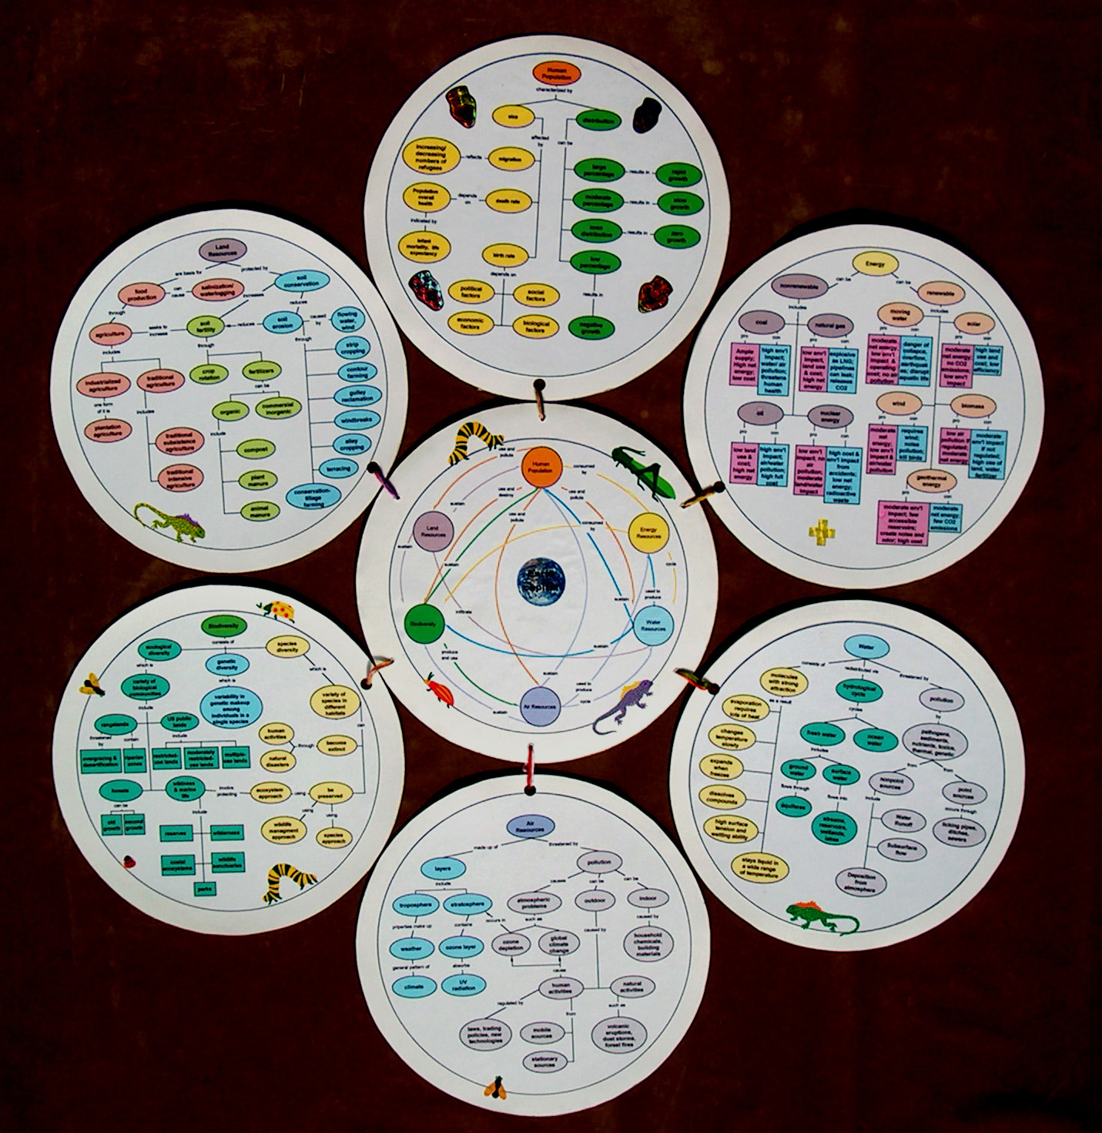

Figure 2A. Earth Capital Overview

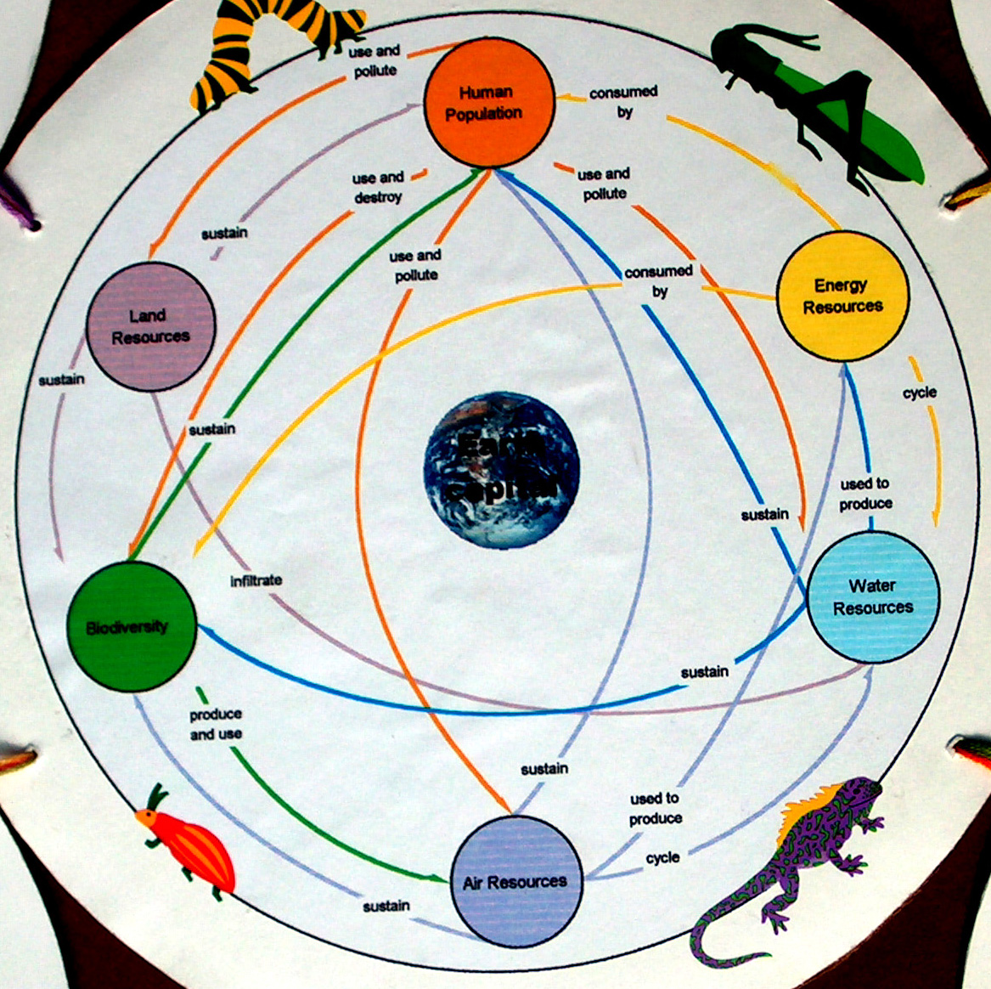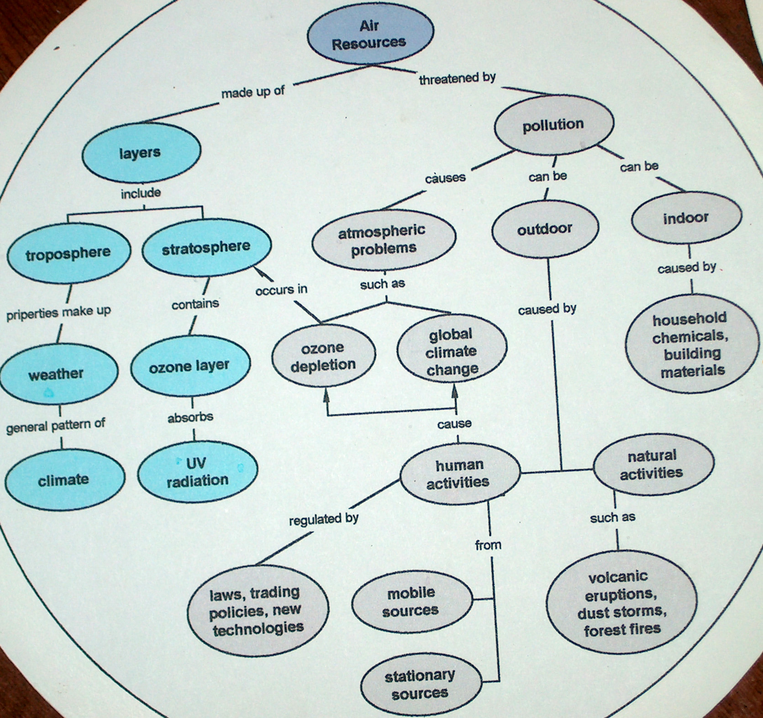

Figure 2B. Earth Capital: Figure 2C Earth Capital:
Superordinate Concepts Subordinate Concepts
in Center Circle in Bottom Circle

Figure 3. Team-generated concept map of “Biodiversity.”

2.5 A Student’s Concept Map as an Organinzer for a Class Web Site
The most recent innovation using concept maps was employed by a group of students who created a web site to showcase students’ research papers and projects. In a “homepage” window, Justin Baum created an interface offering an option to click on key “concept clusters” under which were categorized students’ research papers/projects. In addition, there was a “button” to view “concept maps.” This button linked to Paul Maiorana’s one-window concept map, which was quite simple and similar to the superordinate concepts in Figure 2B. Each of the key concepts was hyperlinked, and a click led to a more detailed concept map similar to Figure 2C. In the future, Cmaptools would allow those two functions to be seamlessly integrated, and the students’ work would actually be linked to the overview map. Research papers were illustrated with a variety of graphic organizers: pre- and post- concept maps; a vee map; and a concise historical representation of the change in a debate over time. This was a class willing to choose research topics and experiment with different strategies of learning and expression. The class web site was presented at the Cybercafe at the North American Association for Environmental Education Conference in Boston in 2002.
This particular class brought concept mapping forward as a way to integrate a class of highly creative individuals and show how their individual research and projects contributed to the understanding of the whole class. Concept mapping was in context and served to link a variety of learning experiences and their visual representations. For today’s computer-literate student body, the experience of this class points toward concept mapping as a tool to integrate the learning experience of a group in a web-based environment, which can be shared with the larger human community.
3 Conclusions from Applications of Concept Mapping in Introductory Science Classes
• This particular instructor had worked for years to create concept maps for the textbook used in her course. Therefore, it was meaningful to her to use these maps as roadmaps for the course and ensure that key understandings were emphasized. The written visuals reinforced the verbal direct instruction. However, the instructor concluded that in order to encourage students to create their own maps, distribution of a sample map-pack of published concept maps was preferable to a full set.
• Use of concept mapping as a learning tool was facilitated by an instructor and students who truly wished to clarify and communicate their thinking. Some students responded very favorably and wondered, “Why haven’t we been taught how to do this before?” They were so relieved to be freed from multiple choice testing. Some students, particularly those who were good at memorization, did not appreciate the time it took to represent their thinking in concept maps.
• Constraints and concerns about concept maps were expressed by both students and administrators. Student concerns included the amount of time it took to create maps, the “spaghetti-type confusion” of some maps with many overlapping propositional linkages, the visual overload of maps with too many concepts, and a preference for “straight-line thinking.” The administration expressed concern that a variety of appropriate teaching/learning strategies be used. The use of concept mapping software, particularly Inspiration in small-group contexts, seemed to alleviate many of these concerns as well as increase diffusion of innovations and preferred strategies. Concept maps counting about 1/4 to 1/3 of the final grade seemed appropriate to produce high-quality maps and balance concept mapping with other learning strategies.
• While concept maps presented by the instructor during lecture and individually produced student concept maps were effective tools, the more innovative applications that grew from this case study were: (1) small-group concept mapping and sharing with the class; (2) concept mapping as a culminating event; and (3) concept mapping to integrate students’ research and projects on a class web site.
• The use of a concept map as a gateway to a class web site showcasing student work integrated a variety of learning strategies. It facilitated communication within the class and within the larger community. Cmaptools (http://cmap.ihmc.us/) with web-based sharing and editing of concept maps offers an even stronger collaborative tool for the future.
4 References
Ausubel, D. P., Novak, J. D., & Hanesian, H. (1968). Educational Psychology: A Cognitive View, Second Edition. New York, NY: Holt, Rinehart, and Winston.
Brooks/Cole Web site to support all of their textbooks with integrated teaching/learning experiences: http://www.brookscole.com/biology.
Heinze-Fry, J. (1998). Instructor’s Manual for Living in the Environment, 10th edition. Belmont, CA: Wadsworth.
Heinze-Fry, J. (1996). Critical Thinking and the Environment: Beginner’s Guide for Living in the Environment. Belmont, CA: Wadsworth.
Heinze-Fry, J. (1993). Green Lives, Green Campuses. Belmont, CA: Wadsworth.
IHMC CmapTools. http://cmap.ihmc.us/. Institute of Human and Machine Cognition. University of West Florida.
Miller, G. T. (2000). Living in the Environment: Principles, Connections, and Solutions, 11th edition. Pacific Grove, CA: Brooks/Cole.
Mintzes, J. J., Wandersee, J. H., & Novak, J. D., eds. (1997). Teaching Science for Understanding: A Human Constructivist View. San Diego, CA: Academic Press.
North American Association for Environmental Education. (1995). Clean Water: Taking Care of Unfinished Business. Environmental Issues Forums. NAAEE: Troy, Ohio. (Contact: 202-884-8914)
Novak, J. D. & Gowin, D. B. (1984). Learning How to Learn. Cambridge: Cambridge University Press.
Novak, J. D. (1998). Learning, Creating, and Using Knowledge: Concept Maps TM as Facilitative Tools in School and Corporations. Mahwah, N.J.: Lawrence Erlbaum Associates.

