CAUSTIC CRACKING

The requirements for caustic cracking to occur are steel which is under:
- local stress
- high temperature
- a solution containing 30 per cent sodium hydroxide

Given these conditions, the solution will corrode the iron along the boundaries of the metal (welded areas) because under local stress, the iron at the boundary (welded areas) is under great stress. The result is embrittlement of the steel and eventual fracture due to boiler pressure.

Concentration of sodium hydroxide in a modern boiler occurs when water is continually removed as steam and replaced by a new supply of water. Each time a bubble forms, a concentration of sodium hydroxide occurs momentarily under the bubble. As the bubble detaches, some of the concentrated sodium hydroxide remains and gradually build up its concentration to a level such that caustic attack may occur if there is local stress. It is because of caustic embrittlement that the pH of the boiler water is held to an upper limit of 11.

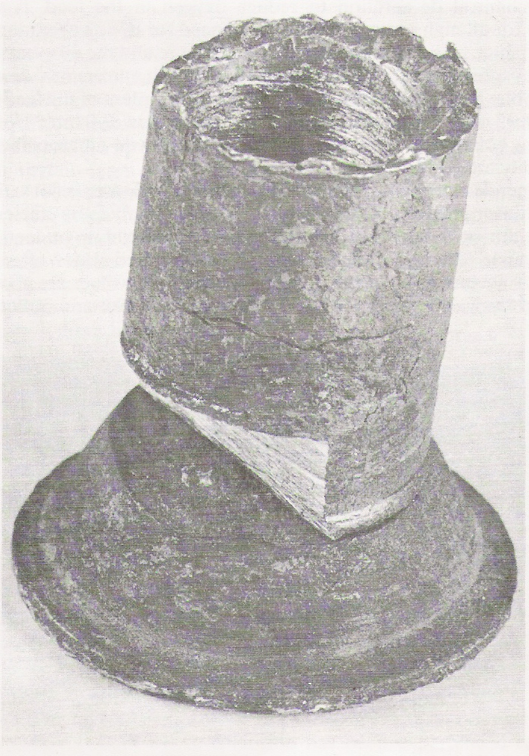

Figure 1 Rivet head subjected to caustic cracking

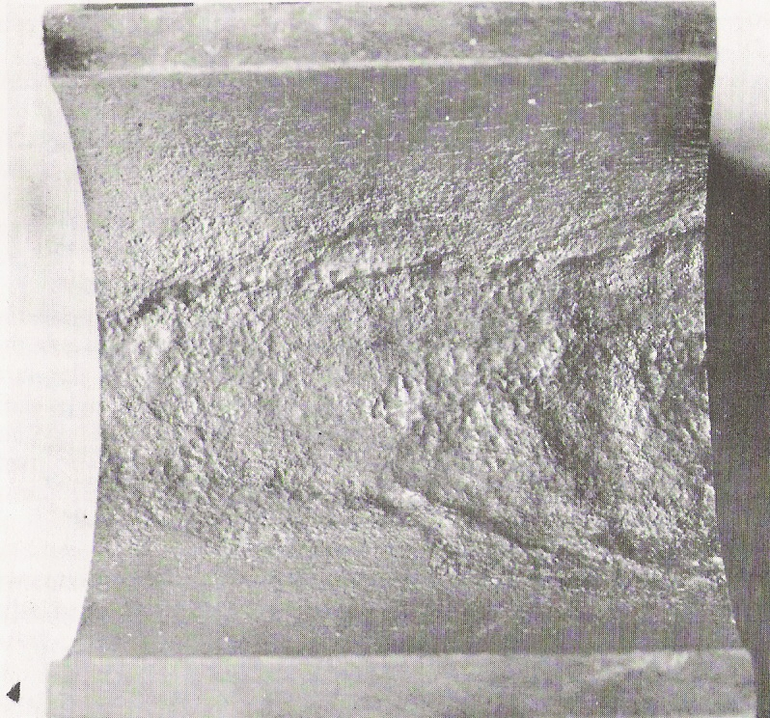
Figure 2 Tube showing caustic attack

