GENERAL CORROSION

Every metal and alloy develops a natural electrochemical potential with an electrolyte, i.e, boiler water. Thus, to a greater or lesser degree according to the potential, all metals have a tendency to react with boiler water and slowly dissolve.

Galvanic Cell Video

The uncontrolled destruction of metals and alloys is prevented by the formation of an oxide film which acts as a barrier between the metal and the electrolyte. Magnetite is formed, at high temperatures and pressures, which protects the steel provided the pH value and temperature of the boiler water are high enough.

In general corrosion of steel, assuming there is no magnetite to protect it. The iron atoms enter the water as ferrous ions, leaving behind two electrons per atom. The electrons are collected by hydrogen ions (from the water) which change into molecular hydrogen, H₂, and form a minute gas bubble on the surface. This layer of hydrogen bubbles prevents hydrogen ions from collecting electrons and the corrosion reaction stops.

When oxygen is present in boiler water, the layer of hydrogen gas bubbles is removed by combining to form water molecules and this is the reason why oxygen is so destructive.

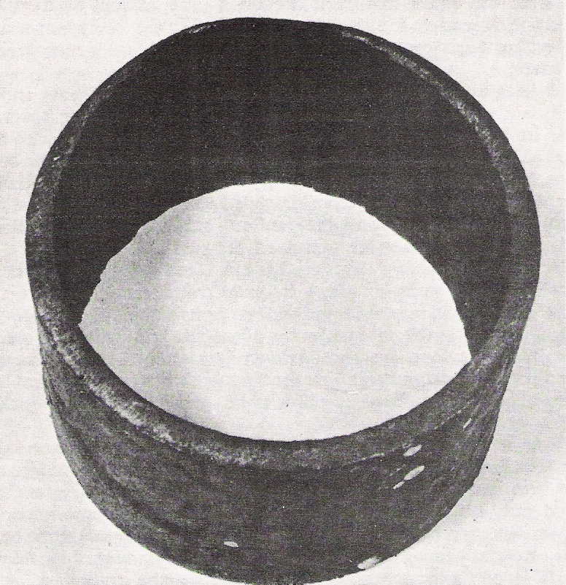

Figure 1 Thinning of boiler tube as a result of corrosion

