CORROSION FATIGUE

Fatigue limit of steel is associated in terms of millions of cycle of stress before fracture occurs.

In the presence of corrosive media the fatigue life is drastically reduced.

For example, corrosion may roughen the surface or start a corrosion pit, both of which act as stress raisers and initiate a fatigue crack. Once a small fatigue crack has started, the difference in stress between the tip of the crack and the rest of the nearby metal will set up a galvanic corrosion cell that increases the rate of the crack exponentially.

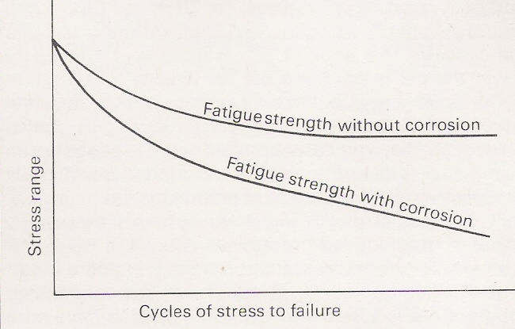

Figure 1 Cycles of stress to failure graph

