Look at the pictures, read the text and choose the right answer:
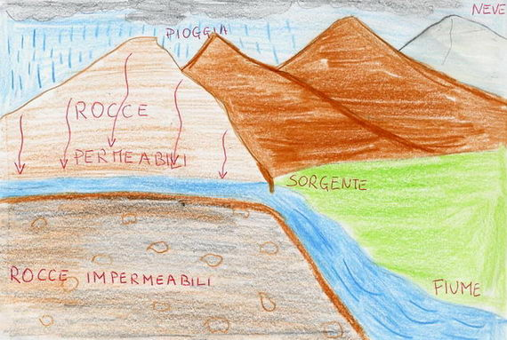
The source of a river has its origin:

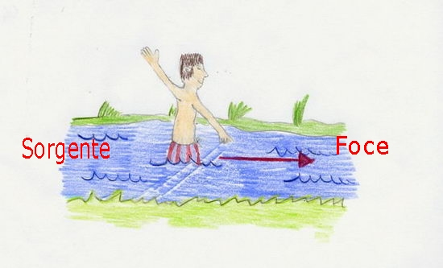
A river comes to the outlet when it reaches:

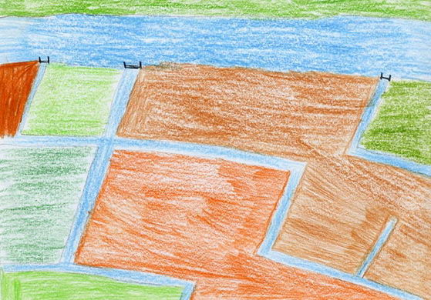
The water of a river is used to:

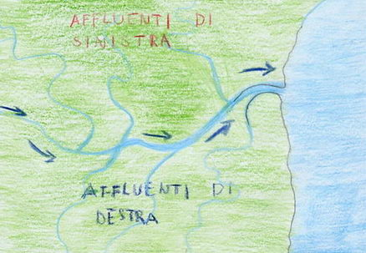
The tributaries of a river are:

