Running head: INFECTION PREVENTION AND CONTROL SURVEILLANCE

Infection Prevention and Control Surveillance – Connecting Data and Systems

Kate Winslett

Athabasca University

MHST/NURS 602: Transforming Health Care through Informatics
Dr. Jack Yensen
December 20, 2001
Abstract
Quality infection prevention and control programs are increasingly recognized as pivotal in the battle against infectious disease spread and the dreaded outbreaks that can paralyze the health care system. A key element of infection prevention and control is surveillance: looking for cases and clusters, tracing contacts, and reporting rates with a view to implementing strategies to reduce risk. Government reporting requirements have increased with heightened awareness of the growing numbers of health care associated infections and related deaths. While it is widely acknowledged that information technology could effectively support infection prevention and control, standardized tools are in short supply and use. A regional surveillance tool, including the use of a hand held device, is a proposed initiative to address this need.

Infection Prevention and Control Surveillance – Connecting Data and Systems

“Any sufficiently advanced technology is indistinguishable from magic” (Clarke, 1961).

Infection prevention and control has risen to the forefront of health care in recent years largely due to the resurgence of infectious diseases, such as tuberculosis, which were once thought to be conquered. There is an ongoing battle with viruses like human immunodeficiency virus and acquired immunodeficiency syndrome (HIV/AIDS), increasing antimicrobial resistance among numerous infectious organisms, and the rise of novel and devastating diseases such as severe acute respiratory syndrome (SARS). While more resources are being added to infection prevention and control (IPAC) programs in many jurisdictions, much more is being demanded of the infection control practitioners/professionals (ICPs) in surveillance - identifying potential infections and contacts of cases, analyzing data and reporting rates and trends, and recommending interventions to control and prevent outbreaks. ICPs are often also called upon to implement the containment and prevention strategies they recommend.
The present drive to implement e-Health strategies and standardize information technology (IT) services across facilities and sectors presents an additional need for enhanced collaboration and efficiency. In Mississauga-Halton, the funding body has requested a regional strategy to reduce the risk of outbreaks that may cripple the health care system. A critical element of this strategy is to rapidly capture and disseminate IPAC information within and between health care providers and organizations, a sphere where wireless technology appears to hold considerable promise.

Current Problem and Identified Need
Healthcare-associated infections (HAIs) present well-identified patient safety risk and are the target of international strategies for mitigation and prevention (World Health Organization, 2008, Institute for Healthcare Improvement, 2008, saferhealthcarenow, 2008). In developed countries 5 to 10 percent of hospital admissions are affected, which in Canada reflects 220,000 patients, and 8,000 deaths annually (Zoutman et al., 2003). Close to 40 percent of these adverse effects are highly preventable, and in order to monitor the efficacy of preventative interventions, it is vital that accurate and standardized data is collected both before and after their implementation. Within the past two years, the province of Ontario has introduced fourteen local health integration networks (LHINs) in an effort to better integrate health care services and facilities, such as hospitals. The provincial Ministry of Health and Long-Term Care has established fourteen Regional Infection Control Networks (RICNs) along the same geographical boundaries, charged with the mandate “to maximize coordination and integration of activities related to the prevention, surveillance and control of infectious diseases across the healthcare spectrum on a regional basis”. . . and “strengthen the coordination between infection prevention and control activities at acute and non-acute facilities and Public Health communicable disease control activities” (MOHLTC, 2006).
In September, 2008, the Minister of Health required mandatory reporting of eight ‘patient safety indicators,’ seven of which are infection prevention and control (IPAC) quality indicators, by all hospitals over the following nine months, beginning with numbers of cases and rates of Clostridium difficile, shortly followed by antibiotic resistant organisms (Methicillin-resistant Staphylococcus aureus [MRSA] and Vancomycin-resistant Enterococcus [VRE]) (MOHLTC, 2008). From April, 2009, rates for ventilator associated pneumonias (VAPs), surgical site infections (SSIs), central line infections (CLIs), and health care worker hand hygiene compliance will be required.
ICPs already spend close to 70 percent of their average work day conducting surveillance (CDC, 2000), defined as “the ongoing systematic collection and analysis of data and the provision of information which leads to action being taken to prevent and control a disease” (MedicineNet.com, 2004). This increase from the average of 35 to 40 percent in the mid-1990s (Nguyen, et al., 2000) may be related to increased incidence and awareness of, and attention to HAIs. Some studies have found 90 percent of data collection to be paper-based (Murphy, 2002). Although commercial systems to help gather and analyze this data do exist, they are generally costly and vary widely in the amount of time required to manually enter or electronically import data, as well as in the quality of reports/outputs.

Informatics to Address the Need

The IPAC SET, Links, and Wireless Tools
The RICN Infection Prevention and Control Surveillance Enabling Tool (IPAC SET) was developed by a consultant for the RICNs in response to the identified ICP needs in some small hospitals that have only paper tools to record cases, contacts, and rates. The IPAC SET is a simple Access-based tool that is offered to these ICPs at no cost. It is user friendly, with clear data-entry screens and tables and easy to understand instructions, and can provide quality reports. However, considerable manual data entry/keyboarding is still required.
In a recent meeting to demonstrate the IPAC SET, one of the hospitals demonstrated the tool they had developed with their IT department, linking IPAC surveillance with Admission/Discharge/Transfer (ADT) information to automatically populate the denominators (e.g., patient days) on a daily basis. The proposed health informatics application that is the basis of this paper, is to merge the technology of both systems, and have it available in a hand held device for ICPs to enter data anywhere at any time (office, nursing station, patient bedside, health records, and remotely at other facilities, home after hours/ while on call, etc.). This would save time and opportunity for error by eliminating the duplication of making notes on paper and later entering them into the database, or relying on anecdotal, phoned or faxed information. This tool could also be utilized across all hospitals in the LHIN and ultimately the province, helping to standardize data collection, analysis, and reporting at local and provincial levels.

System Requirements
A key consideration in selecting a system for use across organizations must be ensuring systems compatibility. The Ontario e-health strategy focuses on everyone having the right information at the right time and in the right place, and freeing providers and clinicians to focus on timely and quality care (Brown, 2006). The goal “to capture health information once and maintain its semantic meaning across the continuum of care . . .” (Brown, p. 8) particularly reflects this focus. Compatibility with existing systems is essential for fluidity of information flow, greater usability, and system longevity. Automatic populating with data from other services and databases (e.g., personal demographics, laboratory services, diagnostic images, immunizations, shared health record, and drugs), will greatly reduce the onerous task of manual data entry, thus saving time, money, and patience.
Perhaps even more importantly is compatibility and interfacing with other broad developing systems. “Panorama,” a pan-Canadian public health surveillance system is an initiative of Canada Health Infoway, for which $100 million has been allocated over 5 years for the development and implementation of a health surveillance program, specifically focusing on management of infectious diseases and immunization (Rand, 2007) (See Appendix A). IBM is the prime contractor but the system involves a “Buy-Adapt-Build” strategy using ‘off-the-shelf’ software and custom adaptations, to allow integration with existing systems (5 operating systems, 3 databases, Websphere and Tivoli software). The Ontario Laboratory Information System (OLIS) is a single provincial system that permits sharing of all laboratory information between health care providers (practitioners, hospitals, and community laboratories [Leung & Ringwood, 2008]), interfaces with existing systems (Laboratory Information Systems[LIS], Hospital Information Systems [HIS], and Clinical Management Systems [CMS]), and will also offer a web-based application. Closer to home, a regional collaboration, Rapid Electronic Access to Clinical Health information, or REACH, enables clinicians to access patients’ electronic health records across six hospitals in the Mississauga Halton and Central West LHINs (Anonymous, 2008).

Review of the Literature
Despite increasing computer use within the general public, the overall use of infection control software decreased between 1995 and 2005 in Canadian hospitals (Zoutman & Ford, 2008), perhaps in part due to an influx of new practitioners unfamiliar with the tools, increased workloads, and budget restraints. Automated detection systems to support IPAC surveillance have been reported as valuable (Hass, et al., 2005), and numerous publications have supported the use of wireless technologies in various clinical settings, including in reducing medication errors and facilitating documentation (Newbold, 2004, Altmann & Brady, 2005), for orthopedic pain management (Hardwick, Pulido, & Adelson, 2007), and sharing laboratory reports and patient information (Tooey & Mayo, 2004).
For IPAC purposes, Farley et al. (2005) compared use of personal digital assistants (PDAs) with the gold standard ICP manual review, for surveillance of urinary tract infections, a frequent HAI that is time-consuming to track, but which carries high costs for patients and the health care system. An estimated 8 ½ weeks of ICP time, and overall savings of more than $10,000 could be realized annually with the PDA system, but validation of the system prior to dissemination of data was recommended. An automated system for laboratory data, e-mail alerts and antibiograms could save ten hours of ICP labour annually through the elimination of the need for manual review of microbiology reports alone (Hebden et al., 2008). The increased flexibility for surveillance from outside the office setting, and inputting data directly through the use of wireless notebooks were other notable benefits. A state-wide standardized surveillance initiative in New South Wales (Australian) hospitals was facilitated through the use of personal and handheld (Palm Pilot) computer combinations, allowing time-savings related to data entry, and the ability to conduct greater amounts of active surveillance (McLaws & Caelli, (2000).
Murphy (2002) found PDAs increased productivity and streamlined data management processes for a range of targeted surveillance data (including SSIs, VAPs, and CLIs), improved outbreak investigation capacity, and were popular amongst users, notably improving surveillance activities and overall work processes. Goss and Carrico (2002) effectively used their infection control PDA software to collaborate with their infusion therapy team to quantify their work and patient-related outcomes.

Implementation – Steps and Strategies

Identify and Communicate Need
The steps involved in moving this project forward are outlined in detail in the draft Project Plan (see Appendix C). The first step in the process of implementing the IPAC SET in a PDA is to identify the need and communicate it to decision-makers. This was begun in April 2008, with a proposal to the LHIN, which included the need for a robust standardized surveillance system across the hospitals, and reinforced at a full-day workshop in November. One of the three afternoon breakout sessions focused on surveillance, and the IPAC SET was showcased.
Address Resources
Next, the necessary resources must be assessed and accessed. Financial resources include funding from the LHIN. In MH LHIN, a standardized data collection tool for IPAC is one of a number of stated goals and required deliverables, for which a dedicated $350,000 one-time funding was provided through the RICN host hospital in August 2008. Based on the costs proposed by Farley et al. (2005) and allowing for inflation, $70,000 for start up and first year costs per hospital, for a total of $210,000, might be projected for a budget (see Appendix B). However, efficiencies of scale could be realized by utilizing the IPAC SET tool which is already developed (thereby eliminating the $10,000 development cost), selecting technology that is compatible with all 3 hospital computer systems and databases, and combining purchases of hardware (PDAs) and software (PDA program), and ICP training. Before submitting the proposal/project plan, IT experts will be consulted as to the feasibility of delivering this project for this budget.
Staffing costs, often a major factor in project costs, may be minimal in this case. Based on the project management tool (Appendix C), which relies on no additional costs for time of the RICN staff managing the project or the participation of the ICPs and IT staff from each facility, a budget as small as $30,000 might be sufficient, and certainly more acceptable to the project sponsors (LHIN). It would be important to ensure that the sponsors realize that this initiative will need ongoing funding in future years to enable the program to grow and flourish. Equipment will need to be maintained, replaced, and upgraded, and new ICPs will need to be trained.
Technical resources would be accessed from the RICN consultant who developed the IPAC SET and local Decision Support staff/IT experts from each of the three hospitals. Again it is anticipated that, with the support of their directors and CEOs, time will be allocated during regular work hours to cover their input, without additional cost to the project.
As previously mentioned, selection of the tool for development and trial is an essential early step. The RICN IPAC SET is under trial in a number of facilities in neighbouring LHINs. There is no cost for the tool, but an estimated $300,000 for a provincial roll-out to cover support, on-site training, etc. (or $21,500 per RICN). Program requirements have been discussed by those trialing the tool and some local ICPs. They seek a flexible tool that can link with Meditech and other hospital computer systems and enable automatic population of fields such as patient demographics; admission, discharge, and transfer information, and laboratory reports.
Human Resources
Building a dynamic and representative project team is the next challenge. A RICN Surveillance Working Group has recently been formed – comprised of at least one ICP from each hospital and Public Health Unit, as well as representation from the LHIN, the RICN, staff, and long-term care. This group is well-placed to take the lead in this initiative, including in train-the-trainer sessions with their colleagues, and other requirements of roll-out. Ad hoc experts, especially decision support and information technology representatives from the three hospitals could participate as required. The group has begun to meet each month, and will share existing tools and technology at the January 15th meeting.

Time Constraints
Although the funding can be carried over into the next fiscal year, as the demand for mandatory reporting grows, it is advisable to move rapidly to initiate the application, building on the optimism and positive energy from the November workshop. As the current economic crisis deepens, there may be new fiscal demands, and funders may be less inclined to provide support and patience. The larger report, which includes a surveillance component, is due to the LHIN by January 30th, 2009, for sign-off by the hospital Chief Executive Officers (CEOs), and a proposed commencement date of April 1 for the surveillance deliverables would seem appropriate and realistic.

Other Issues Related to Implementation
As published data appears to support the use of handheld technology to gather and organize IPAC surveillance data, it is worth further exploring why this has not been more generally accepted and implemented. Communications have been sent to ICPs in major hospitals in Toronto that have used PDAs in the past requesting their feedback on the benefits and risks. Anticipated responses may include challenges related to the initial cost of equipment and training, ICPs’ resistance to change, competing systems, lack of standardization, and built in obsolescence of computer equipment and programs.
Once there is buy-in from the funders (LHIN) and sign-off by the key decision-makers (CEOs), the ICPs should be an ‘easy sell’. This small band of approximately twenty dedicated individuals is keen to implement a standardized system that will save them time and duplication. It is important to plan for delays and contingencies, as outlined in the risk management plan in the project plan (Appendix C), such as the sponsor or project manager leaving, difficulty obtaining IT liaisons, failure to agree on tools or technology, and poor ICP utilization. The involvement of Decision Support to facilitate linkages between the various program needs and components may be crucial (Payne, 2000).
Privacy and security concerns related to the use of PDAs should be addressed and communicated early in the program (Lee, 2005). As the PDAs will for the most part be utilized at the bedside, patient care units, or IPAC office, the information will be largely entered within the hospital setting. However, there is always the risk that a PDA may be left in a public place within or outside the hospital or be lost or stolen. Therefore it is imperative that password security, encryption, and antiviral support be included in the hand held tools (Tooey & Mayo, 2003, Cavoukian, 2007a & b). As information may be shared between sites and facilities, the security features of the hospitals’ computer and electronic health records should be applied to the PDAs as well, and the highest level should prevail.

Conclusions
Informatics applications are changing the face of health care delivery, but have been only randomly applied and sporadically utilized in infection prevention and control programs. A local initiative to reduce outbreaks, in part through consistent and standardized surveillance, has opened an opportunity to use a simple tool, link and populate it with existing databases, and incorporate a hand held wireless tool to eliminate duplication of effort. The success of this project relies on team work, recognizing and building on the expertise of IPAC professionals and Decision Support and IT personnel to understand the surveillance needs, access the most appropriate available technology, and consider compatibility with current and developing programs and systems in health care across the facilities, region, province, country, and perhaps beyond. The principle goals of IPAC and epidemiology are to protect the patient, the health care worker, visitors, and others in the health care environment and to do this in a cost-effective manner whenever possible (Scheckler, et al., 1998). These goals are best realized when ICPs are supported to become change agents, or “ e-ICPs” (Olmsted, 2000), gathering and utilizing a variety of tools and techniques, including those borrowed from IT and biomedical fields, to manage and transform information and apply this to improve quality care.
References
Altmann, T. K. and Brady, D. (2005). PDAs bring information competence to the point-of-care. International Journal of Nursing Education Scholarship, 2(1), 10. Available at: http://www.bepress.com/ijnes/vol2/iss1/art10
Anonymous. (2008). Credit Valley physicians REACH the electronic health highway. Longwoods Online: Plans, Policies and Programs. Retrieved November 22, 2008 from http://www.longwoods.com/product.php?productid=19350&page=2
Brown, A. (2006). Ontario’s eHealth strategy and Standards: Ready set standards! Retrieved November 18, 2008, from http://sl.infoway-inforoute.ca/downloads/Stein_Brown_-_Ontario_eHealth_Strategy_and_Standards.pdf
Cavoukian, A. (2007a). Encrypting personal health information on mobile devices. Office of the Information and Privacy Commissioner/Ontario, 12, 1-5.
Cavoukian, A. (2007b). Wireless communication technologies: Safeguarding privacy and security. Office of the Information and Privacy Commissioner/Ontario, 14, 1-4.
Center for Disease Control (CDC). (2000). Monitoring hospital-acquired infections to promote patient safety. MMWR, 49, 149-153. Retrieved November 20, 2008, from http://www.cdc.gov/mmwr/preview/mmwrhtml/mm4908a1.htm
Clarke, A. C. (1961). Profiles of the future: An inquiry into the limits of the possible. New York: Harper and Row.
Farley, J. E., Srinivasan, A., Richards, A., Song, X., McEachen, J., & Perl, T. M. (2005). Handheld computer surveillance: Shoe-leather epidemiology in the “palm” of your hand. American Journal of Infection Control, 33(8), 444-449. Retrieved November 20, 2008, from http://download.journals.elsevierhealth.com/pdfs/journals/0196-6553/PIIS0196655305005833.pdf
Goss, L. & Carrico, R. (2002). Get a grip on patient safety: Outcomes in the Palm of your hand. Journal of Infusion Nursing, 25, 274-279.
Haas, J. P., Mendonca, E. A., Ross, B., Friedman, C., & Larson, E. (2005). Use of computerized surveillance to detect nosocomial pneumonia in neonatal intensive care unit patients. American Journal of Infection Control, 33, 439-443.
Hardwick, M. E., Pulido, P. A., & Adelson, W. S. (2007). The use of handheld technology in nursing research and proactive. Orthopaedic Nursing, 26(4), 251-255.
Hebden, J. N., Wright, M-O., Fuss, E. P., & Standiford, H. C. (2008). Leveraging surveillance technology to benefit the practice and profession of infection control. American Journal of Infection Control, 36(3), S8-11. Retrieved November 21, 2008, from http://download.journals.elsevierhealth.com/pdfs/journals/0196-6553/PIIS0196655307007808.pdf
Institute for Healthcare Improvement. (2008). Protecting 5 million lives from harm. Retrieved November 20, 2008, from http://www.ihi.org/IHI/Programs/Campaign/
Lee, T-T. (2005). Adopting a personal digital assistant system: Application of Lewin’s change theory. Journal of Advanced Nursing, 55(4), 487-496.
Leung, L. & Ringwood, G. (2008, October 21). Ontario laboratories information system fundamentals. Retrieved November 17, 2008, from http://www.ocri.ca/events/presentations/it_health/oct2108.pdf
McLaws, M.-L., & Caelli, M. (2000). Pilot testing standardized surveillance: Hospital infection standardize surveillance. Infection Control and Hospital Epidemiology, 29(10), 901-994.
MedicineNet.com. (2004). Definition of disease surveillance. Retrieved November 30, 2008, from http://www.medterms.com/script/main/art.asp?articlekey=26702
Murphy, D. (2002). From expert data collectors to interventionists: Changing the focus of infection control professionals. American Journal of Infection Control, 30, 120-132. Retrieved November 21, 2008, from http://download.journals.elsevierhealth.com/pdfs/journals/0196-6553/PIIS0196655302411947.pdf
Newbold, S. K. (2004). New uses for wireless technology. The Nurse Practitioner, 29(4), 45-46.
Nguyen, G. T., Proctor, S. E., Sinkowitz-Cochran, R. L., Garrett, D. O., Jarvis, W. R. (2000). Status of infection surveillance and control programs in the United Sates, 1992-1996. American Journal of Infection Control, 28(6), 392-400.
Olmsted, R. N. (2000). Turning information into knowledge to prevent health care-associated infections and other adverse events: The electronic ICP as an agent of change. American Journal of Infection Control, 28(6), 389-391.
Ontario Ministry of Health and Long-Term Care (MOHLTC). (2006). Regional infection control networks: Guiding principles for network development. Retrieved November 10, 2008, from http://www.health.gov.on.ca/english/providers/project/ohp/ricn/gp.html
Ontario Ministry of Health and Long-Term Care (MOHLTC). (2008). News release: Ontario launches transparency in patient safety indicators. Retrieved November 18, 2008, from http://www.health.gov.on.ca/english/media/news_releases/archives/nr_08/may/nr_20080528.html
Payne, T. H. (2000). Computer decision support systems. Chest, 118(2), 47S-52S. Retrieved November 21, 2008, from http://www.chestjournal.org/cgi/reprint/118/2_suppl/47S
Rand, S. (2007, March 26). Pan-Canadian public health surveillance system. Pan-Canadian Public Health Communicable Disease Surveillance and Management Project. Retrieved November 26, 2008, from http://www.fntc.info/files/documents/Panorama_Pan_Canadian_Public_Health_Surveillance_System__FNTPP_Susan_Rand_March_26_2007.pdf
saferhealthcarenow. (2008). Background. Retrieved November 27, 2008, from http://www.saferhealthcarenow.ca/Default.aspx?folderId=26&contentId=14
Scheckler, W. E., Brimhall, D., Buck, A. S., Farr, B. M., Friedman, C., Garibaldi, et al. (1998). Requirements for infrastructure and essential activities of infection control and epidemiology in hospitals: A consensus panel report. American Journal of Infection Control, 26(1), 47-60.
Tooey, M. J. & Mayo, A. (2003). Handheld technologies in a clinical setting: State of the technology and resources. AACN Advanced Critical Care, 14(3), 342-349.
World Health Organization. (2008). Clean care is safer care: Countries and regions committed to address health care-associated infection. Retrieved November 18, 2008, from http://www.who.int/gpsc/statements/countries/en/index.html
Wright, M-O. (2008). Automated surveillance and infection control: Toward a better tomorrow. American Journal of Infection Control, 36(3), S1-S6.
Yohoe, D. S., Mermel, L. A., Anderson, D. J., Arias, K. M., Burstin, H., Calfee, D., et al. (2008). A compendium of strategies to prevent healthcare-acquired infections in acute care hospitals. Infection Control and Hospital Epidemiology, 29(10), 901-994. Retrieved November 24, 2008, from http://www.journals.uchicago.edu/doi/full/10.1086/591060
Zoutman, D. E., Ford, B. D., Bryce, E., Gourdeau, M., Hebert, G., Henderson, E. & Paton, S. (2003). The state of infection surveillance and control in Canadian acute care hospitals. American Journal of Infection Control, 31, 266-272. Retrieved November 20, 2008, from http://www.ncbi.nlm.nih.gov/pubmed/12888761
Zoutman, D. E., & Ford, B. D. (2008). A comparison of infection control program resources, activities, and antibiotic resistant organism rates in Canadian acute care hospitals in 1999 and 2005: Pre- and post-severe acute respiratory syndrome. American Journal of Infection Control, 36(10), 711-717.
Appendix A
Panorama (Architecture)
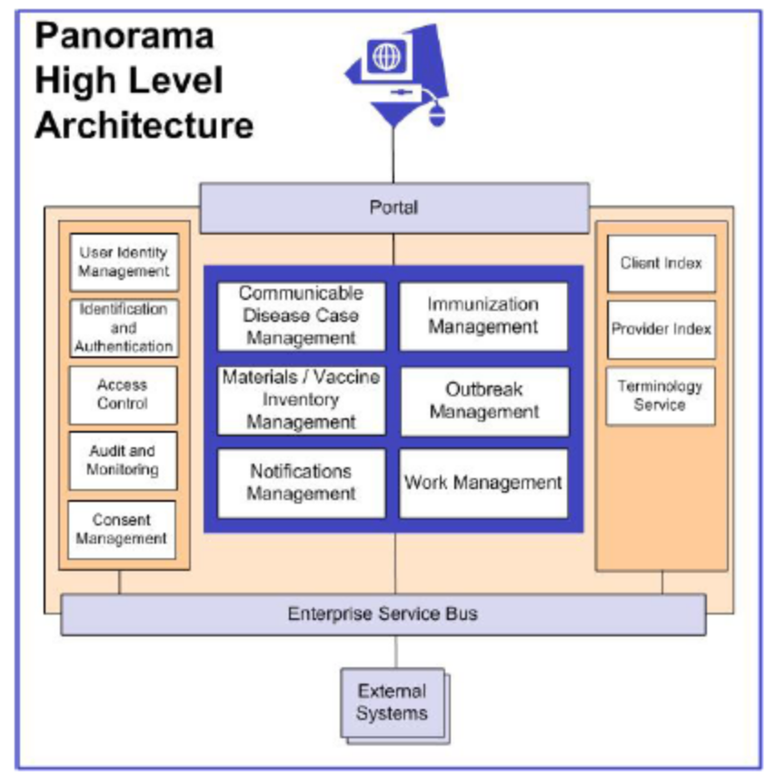
(Rand, 2007)

Appendix B
From Farley et al., 2005
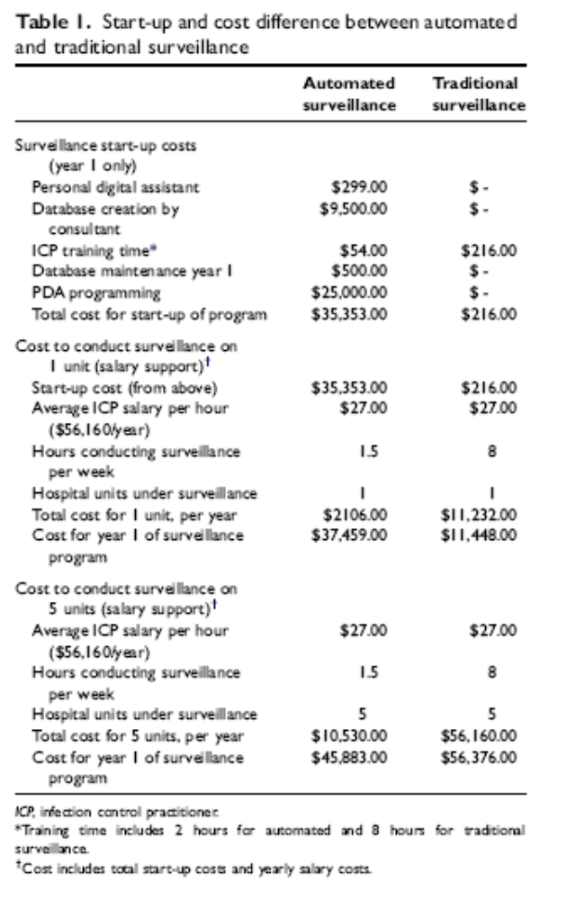
Appendix C
Draft Project Plan

Project Plan Report
MH LHIN Surveillance Tool

Project Manager: Madeleine Ashcroft
Sponsor Name: MH LHIN
Requested By: MH LHIN

Table of Contents

Project Tool | Why do it?
Project Charter | - Answers basic questions: what will this project accomplish? For whom? By when? And for how much money?  - Provides a discussion document for briefing team and stakeholders, and for sponsor approval.
Work Breakdown Structure & Resource Plan | - Defines the project activities and who will carry them out. A “To Do” list for the project
Network Diagram (Logical Dependencies) | - Graphically reveals the flow of the project activities – things that need to finish before other things can start
Project Schedule (Gantt chart) | - Graphically displays the time line of the project – the project calendar showing what happens when
Estimate Costs & Budget | - The way money will be spent. Eliminates unexpected expenditures and project delays
Risk Management Plan | - A list of potential unexpected events and their impact. Ensures contingency plans for potential hazards
Communication Plan | - What messages are to be sent to what audiences? Ensures project stakeholders become boosters, not barriers
Project Change Request | - Ensures changes to the scope or tasks must go through the change process to be validated by the team.
Project Status Report | - Review with project team what milestones and deliverables have been accomplished, outstanding and address any issues
Lessons Learned/Evaluation | - Allows you to gather information and identify ways to improve project management.

PROJECT CHARTER

Project Mission & Objectives | - The project will support the LHIN’s overall strategy of integration within and between the hospitals and is a step in building our e-Health capacity.
Project Benefits | - Primary benefit will be standardization of the surveillance and reporting processes and activities for the infection control professionals (ICPs) across all hospitals.  - Secondary benefits expected will be a streamlined process that saves time and money, enabling greater efficiency in infection prevention and control (IPAC) departments.
Project Scope | - Project includes introduction of RICN IPAC SET tool in each hospital IPAC department shared drive and one handheld unit (PDA) for each ICP for trial.  - We will cover the costs of the tool, the 20 PDAs, the PDA programming, and the initial training session and 3 follow-up sessions for ICPs (materials and food).  - ICP time for training and follow-up would be covered by the employing organization.  - Developing the necessary interfaces between the RICN IPAC SET tool and each hospital’s existing computer systems (to automatically input patient data (demographics, admission/transfer/discharge information, laboratory and diagnostic imaging reports/results, medications, and other data) will be managed as a separate project using time donated by the IPAC SET developer and an identified IT staff in each hospital.
Project Linkages & Key Stakeholders | - The project will be spearheaded by the MHICN Surveillance Working Group (SWG), reporting to the MHICN Steering Committee and LHIN, and linked to the MH LHIN Outbreak Prevention Strategy.  - Key stakeholders are ICPs and IT and/or Decision Support staff at each hospital.
Project Deliverables | - IPAC SET in each IPAC department shared drive  - Programmed PDA for each ICP (20)  - Training session and 3 follow-up sessions  - Quarterly evaluation of program implementation and written report
Proposed Approach | - What specific tools, techniques, enrolment strategy, leadership model, technical approach?  - The Surveillance Working Group will take a very consultative approach in developing the program – gaining the input of IPAC staff, department heads, Infectious Disease Physicians, and facility IT consultants through a series of focus groups (one at each facility, led by the SWG member for the facility and RICN staff).  - A dedicated implementation team (ICPs and IT lead) will be established in each hospital, with ongoing support from the RICN staff and the IPAC SET developer.
Roles & Responsibilities | - Role of sponsor, project manager and team members  - Role of senior managers, department heads, other resources  - Sponsor will assist in procurement of resources (including start-up money), provide introduction to the project and updates to hospital CEOs at their regular meetings, and troubleshoot conflicts that may arise at a high level  - Project Manager and Team will conduct all other project phases, liaising and negotiating with functional managers for resources
Project Milestones | - What “work-in-progress” products will be marked? How will we mark them?  - We expect reports as these stages: following January SWG meeting where commitment to the project will be agreed; when IPAC SET has been explored by ICPs at each hospital; when PDAs have been sourced: when PDAs have been programmed; when training has been completed; following the 3 follow-up sessions; and otherwise as may be required.
Budget | - Regional portion of $300,000 estimated cost for provincial implementation/support of IPAC SET ($21,5000)  - PDA purchase ($6,000) and programming ($30,000)  - IPC training (2 hours covered by employing facility), session hosted at RICN offices ($150)  - IT support from each hospital (at their expense)
Risks & Other Considerations | - The main risk is that the program will not advance as the ICPs will be overburdened with other IPAC requirements within the facility and dedicated IT support will not be forthcoming – this to be managed by securing CEO commitment to the project through sign-off at the LHIN.  - The assumption is that the LHIN funding will remain available beyond the 2008-2009 fiscal year.  - All 3 hospitals will be utilizing compatible computer systems within the year (e.g., using REACH and other linkages)
Project Mgmt & Sponsor | - Changes to scope, stop/start, additions to team, will be recommended by the Project Manager, approved by Sponsor

Approval to Proceed to the Plan Stage

Sponsor Signature: | Date:

WORK BREAKDOWN STRUCTURE & RESOURCE PLAN

Main Task or Deliverable | Sub-Tasks | Resource Name | Work (hrs) | Elapsed Days
1. Provide IPAC SET tool to ICPs | - Demonstration at Outbreak Prevention Launch (November)  - Demo. at OTMH (December)  _____________________  - CVH & THC (January) | RICN Coordinators (Cathy & Madeleine  RICN Coordinators (S/A)  _______________________  RICN Coordinators  (Madeleine) | 2  2  ________________  4 | 4 weeks  3 weeks__________
2. Communicate tool to other stakeholders and decision-makers | - Focus group at each hospital  - Feedback to SWG and LHIN | Hospital ICP from SWG (Faye, Tina, Diane) & Madeleine  S/A | 6  2 | 2 weeks  1 week
3. Select, purchase and program PDAs | - Meet with Host Hospital Decision Support and IT experts  - Communicate options for PDA technologies to other hospital IT leads | Madeleine, RICN IPAC SET developer (Chuck)  Madeleine & Chuck | 2  2 | 1 week  1 week
4. ICP Training with PDAs | - Agree date  - Prepare PowerPoint, manuals, quick reference guide  - Arrange room and refreshments | Tina, Faye, Diane, Madeleine, Host Hospital IT and/or company representative  Madeleine, MHICN Office staff (Risa & Sandra)  Sandra | 1  5  2 | 1 week  Concurrent  Concurrent
5. Implement use of PDAs for data input | - Each hospital to ‘go-live’ on agreed date(s)  - Feedback gathered and forwarded to RICN  - Reports prepared and disseminated | Tina, Faye, Diane, IT supports  S/A  Madeleine & Sandra | 2  2  2 | 1 week  1 week  1 week
6. On-going evaluation  (3 progress reports) | - Feedback gathered and forwarded to RICN  - Reports prepared and disseminated LHIN and other stakeholders | Tina, Faye, Diane  MHICN Staff | 2  3 | Monthly or bi-monthly intervals (TBA)

NETWORK DIAGRAM (LOGICAL DEPENDENCIES)

To be drafted once Project Charter is approved and following discussion with Working Group
PROJECT SCHEDULE

To be completed once Project Charter is approved and following discussion with Working Group

Task and Assigned  Resource | Type the Month or Week |  |  |  | Type the Month or Week |  |  |  | Type the Month or Week |  |  |  | Type the Month or Week |  |  |  | Type the Month or Week

Approval of Project Schedule

Sponsor Signature: | Date:

ESTIMATE COSTS & BUDGET

Budget Item | Specifics | Timing | Dollar Amount
Project Manager time cost | RICN Coordinator (consider additional administrative support for reports)  Backfill with RICN Consultant as required | - N/A - | Nil
Project Team time costs | Borrowed from employing hospitals | - N/A - | Nil
Surveillance Program | Portion of provincial implementation costs for IPAC SET | After initial trial (likely 6 months) | $21,500
PDAs | Purchase of PDAs |  | $6,000
PDA Programming | IT time and program |  | $30,000
ICP Training  - Staff costs | Covered by employing hospitals | - N/A - | Nil
ICP Training  - Food, Materials | Refreshments for participants  Manuals and reference guides |  | $150  $200
IT support/time | IT support from each hospital (at their expense) | - N/A - | Nil
TOTALS |  |  | $27,880

Approval of Budget

Sponsor Signature: | Date:

RISK MANGEMENT PLAN

Risk | Frequency* | Consequence* | Action to Lower Risk
Sponsor or Project Manager leaves | Medium | High | Assign 2nd in command for PM. Ensure hospital and LHIN CEO buy-in to project.
Difficulty in getting IT leads | Medium | Medium | Discuss early (January meeting). Elicit SWG ICPs help in identifying lead in each hospital. Ensure IT leads and their managers are involved in the site-specific focus groups.
Failure to agree on PDA or program | Medium | High | Engage IT experts from each hospital early.
ICPs will not continue to utilize and embrace the program | Medium | High | Encourage early involvement of all ICPs and ensure program is user friendly and time-saving.  Actively recruit feedback and pass it on the appropriate experts.
*Scale: High Medium Low
COMMUNICATION PLAN

Communication Rollout
Target Audience /Stakeholders | Message/Action | Persons Responsible | Method of Communication
ICPs Representatives from each hospital (SWG members) | Demonstrations:  - Nov. workshop  - Dec. at OTMH  - Jan. at SWG meeting | Project sponsor  RICN/IPAC SET developer | Demonstration followed by downloading into IPAC shared folder
All ICPs in each hospital | Demonstrations and hands on practice | SWG members in each hospital | ‘Train-the-trainer’
Hospital Decision Support/IT Contacts | Direct request | SWG member | In-person, telephone, or e-mail
Hospital ID Physicians and other stakeholders | Focus groups | SWG members, RICN Coordinator/  Project Manager | Focus groups
Hospital CEOs, Directors and department heads | Communication from LHIN | RICN Coordinator to forward information to LHIN  LHIN Program Sponsor to communicate to CEOs | Letters for sign-off

Approval of Communication Plan

Sponsor Signature: | Date:

PROJECT CHANGE REQUEST

Part 1: Description of Change

- Describe the proposed project change.

- List the reasons for the proposed change in relation to the project objective.

- Identify how the change will affect the following project elements:

- The Project Schedule:

- Cost Impact

- Original Budget Cost
- Cost of Change
- Changes to Date

- Total Revised Project Cost:

- The resources:

- Describe the effect on the project if this change is not made.

Part 2: Authorization

Changed Requested by: Date Requested:

Approved by: Date Approved:

Authorization Signature:

PROJECT STATUS REPORT (INTERNAL)

Schedule & Scope Status
Milestone/Activity | Planned Date |  | Actual Date |  | Accountability | Comment(s)
Deliverables completed since last update
Deliverable |  | Accountability |  | Actual Date |  |  | Met Quality Criteria?
Deliverables scheduled for completion
Deliverable |  | Accountability |  | Schedule Completion Date |  |  |  | Projected Completion Date

LESSONS LEARNED/EVALUATION

Lessons Learned Evaluation Form
Project Results | Went Well  (Yes or No) | Ideas for Improvement
Scope/deliverables
Team composition
Schedule
Staffing/Resources
Spending
Risks
Project Management Process
Project initiation (Business Proposal)
Project planning
Implementing
Change control
Communications
Other

