The last years of John II
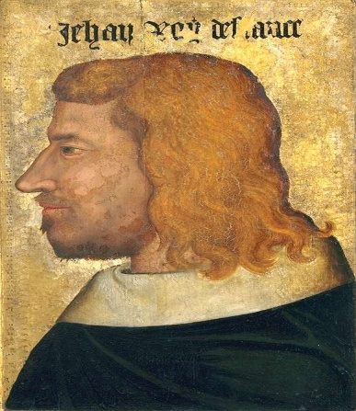
In 1360, by the Treaty of Brétigny, John was released in exchange for a ransom and hostages. In 1364 one of the hostages escaped, and John saved his honor by returning to England, where he died.

