Are Mr. C’s memory problems stroke related?

Stroke is a "brain attack" commonly caused by a focal interruption of cerebral blood flow that causes neurological deficits. Eighty percent of all strokes are called ischemic due to loss of blood flow. About 20% of strokes are called hemorrhagic due to bleeding. People with uncontrolled high blood pressure and diabetes often have small ischemic strokes that involve very small arteries in the brain. Small ischemic strokes may not cause any symptoms. It is not unusual to find these asymptomatic or "silent" strokes on brain scans that are done for other reasons (The pathophysiology of stroke is being discussed in great detail by group 1).

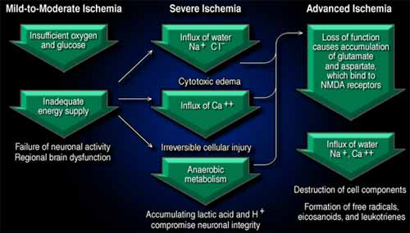
PATHOPHYSIOLOGY OF ISCHEMIC STROKE

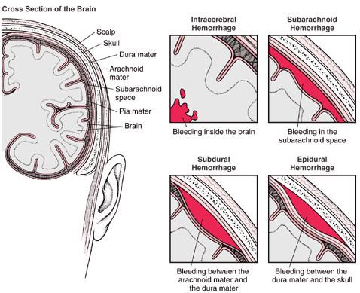

INTERCRANIAL HEMORRHAGIC STROKE

It is estimated that approximately one third of stroke victims will develop memory problems and serious difficulties in other aspects of performing daily activities. The memory problems can be so severe that they interfere with normal functioning and are then called dementia. This is more common as people get older. The two most common causes of dementia are Alzheimer’s disease and vascular dementia. Alzheimer disease is a common neurological disorder, and has now been demonstrated to be one of the most common causes of severe cognitive dysfunction in older persons. Its more prevalent forms are late-onset familial Alzheimer dementia (FAD), and nonhereditary, or sporadic, late onset AD. Both FAD and sporadic, late onset AD are known as senile dementia of the Alzheimer type (SDAT). AD is also associated with Down syndrome. The greatest risk factor is age. Aging and injury may result in changes that contribute to the development of the disease. Such changes include decreased oxygen and glucose transport, loss of the blood-brain barrier, and mitochondrial defects that alter cell metabolism and processing of proteins. Another cause of memory loss is called vascular dementia. The blood flow to the memory center of the brain is often blocked, and often occurs as a result of a stroke. Memory loss can also occur as the result of many small repetitive strokes.
In Mr. C’s scenario it is a case of which came first…the chicken or the egg? Mr. C’s memory problems could be a combination of age related changes progressing towards Alzheimer’s disease, and could also be caused from his previous stroke. His memory loss is most likely due to his recent CVA. Mr. C was discharged six weeks ago with a diagnosis of a right sided CVA with left sided weakness to his extremities. His wife also mentions that his memory is not as good since the stroke. A CVA located in the right cerebrum can affect Mr. C’s memory (he forgets where he puts things, forgets about appointments), orientation to surroundings and thinking (sometimes he forgets where they are going), and it can also his thinking and judgment, emotional control, and movement. Mr. C. also may have had more than one stroke, since they can sometimes be asymptomatic. Memory loss may resolve or may be permanent following a stroke.
Initial clinical manifestations of AD are insidious and often are attributed to forgetfulness, emotional upset, or other illness. Memory loss increases as the disorder advances, and the person becomes more disorientated and confused. The mental status changes induce behavioral changes, including irritability, agitations, and restlessness. The person may become anxious, depressed, hostile, emotionally labile, and prone to mood swings. Motor changes may occur if the posterior frontal lobes are involved.

The diagnosis of AD is made by ruling out other causes of a dementing process by CT and blood tests. Mr. C’s CT scan could show an old infarct from his previous stroke. The stroke may have been located in the right hemisphere, which could have caused his left sided weakness, memory loss, and impulsive behavior. The CT scan could also possibly show altered cerebral blood flow related to Alzheimer’s disease. The history including the mental status exams (mini-mental state examination, the clock test, functional assessment staging) and the course of the illness is used for the diagnosis.

The course of the disorder is highly variable, usually developing over 5 years of more. Cholinesterase inhibitors are used in mild to moderated AD to enhance cholinergic transmission. Namenda is a new drug with a different mechanism of action; it works as an uncompetitive NMDA receptor antagonist that blocks the activity of glutamate. Treatment of AD is also directed at decreasing the need for the impaired cognitive function by a compensation technique, such as memory aids, maintaining those cognitive functions that are not impaired, and maintaining or improving the general state of hygiene, nutrition, and health. Environmental management, counseling, education, pharmacotherapy, and health promotion measures provide the foundation on which a comprehensive treatment program is built. Many of the above treatments can also be used to aid in Mr.C’s recovery of memory loss due to the stroke.

References
Alzheimer’s Online Website. Retrieved May 23, 2007 from www.alzheimeronline.com/recognize/tests.aspx
Boss, B. (2006). Alterations of neurologic function. In McCance, K.L., & Huether, S.E. (Ed.), Pathophysiology: The biological basis for disease in adults and children (5th ed., p. 566-567) St. Louis: ElsevierMosby.
Boss, B., & Wilkerson, R.R. (2006). Concepts of neurologic dysfunction. In McCance, K.L., & Huether, S.E. (Ed.), Pathophysiology: The biological basis for disease in adults and children (5th ed., p. 518-521) St. Louis: ElsevierMosby.
The Heart and Stroke Foundation of Canada Website. Retrieved May 23, 2007 from www.heartandstroke.ca
The Internet Stroke Center: Stoke education for students and clinicians. Retrieved on May 22, 2007 from www.strokecenter.org
Maud, A. (2006). Memory loss after stroke. American Academy of Neurology, 67. Retrieved on May 23, 2007 from www.neurology.org/cgi/content/full/67/8/E14

