Is stroke damage reversible?

Symptoms that suggest an ischemic stroke require immediate medical attention. Acting quickly can reduce loss of function and sensation that results from loss of blood supply (oxygen and nutrients) to the affected area. Magnetic resonance imaging (MRI) and computed tomography (CT) are used to confirm the stroke diagnosis and to locate the area in the brain affected. If the stroke is due to a blood clot a clot busting drug tPA (tissue plasminogen activator) can be given intravenously to break up the clot or reduce its size. This technique must be performed within three hours from the onset of symptoms. Because thrombolytic drugs can cause bleeding a complete history and physical examination is needed (Mayo Clinic, 2006).

In most people who have had an ischemic stroke the loss of function usually occurs immediately after the stroke occurs and becomes stable (completed stroke). However in 15-20% of cases the stroke is progressive causing greatest function loss after one to two days (evolving stroke). Over days to months some function is regained because even though some brain cells die, others are only damaged and they recover. Sometimes certain areas of the brain can switch and do the functions of the damaged part (plasticity).
(Merck Manual, 2007).

When large arteries of the brain are blocked some patients have no symptoms or a small stroke while others have a massive ischemic stroke. This is due to the Circle of Willis and the size of its diameter. If the diameter is large the circle of Willis can redistribute the blood to the whole brain when one of the arteries are blocked. When the diameter is small or if the circle of Willis is incomplete then redistributing blood is more difficult and symptoms occur. With other patients they grow new collateral blood vessels that bypass a blockage in these arteries (Merck Manual, 2007).

The symptoms that occur depend on several factors including the location of the obstruction and how much tissue was affected. When the arteries that branch from the internal carotid artery are affected the patient can have the following symptoms: blindness in one eye or abnormal sensations and weakness in one arm or leg or on one side of the body. When the arteries that branch from the vertebral arteries in the back of the brain are affected the following symptoms are present: dizziness, vertigo, double vision, and generalized weakness on both sides of the body are seen. Difficulty speaking or understanding speech and loss of coordination can also occur (Merck Manual, 2007). If the stroke affects the brain’s right side the left side of the body and the right side of the face will be affected. Paralysis, vision problems, quick inquisitive behavior style and memory loss may result. If the stroke occurs in the left side of the brain the right side of the body and the left side of the face is affected. Paralysis on the left side, speech and language problems, slow cautious behavior and memory loss may be present (American Stroke Association, 2007). The area of the brain affected by the stroke may span adjacent cerebral areas or affect nerve fibers passing through an area (Collins, 2007).

Certain factors suggest a poor prognosis for the patient. Strokes that cause unconsciousness or that affect a large part of the left side of the brain (responsible for language) have poor outcomes. Neurological losses that remain after 6 months are usually permanent in adults, although children continue to improve slowly over several months. Older people do not do as well as younger people (Merck Manual, 2007). About 10% of people who have an ischemic stroke recover almost all-normal function and about 25% recover almost all of it. About 40% of patients have moderate to severe impairments and require special care. Long-term care is needed for about 10% of the patients. About 15% of people who have a stroke die in hospital and this rate increase with the frail elderly (Merck Manual, 2007).

During the first few days after an ischemic stroke it is difficult to predict whether a person condition will improve or decline. About 50% of people with one-sided paralysis and those with less severe symptoms recover some function before they leave the hospital (Merck Manual, 2007). They may be able to think clearly and walk adequately, with limited use of the affected arm or leg. The use of the arm is often more affected than the leg (Merck Manual, 2007).

A stroke can be a chronic lifelong disease that is treated to relieve symptoms, improve the quality of life and reduce early death. The goals of rehabilitation are to regain as much function as possible, to maintain and improve the patient’s physical condition, and to help him/her relearn old skills and learn new ones as needed (Merck Manual, 2007). A multitude of interventions, such as drugs, surgical procedures and education about lifestyle adjustments, is used in ambulatory and hospital settings.

Success depends on the area of the brain damaged and the person’s general physical condition, functional and cognitive abilities before the stroke. The patient’s social situation, learning ability and attitude play a part in rehabilitation. Intensive rehabilitation can help people overcome some of the disabilities after a stroke. Exercises and training help develop the plasticity of the brain and teach the patient new ways to use muscles that were unaffected by the stroke. The key is to use the affected area as much as possible and to repeat activities several times a day (American Stroke Association, 2007).
Mayo Foundation for Medical Education and Research (MFMERMayo Foundation for Medical Education and Research (MFMERMayo Foundation for Medical Education and Research (MFMER
.
Figure 4 - 2

Figure 4 - 2

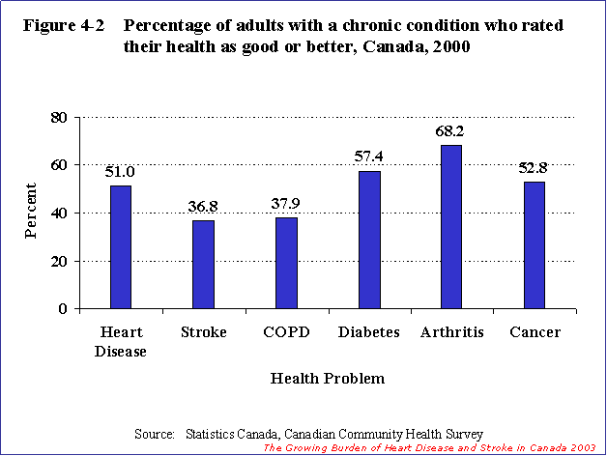
Quality of Life
Canadian Institute for Health & Statistics Canada. (2003 report that” heart disease has a major impact on quality of life. In 2000, 90.0% of the population without heart disease reported their health as being good, very good or excellent. The percentage was much lower among those with self-reported heart disease (51.0%) or stroke (36.8%). Among people with chronic diseases, those with stroke had one of the lowest percentages reporting good or better health

In 2000, a high percentage of individuals who had had a stroke reported having activity restrictions and needing help with activities of daily living (Figure 4-3). The percentage was also high among those with self-reported heart disease, but lower than among those with stroke. Slightly more than one-quarter of individuals with either heart disease or stroke reported more than one disability day in the previous 14 days. Of those with heart disease, 16.0% reported being depressed during the previous 12 months, as did 18.4% with stroke. A much lower percentage of individuals without heart disease or stroke reported specific limitations in their lives" (Canadian Institute for Health & Statistics Canada, 2003, chapter 4)
Figure 4 - 3

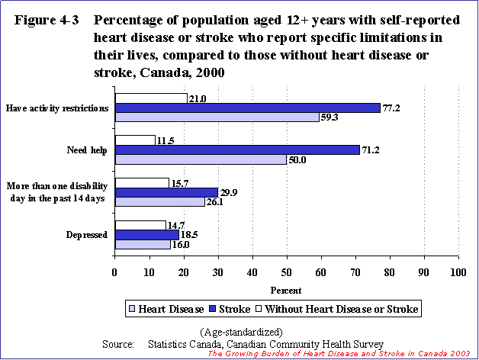
The above graphs and information taken from The Growing Burden of Heart Disease and Stroke in Canada.

American Stroke Association. (2007). America Stroke Association. Retrieved May 23, 2007 from: http://www.strokeassociation.org/presenter.jhtml?identifier=1200037
Canadian Institute for Health & Statistics Canada. (2003). The Growing Burden of Heart Disease and Stroke in Canada. Canadian Institute for Health & Statistics Canada. Retrieved May 23, 2007 from:
http://www.cvdinfobase.ca/cvdbook/En/Index.htm
Collins, C. (2007). Pathphysiology and classification of stroke. Nursing Standard. 21, (28). Retrieved May 23, 2007 from: http://0-find.galegroup.com.aupac.lib.athabasca.ca/itx/printdoc.do?&prodId=SPJ.SP11
Mayo Clinic. (2006). Stroke. Mayo Clinic. Retrieved May 21, 2007 from: http://www.mayoclinic.com/
Merck Manual. (2003). Ischemic Stroke. Merck Manual. Retrieved May 22, 2007 from:http://www.merck.com/mmhe/sec06/ch086/ch086a.html#sec06-ch086-ch086a-658 Figure 4 - 2

