Pathophysiology of Alzheimer’s Disease
Alzheimer’s disease (AD) is a common neurologic disorder causing progressive cognitive deterioration leading to dementia and accounts for >65% of dementias that occur in the elderly. AD affects 4% of 65-74 year olds and 30% of elderly >80 years of age. The majority of cases are sporadic in nature occur with later onset (>60) and 5-15% are familial in origin (late onset FAD) with ½ of these occurring before age 60(familial early onset FAD). (Beers et al, 2006) These early onset familial cases involve 3 known gene defects which include: amyloid precursor protein gene on chromosome 21; presenilin 1 on chromosome 14 and presenilin2 on chromosome 1. Late onset familial AD is related to a gene defect in apolipoprotein E on chromosome 19. (McChance & Huether, 2006)
Histologically AD brain tissue changes include: extracellular B-amyloid deposits, intracellular neurofibrillary tangles, and senile plaques with loss of neurons. Cerebrocortical atrophy occurs (figure 1a & 1b) along with a decrease in perfusion in the temporal cortices, prefrontal cortex and parietal lobe. Mutations in the previously listed genes (21,14,1,19) may alter the processing of amyloid precursor protein resulting in deposition and fibrillar aggregation of B-amyloid which in turn may lead to neuronal death and formation of senile plaques (figure 3 & 4) which deposit in brain tissue and blood vessels, and neurofibrillary tangles (figure 2 & 4 )which are deposited in the brain tissue. Senile plaques consist of degenerated axonal or dendritic processes, glial cells, and astrocytes an amyloid core. These plaques disrupt nerve impulse transmission. Neurofibrillary tangles consist of insoluble helical filaments which developed from Tau proteins which once were attached to microtubules and in the normal setting stabilized the microtubular transport system. The plaques and tangles described are found to be more concentrated in the cerebral cortex and hippocampus of patients with AD. The greater the number of plaques and tangles found the greater the dysfunction of the patient. As mentioned previously amyloid also deposits in the cerebral arteries resulting in amyloid angiopathy. I assume this is the cause for a decrease in cerebral perfusion. (Beers, 2006; & McCance & Huether, 2006)
The etiology is unknown but research includes but not limited to: the link between aluminum and AD (not found yet); a viral cause (a virus has not been isolated but submicroscopic proteinaceous infectious particles (pirons) have been isolated); and an autoimmune cause (when plaques form, complement proteins attach to them thus attracting micoglia which release toxins to attempt to destroy the plaques which are indestructible leading to continued immune response by the microglia). (McCance & Huether, 2006
Figure 1a.
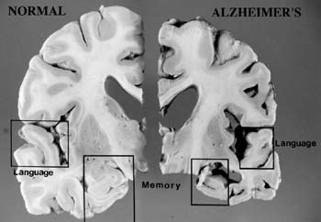

Figure 1b.
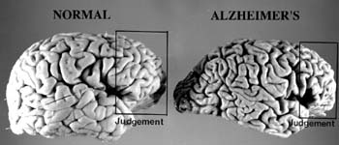

Photo’s retrieved from: http://w3.uokhsc.edu/pathology/DeptLabs/diabnostic_center_for_alzheimer.htm#Causes%20Alzheimer’s%20Disease

Figure 2.
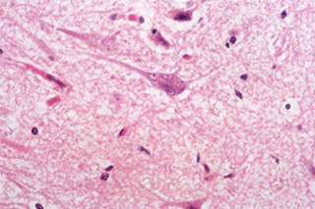
Neurofibrillary tangles are seen in the cytoplasm of affected neurons as demonstrated in the center of this slide (Bodian stain).

Figure 3.
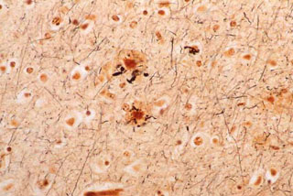
Extracellular deposits of senile plaques are shown (Bielschowsky stain).

Photo retrieved from: http://www.clevelandclinicmeded.com/diseasemanagement/neurology/alzheimers/alzheimers.htm
Figure 4
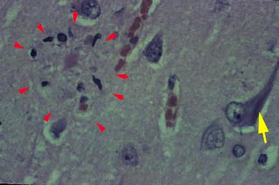
H&E stained microscopic section showing neuritic plaques (red arrowheads) and neurofibrillary tangle (yellow arrow) characteristic of Alzheimer’s
Photo retrieved from: http://www.mcl.tulane.edu/classware/pathology/medical_pathology/neuropathology/deg_demyel.htm

References
Beers, Porter, Jones, Kaplan, & Berkwits (2006). The Merck Manual of Diagnosis and Therapy, 8th
Edition. Whitehouse Station, NJ: Merck & Co. Inc.
Delagarza, Vincent (2003). Pharmacologic Treatment of Alzheimer’s Disease: An Update.
American Family Physician, Vol.68, No. 7, pp 1365-1372.
Ross Klingsberg; Byron Crawford; Luisa Florez; Meena Bhattacharjee; Carlos Garcia; Curtis Sutton,
Robert McLay (2007), Degenerative and Demyelinating Diseases. Retrieved from:
http://www.mcl.tulane.edu/classware/pathology/medical_pathology/neuropathology/deg_demyel.htm
McCance, K. & Huether, S. (2006). Pathophysiology The Biologic Basis for Disease in Adults and
Children, 5th ed. St. Louis, Missouri: Elsevier, Mosby.
Tavee, J. & Sweeney, P. (2007). Alzheimer’s Disease. Retrieved from:
http://www.clevelandclinicmeded.com/diseasemanagement/neurology/alzheimers/alzheimers.htm

