Group D: Unit 6 Renal

- Pathophysiology of Acute Glomerulonephritis

Acute glomerulonephritis is a category of kidney disorders that result in inflammation of the glomeruli. It is often a result of an immune response triggered by an infection, injury, toxin, or disease process. Understanding the disease process is important because permanent damage can result if it is not identified and treated promptly. The events that lead to an immune response are poorly understood except in the case of poststreptococcal glomerulonephritis (Papanagnou & Kwon, 2008).
McPhee & Ganong (2006) list the causes of acute glomerulonephritis as:

- Infectious diseases: poststreptococcal; nonstreptococcal postinfectious; bacterial (infective endocarditis, shunt nephritis, sepsis, pneumococcal pneumonia, typhoid fever, secondary syphilis, meningococcemia); viral (hepatitis B, infectious mononucleosis, mumps, measles, varicella, echovirus, coxsackievirus; parasitic (malaria, toxoplasmosis)

- Multisystem diseases: systemic lupus erythematosus, vasculitis, Henoch-Schonlein purpura, Goodpasture's syndrome

- Primary glomerular diseases: mesangiocapillary glomerulonephritis, Berger's disease (IgA nephropathy)

- Miscellaneous: Guillain-Barre syndrome, irradiation of Wilm's tumor, diptheria-pertussis-tetanus vaccine, serum sickness

Activation of the immune system results in the presence of immune complexes within the glomerulus. Autoimmune complexes are formed when the glomerular basement membrane acts as an antigen to a circulating antibody or circulating antigens can form complexes with circulating antibodies. These antibody complexes then deposit themselves in the glomerulus which can damage and/or occlude the glomerular capillaries. Furthermore, once these complexes are deposited in the glomerulus, mediators of inflammation (complement, leukocytes, fibrin) are activated (Mc Cance & Huether, 2008, p 1319). This leads to: cellular proliferation of PMNs and macrophages; phagocytosis; release of enzymes and toxins; platelet aggregation and fibrin formation (Couser, 2008).
Acute forms of glomerulonephrits usually resolve with little or no kidney damage, however some will rapidly progress to renal failure by rapid inflammation and necrosis. This happens with 70% extracapillary cellular proliferation of glomeruli (McPhee & Ganong, 2006). Slow progression from acute glomerulonephritis to chronic glomerulonephrits can also occur over 5-20 years from slowly progressive glomerulosclerosis and fibrosis. The type of glomerular injury depends on the initial immune response, the extent to which it is perpetuated, and if it resolved without scarring (Johnson & Feehally, 2003).
The following table (Johnson & Feehally, 2003) summarizes the process of glomerulonephritis.

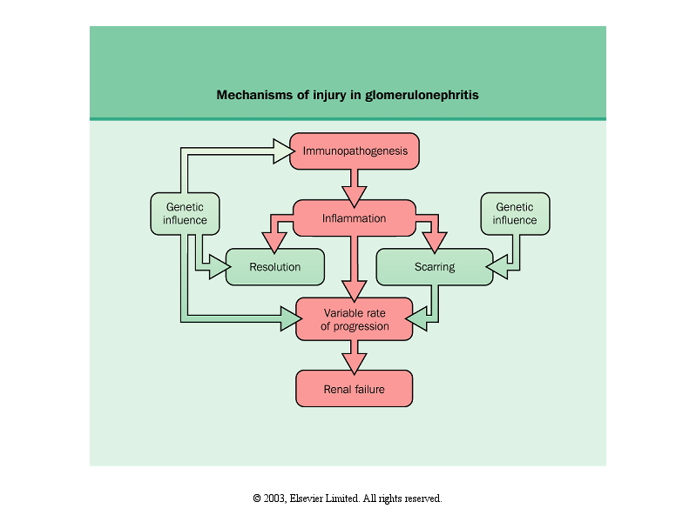

The Pathogenesis of Glomerulonephritis(GN) (Lemone & Burke, 2004)
Initiating event(antigen/antibody formation)
Glomerular-capillary membrane inflammation

Increased glomerular permeability Decreased GFR

hematuria proteinuria azotemia activation of RAS
hypoalbunemia Na and water retention
edema Hypertension

- Infection of the pharynx or skin with group A beta-hemolytic streptococcus is the usual initiating event for this disorder. The patient reports taking ibuprofen for C/O sore throat 2 weeks ago. The latent period of 7-21 days between the development of a strep infection and the development of clinical GN is charactersitic (http://www.emedicine.com/ped/TOPIC27.HTM).

- Acute GN is characterized by an abrupt onset of hematuria, proteinuria, salt and water retention and evidence of azotemia occurring 10-14 days after the initial infection (Lemone & Burke, 2004). The patient's subjective report of "reddish-brown urine" and the objective data of 3+ blood are evidence of hematuria. Proteinuria is supported by the lab value of 2+ protein. "Characteristics of hematuria from red blood cells escaping through the glomerular membrane [italics added] include a smoky brown-tinged urine, red blood cell casts, and an accompanying proteinuria. Bleeding from sites lower...may produce a pink- or red-colored urine" (McCance & Huether, 2006, p. 1319). Gross proteinuria is associated with nephrotic syndrome (McCance & Huether, 2006).

- The immune-mediated inflammatory response with cellular infiltration decreases GFR, which leads to fluid retention (McCance & Huether, 2006, p. 1319). Salt and water retention is evidenced by the edema--periorbital and dependent (hands and feet). "Renal edema...is...in areas of low tissue pressure, such as periorbital regions" (McCance & Huether, 2006, p. 1321). The edema is related to the hypoalbunemia and the retention of sodium and water. The hypolabunemia limits oncotic pull of fluids back into vessels and allows fluids to leak into surrounding tissues. Edema is also r/t sodium and water retention. Aldosterone is secreted when renal perfusion is decreased; reabsorption of sodium, and hence, water, occurs. Edema is present in 85%, usually occurs abruptly and varies in relation to glomerular involvement, fluid intake and degree of hypoalbuminemia. It is the most frequent and sometimes only clinical finding (http://www.emedicine.com/ped/TOPIC27.HTM)

- The patient also reported that he was urinating less than normal (oliguria); decreased urine output is r/t decreased GFR.

- The patient was hypertensive with a BP reading of 172/110. The degree of hypertension is variable and both systolic and diastolic elevations may be present (http://www.emedicine.com/ped/TOPIC27.HTM). Renin is likely released following decreased perfusion of the kidney (McCance & huether, 2006). Renin stimulates the formation of angiotensin I which is converted to angiotensin II. As a vasoconstrictor, angiotensin II activates vascular smooth muscle throughout the body. Angiotensin II also stimulates the secretion of aldosterone, promoting sodium and water retention and elevating BP (McCance & Huether, 2006, p. 99). However, the pathogenesis of the HTN may not be this clear cut. In the article, Acute Poststreptcoccal Glomerulonephritis, the authors report that the pathogenesis of the HTN is likely multifactorial as evidenced by the following points:

- the ECF volume is elevated but BP does not always return to normal levels with diuresis;

- renin levels have been reported as low, normal or elevated;

- lack of response to drug-induced blockade of the angiotensin system does not support this system as the primary cause for the HTN, and;

- various cytokines are known to have pressor properties and are likely to have a role (http://www.emedicine.com/ped/TOPIC27.HTM).

References

Acute poststreptococcal glomerulonephritis. Retrieved June 16, 2008 from emedicine http://www.emedicine.com/ped/TOPIC27.HTM.

Couser, W (2008). Pathogenesis of tissue injury in glomrulonephritis. Retrieved June 16, 2008 from UpToDate database.

Johnson, R.J. & Feehally J. (2003). Comprehensive Clinical Nephrology (2nd ed.). Philadelphia, PA: Elsevier Mosby.

Lemone, P. & Burke, K. (2004). Medical-surgical nursing: Critical thinking in client care (3rd ed.). Upper Saddle River, NJ: Pearson Preston Hall.

McCance, K. L. & Huether, S. E. (2006). Pathophysiology: The biological basis for disease in adults and children (5th ed.). St. Louis, MO: Elsevier Mosby.

MCPhee, W.F. & Ganong, W.F. (2006). Pathophysiology of disease: an introduction to clinical medicine (5th ed). McGraw-Hill. Retrieved June 16, 2008 from McGraw-Hills Access Medicine.

Papanagnou, D. & Kwon, N.S. (2008). Glomerulonephritis, acute. Retrieved June 16, 2008 from http://www.emedicine.com/emerg/topic219.htm.

