Unit 7 Case study
Group D: Alex, Alexis, Jennifer, and Michelle
What is the definitive nonsurgical treatment of this condition (Grave’s Disease)?
We believe diagnosis is suggestive of Graves’s disease which is an autoimmune disease. The body’s normal immune system mistakenly attacks the thyroid gland. During this process, the thyroid gland is altered to overproduce the hormone thyroxine.
The two basic nonsurgical treatment methods of Grave’s disease consist of:
- Blocking or decreasing the production of thyroxine
- Symptom management.
Blocking or decreasing the production of thyroxine
The “appropriate treatment depends on the size of the goiter, the causes, the patient’s age and parity, and how long surgery will be delayed (if the patient is an appropriate candidate for surgery)” (Carpenter, 844). One of the down sides to the treatment of Grave’s disease today, “does not reverse the infiltrative ophthalmopathy or the pretibial myxedema” (McCance & Huether, 634).
- Beta blockers: propranolol , atenolol, metoprolol. They help block the effects of excess thyroxine by keeping the heart rate under control.
- Radioactive iodine treatment: The main goal of this treatment is to “reduce the level of thyroid hormone” (Porth, 795). The way Iodine-131 works is it “picks up the radioactive element as it would regular iodine” then the “radioactivity destroys some of the cells that normally concentrate iodine and produce T4” (Carpenter, 845). In other words, it “prevents the thyroid gland from converting iodine to its organic form in the thyroid and blocks the conversion of T4 to T3” (Porth, 795). This action is going to decrease the “thyroid production and normalize thyroid size and function” (Carpenter, 845). It should be noted that this method of treatment may cause hypothyroidism, but that is relatively easy to treat with Synthroid medication.
- Anti-thyroid medications: Since Mary is of reproductive age and may not want to elect radioactive iodine option. In her case, the doctors could prescribe a “thyroid hormone antagonist which includes propylthiouracil and methimazole, which block thyroid hormone synthesis” (Carpenter, 844). Both of these drug regimen work in about the same time being 6 to 8 weeks, but the difference here is that the “patient must continue the medication for 6 months to 2 years, depending on the clinical circumstances” (Carpenter, 844).
- Glucocorticoids: Although sometimes considered an unattractive treatment option because of the adverse long term effects, these drugs have been shown to decrease thyroid hormones and T4 to T3 conversion.
The following table, taken from RN Web, reviews the different treatment options and their actions:
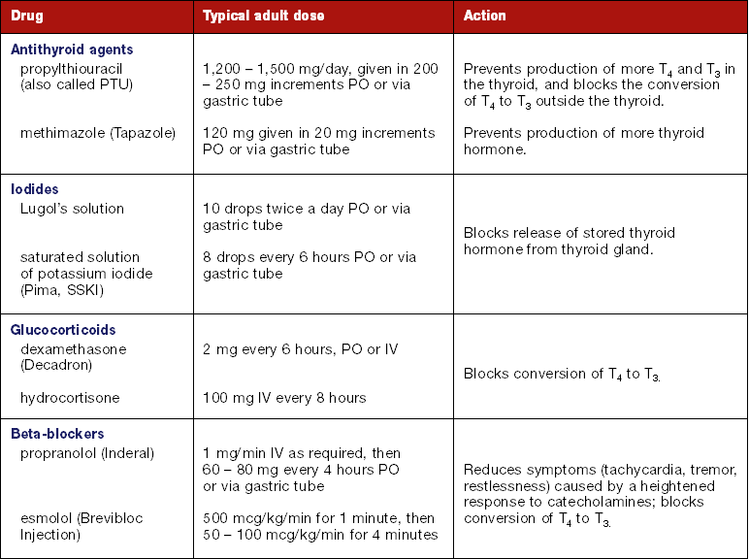

Symptom management
- Corticosteroids: to decrease inflammation behind the eye balls caused by exophthalmoses
- Sunglasses: to “help protect her eyes from the sunlight” (Carpenter, 846) due to her lid retraction.
- Eye drops: to keep the eyeball moist and warn Mary about “sudden physical movements that might cause the lid to slip behind the eyeball” (Carpenter, 846).
- Prisms: Special eye glasses to help correct double vision.
- Orbital radiotherapy: using X-rays to shrink the tissue behind the eyes
- Cool compress over the eyes
- Elevate bed: Let gravity reduce fluid accumulation in the head
- Promote weight gain by small frequent meals
- Leg wraps and hydrocortisone cream: Treatment for Mary’s persistent rash on her shins.

References:
Dulak, S. (2005). Thyroid Storm: A Medical Emergency. Retrieved on October 18, 2007 from http://www.rnweb.com/rnweb/article/articleDetail.jsp?id=153278.
Graves Disease. (2005). Retrieved on October 18, 2007 from http://www.emedicine.com/med/topic929.htm.
Graves' disease - CNN.com. Retrieved 10/18/2007, 2007, from http://www.cnn.com/HEALTH/library/DS/00181.html
Porth, C.M., Pathophysiology: Concepts of Altered Health States. 5th Edition. (1998).
Carpenter, D.O., Professional Guide to Diseases. 7th Edition. (2001).
McCance, K. & Huether, S., Pathophysiology: The Biologic Basis for Disease in Adults & Children. 4th Edition. (2002).

