What is the Underlying Pathophysiology of Asthma?

The major pathologic feature of asthma is an inflammation resulting in hyperresponsiveness of the airways.
The allergen binds to IgE on the surface of the mucosal mast cell. Crosslinking of these molecules triggers degranulation of the mast cells and release mediators, such as histamine, leukotrienes, prostaglandin D2, platelet-activating factor, chemotactic chemokines, and certain cytokines (IL-1 beta).

Inflammatory and Bronchoconstriction Events of the Early Phase of an Acute Asthmatic Response to Allergen Exposure

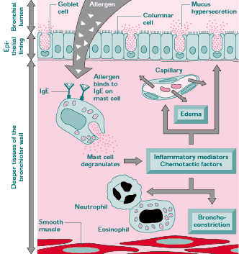
Adapted from Barnes et al. (1998).

These mediators cause:
- Airway smooth muscle constriction (bronchospasm)
- Increased vascular permeability (mucosal edema)
- Mucus secretion
Acute inflammation opens intercellular tight junctions, and antigen penetrates and activates submucosal mast cells. At the same time, dendritic cells receive, process, and present the antigen in regional lymph nodes to naïve T lymphocytes (Th0) or locally to memory cells (Th2) in the airway mucosa.
According to McCance and Huether (2006), a key determinant of asthma is the T-lymphocyte phenotype. In case of “Th2 response”, CD4 T-helper (Th) cells produce specific cytokines, such as IL-3, IL-4, IL-5, IL-13, and granulocyte-macrophage colony-stimulating factor. IL-4 and IL-13 are important for B cells switching to IgE production. IL-3, IL-5, and granulocyte-macrophage colony-stimulating factor are critical for differentiation and enhanced survival of eosinophils in the airways. Oppositely, “Th1 response-mediated” is related to delayed type hypersensitivity and phagocyte-mediated host defense.
This inflammatory process results in bronchial muscle spasm, vascular congestion, increased vascular permeability, edema formation, production of thick tenacious mucus, impaired mucociliary function, thickening of airway walls and bronchial hyperresponsiveness.
Other inflammatory cytokines, such as TNF and IL-1 alter Muscarinic receptor function which leads to increased level of acetylcholine. Acetylcholine causes further bronchial muscle contraction and mucus secretion.
Late asthma response occurs 4 to 12 hours after initial attack because of persistent eosinophil and lymphocyte activation.

Inflammatory and Bronchoconstriction Events of the Late Phase of an Acute Asthmatic Response to Allergen Exposure

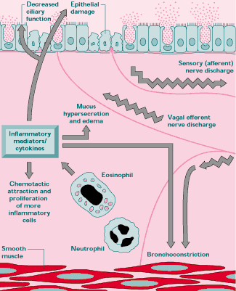
Adapted from Barnes et al. (1998).
In the late asthmatic response, there are areas of epithelial damage. The damage is caused by toxicity of eosinophil products, such as major basic protein, eosinophilic cationic protein, eosinophil derived neurotoxin, and eosinophil peroxidase. Local T lymphocytes display predominant Th2 cytokine profile.
Airway obstruction increases resistance to airflow. Flow rates, including expiratory flow decrease. Impaired expiration causes hyperinflation distal to obstructions. Work of breathing increases.
Regional differences in airflow result in uneven distribution of inspired air with more air flowing to the less resistance portions of lungs.
Increased lung volume and obstruction trigger hyperventilation via lung receptors. Continued air trapping increases intrapleural and alveolar gas pressure. Perfusion of the alveoli decreases. Increased alveolar gas pressure, decreased ventilation, and decreased perfusion lead to variable and uneven ventilation-perfusion relationships within different lung segments.
Hypoxemia, hypocarbia, and respiratory alkalosis are the typical changes in arterial blood gases in acute asthma. Respiratory rate is usually high to compensate for hypoxemia. Hypoxic vasoconstriction and increased intra-alveolar pressure alter pulmonary circulation, and perfusion of alveolar capillaries decreases.
The hypoxemic hyperventilation reduces arterial PCO2 to 30-35 mm Hg. When FEV1 falls to 15-20%, then retention of CO2 occurs.
Asthma Airway Obstruction Cascade:
Edema, mucus, muscle spasm
↓
Resistance to air flow
↓
Impaired expiration
↓
Air trapping
↓
Alveolar hyperinflation
↓
Uneven ventilation/perfusion
↓
Increased work of breathing
↓
Hypoxemia
↓
Hypercapnia
↓
Respiratory failure

(McCance & Huether, 2006, p.1267)
Asthma represents a chronic inflammatory process followed by healing. The end result may be an altered structure called a remodeling of the airways. Repair involves replacement of injured tissue by parenchymal cells of the same type and replacement by connective tissue and its maturation into scar tissue (DiPiro, Talbert, Yee, Matzke, Wells, & Posey, 2005).
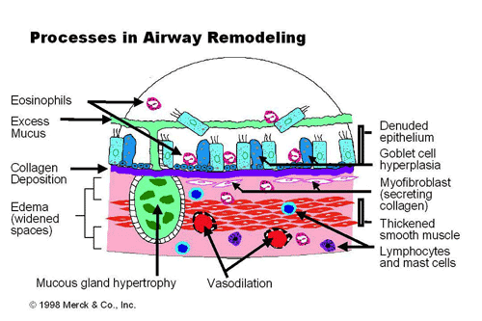

The repair process can follow by complete or altered restitution of airway structure and function, presenting as fibrosis and an increase in smooth and mucus gland mass.

References

Barnes, P. J., Rodger, I. W., Thomson, N. C. (1998). Asthma Basic Mechanisms and
Clinical Management. San Diego, CA: Academic Press.
DiPiro, J.T., Talbert, R. L., Yee, G., Matzke, G. R., Wells, B. G., Posey, M.L. (2005).
Pharmacotherapy: A pathophysiologic approach. McGRAW-HILL: Medical
Publishing Division.
McCance, K.L., Huether, S.E. (2006). Pathophysiology: A Biologic Basis for Disease in
Adults and children. Philadelphia: Elsevier Mosby.
MerchMedicus Models: Asthma. Retrieved May 21, 2008, from
http://www.merckmedicus.com/pp/us/hcp/diseasemodules/asthma/pathophysiology.jsp.

