Database of Sensors
BY
ALI MOHAMMAD SALIH
P-RM0007/09

Definition of Sensors:
A device that is measures or detects a real-world condition, such as motion, heat or light and converts the condition into an analog or digital representation. An optical sensor detects the intensity or brightness of light, or the intensity of red, green and blue for color systems.

Smart sensor:

A sensor that is includes a microprocessor that conditions the signals before transmission to the control network. It filters out unwanted noise and compensates for errors before sending the data. Some sensors can be custom programmed to produce alerts on their own when critical limits are reached
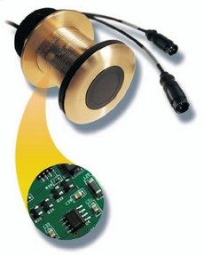
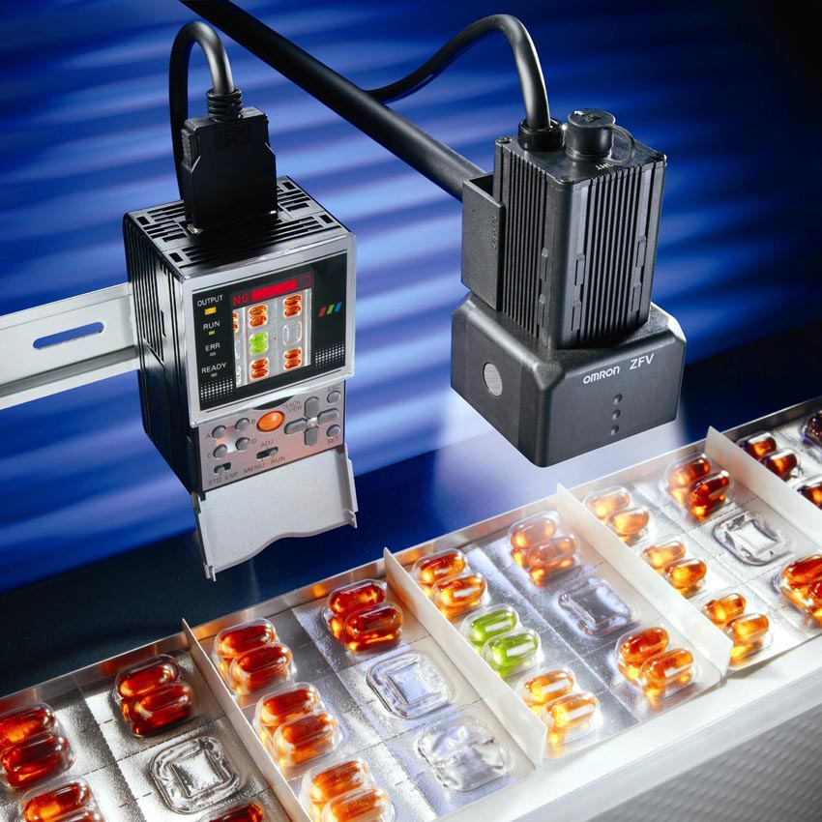
http://news.thomasnet.com/fullstory/490653
http://www.proactiveimage.com.au/home.htm

Sensors types
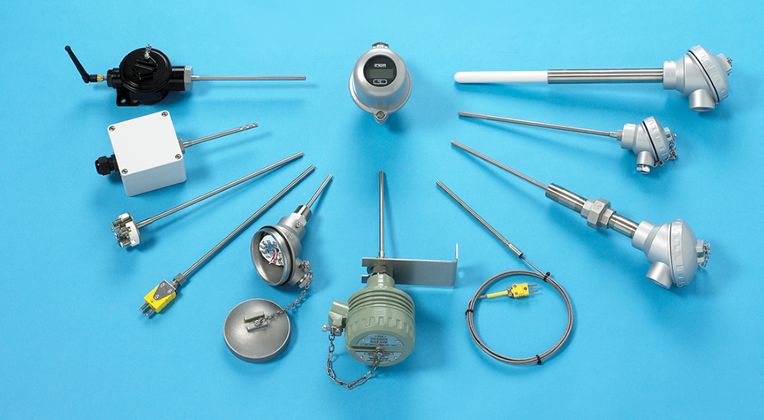
There are many types of sensors. They are used to measure and/or detect a huge variety of conditions including: temperature, pressure, level, humidity, speed, motion, distance, light or the presence/absence of an object and many other types. There are many versions of each type which may use a different sensing principle or may be designed to operate within different ranges.

http://www.temperature.com.au/ (Thermocouples & RTD Sensors) RTD

Sensors in some cases react to the environment in which they are placed and this reaction is used to measure the property being sensed. For example, a common temperature detector is known as an RTD (resistance temperature detector) and this contains a platinum wire. The electrical resistance of the wire changes with temperature so how the resistance changes can be used to measure the temperature. Many sensors use this type of principle where the variation of an electrical property of a sensing element is a measure of a property being sensed.
Other types of sensors emit a signal and either measure how the area reacts to the emission or measure the reflection of the signal bouncing off an object in front. Inductive proximity sensors are one of the commonest sensors in use today. They emit a small electromagnetic field and use this to sense the properties of the area in front of the sensor.

Some sensors send out a light signal and measure if it is reflected back. These are called photoelectric sensors and come in a multitude of varieties. Some directly detect a reflected signal (Direct detection mode), some check if a beam being reflected from a reflector is interrupted (retroflective mode) and others send a beam to another sensor receiver and detect an interruption of the beam (Opposed mode sensor).
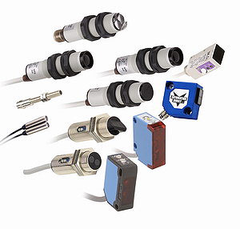
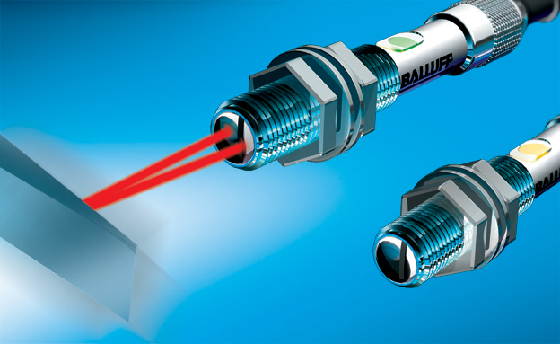
http://www.balluff.com (photoelectric sensors)

Sensor Data
A sensor database involves stored data and sensor data. Stored data include the set of sensors that participate in the sensor database together with characteristics of the sensors (e.g., their location) or characteristics of the physical environment. These stored data are best represented as relations.
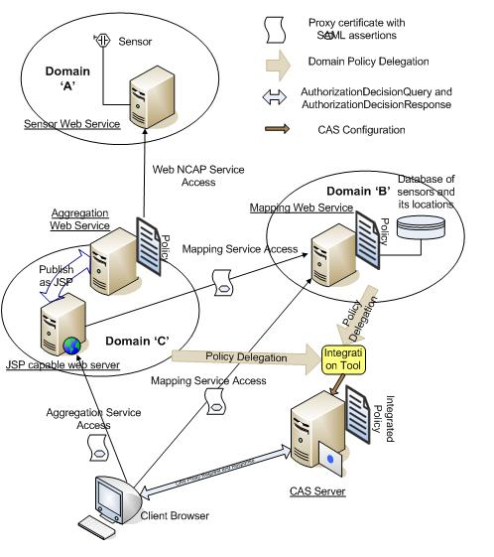
http://faculty.uoit.ca/liscano/projects.html

Sensors in building (BUILDING AUTOMATION)

The concept of building automation previously used to cover the task of providing a proper indoor climate for the inhabitants inside a building, with the owner’s restriction of spending an acceptable initial investment. Later, as a result of increasing energy costs during the 70´s, an added restriction became the desire to minimise the running energy consumption. Initially, in many buildings. this was implemented on the expense of the air quality, resulting in all kinds of indoor air quality problems

Sensors on the actual outcome clearly were needed to achieve acceptable indoor climate. Not only temperature sensors were found to be needed, but also sensors for pressure, in order to balance the air flows, humidity sensors to detect leakages, avoid water condensation orprevent a build-up of too humid or too dry air. Automatic detection of the occupancy state became possible by using carbon dioxide sensors to detect the amount of already used up air, and motion detectors to find out whether the illumination was allowed to be switched off or not. All this information needs to be collected, evaluated, and proper action needs to be taken by addressing different actuators “running the house” in an optimum way.
And the hierarchy of a fully networked building automation system with the communication standards recognised by CEN/TC247

The major building automation companies have developed complete solutions that comply with the modern views. Basically, one distinguishes between three levels in a building automation hierarchy; the management information level at the top, the field level at the bottom, and the processing level in between

This structural view of the building automation system is also reflected by the European standard committee work CEN/TC247.

European standard committee work CEN/TC247

Sensors Applications:
- Sensors in Manufacturing
- Sensors in Intelligent Buildings
- Sensors in Medicine and Health Care
- Sensors in Automotive Technology
- Sensors in Aerospace Technology
- Sensors in Environmental Technology
- Sensors in Household Appliances

SENSORS FEATURES
&
TYPES
IN INTELLIGENT
BUILDINGS
Sensor Name | Physical characterization |  |  |  | Parameter(s)  measured | Output characteristics |  |  | Operating range |  |  |  | CE Conformity | Comments
Sensor Name | Materials | size | Temperature range |  | Parameter(s)  measured | voltage | current | deformation | Max  Setting |  | Min  Setting |  | CE Conformity | Comments
FS-521  Duct air flow switch | Stainless steel | 113 x 70 x 65mm | Working | Housing | monitor air flow | 24-250Vac 15A |  |  | 2  m/s | 1  m/s | 9  m/s | 8  m/s | EN 60529 (ex IEC 529), protection class I, acc. to EN 60335-1 (ex IEC 335-1) | The FS-521 is a paddle switch intended to monitor air flow within ductwork and provide a switch output on detection of either a specific flow rate or flow failure.
FS-521  Duct air flow switch | Stainless steel | 113 x 70 x 65mm | -40°C to +85°C | -40°C to +85°C
Type of sensors:
Indoor Air Quality Sensors
- Air Flow Switch
(FS-521) Features
- Single unit to suit most applications
- Switches 240Vac directly in unit

- Liquid Flow Switch:

Features
- IP65 Rated enclosure
- Standard unit is suitable for applications up to 11bar
- Complete with paddles to suit all relevant pipe sizes and flow rates.
Sensor Name | Physical characterization |  |  |  |  | Parameter(s)  measured | Output characteristics |  |  | Operating range |  | CE Conformity | Comments
Sensor Name | Materials | size | Ambient |  |  | Parameter(s)  measured | voltage | current | deformation | Max  Pressure | Min  Pressure | CE Conformity | Comments
FS-541  Standard water flow switch 1” BSP brass fitting | 1.Stainless steel  2.Brass  3.Galvanised | 113 x 70 x 65mm | Media | Housing | Humidity | Water flow switch | 15 (8)A @ 24-250Vac |  |  | 11 bar | 30 bar | EN 60529 (ex IEC 529), protection class I, acc. to EN 60335-1 (ex IEC335-1). | The FS-541 is a paddle switch intended to monitor liquid flow within pipes and provide a switch output on detection of either a specific flow rate or flow failure.
FS-541  Standard water flow switch 1” BSP brass fitting | 1.Stainless steel  2.Brass  3.Galvanised | 113 x 70 x 65mm | -40 to +120°C | -40°C to +85°C | 10 to 90%

- Automatic Liquid Level Float Switch

- Liquid Level Float Switch
Sensor Name | Physical characterization |  |  |  | Parameter(s)  measured | Output characteristics |  |  | Operating range |  | CE Conformity | Comments
Sensor Name | Materials | size | Temperature |  | Parameter(s)  measured | voltage | current | deformation | Operation | Operating pressure | CE Conformity | Comments
Liquid Level Float Switch | 1.Acrylic  2.Brass  3.Galvanized |  | Working temp | Max. liquid temp | monitor liquid level in a tank | 15(8)A SPDT @ 230Vac |  |  | For high or low level | 11bar max. | IP65 | The LS-541 is liquid level float switch which is intended to  Monitor liquid level in a tank or vessel, to provide a switched output to provide local alarm pump or valve control.
Liquid Level Float Switch | 1.Acrylic  2.Brass  3.Galvanized |  | -40 to +85°C | 85°C

- Liquid Level Float Switch
Features
- Reliable
- Easy to install
- Easy to adjust
- Simple wiring
Sensor Name | Physical characterization |  |  |  | Parameter(s)  measured | Output characteristics |  |  | Float Operating range |  | CE Conformity | Comments
Sensor Name | Materials | size | Temperature |  | Parameter(s)  measured | Maximum switching voltage | Current rating |  | Maximum | Minimum | CE Conformity | Comments
 |  |  |  |  |  |  | Resistive | Inductive
Automatic Liquid Level Float Switch | 1.Polypropylene  2. Brass  3. Nylon | Float  125mm x 63mm dia.  Housing  59mm x 56mm x 132mm  Cord length  920mm | Ambient temp | Media temperature | control a pump for  either tank filling | 250Vac | 20A | 8A | 700mm | 50mm | IP22 | The LS-AFS is designed for simple reliable water level control.  The float switch can be used to control a pump for  either tank filling or tank emptying (a high or low level cut-out). It is easily achieved by positioning the float stops on the cord.
Automatic Liquid Level Float Switch | 1.Polypropylene  2. Brass  3. Nylon |  | -0 to +50°C | 4 to 50°C

- Ultrasonic Level Transmitter
Features

- Wire loop powered
- IP67 Housing
- 12 to 30Vdc power supply
- Fast speed of response, as much as 10m per minute
Sensor Name | Physical characterization |  |  |  | Parameter(s)  measured | Output characteristics |  |  | Float Operating range |  | Accuracy (measured range) | Comments
Sensor Name | Materials | size | Temperature |  | Parameter(s)  measured | Supply | Current rating |  | Damping | Process connection | Accuracy (measured range) | Comments
 |  |  |  |  |  |  | Output | Measurement range
Ultrasonic Level Transmitter | 1.PVDF  2. Glass filled nylon | 205.5 x 141mm | Temperature range | Operating pressure | control a pump for  either tank filling | 12 to 30Vdc loop powered | 4-20mA | 0.3m to 8m | 1 to 99 seconds (adjustable) | 2” BSPT | <1.0mm ±5mm  >1.0mm ±0.5% of measured distance | The LS-MC is a ultrasonic level transmitter for measurement  of liquids in tanks or sumps. The 4-20mA output represents  the distance between the surface of the liquid being detected  and the sensor.
Ultrasonic Level Transmitter | 1.PVDF  2. Glass filled nylon | 205.5 x 141mm | -20 to +70°C | -0.25 to 3bar max. (20°C)
- Locking nut supplied

- Side Mounting Liquid Level Switches
Features
• Low cost
• Stainless steel version suitable for most fluids
Sensor Name | Physical characterization |  |  |  | Parameter(s)  measured | Output characteristics |  |  | Float Operating range |  | Installation Category | Comments
Sensor Name | Contact Rating | Contact Resistance | Temperature |  | Parameter(s)  measured | Max. Switching Voltage | Current rating |  | Damping | Shock Resistance | Installation Category | Comments
 |  |  |  |  |  |  | Dialectric Strength | Insulation resistance
Side Mounting Liquid Level Switches | 50VA AC/DC | 200mW | Max. Temp | Max. Pressure | control a pump for  either tank filling | 350Vdc / 300Vac | 600Vdc | 10 MW | 1 to 99 seconds (adjustable) | 20G | IEC 664 Category II | The LS-S range of side mounting level switches designed for  high or low liquid level detection in tanks and vessels. Units  consist of a lever arm reed switch assembly and a tank fixing  boss..
Side Mounting Liquid Level Switches | 50VA AC/DC | 200mW | LS-SN1 & SN2 80°C  LS-SS1 & SS2 120°C | LS-SN1 & SN2 1.9bar  LS-SS1 & SS2 4.9bar

- Gas Leak Alarm Systems
Features
• Remote sensors for Natural Gas, LPG or CO
• Audio & visual alarms
• Adjustable alarm threshold
• Self-diagnosis fault system
• 2 x SPST relay outputs
• DIN rail, panel or wall mounting
Sensor Name | Physical characterization |  |  |  | Parameter(s)  measured | Output characteristics |  |  | Float Operating range |  | RH | Comments
Sensor Name | Size | Sensor material | Temperature |  | Parameter(s)  measured |  |  |  | Radio disturbance | Vibration test | RH | Comments
 |  |  |  |  |  | Power supply | Power consumption | Relay outputs
Gas Leak Alarm Systems | 77 x 77 x 44 | 1. Nylon  2. ABS | Storage temp | Operating temp | gas leak alarm systems | 230Vac ±10% @ 50/60Hz  12V ±10% | 7VA | 2 x SPDT, 250V @ 5 (1) A | VDE0875/0871 | with 2g (DIN 40046) | Class F Din 40040 | The CL-CO-RFG65x is a series of gas leak alarm systems,  that are designed for the detection of gas leaks in spaces  such as boiler plant rooms, workshops and other industrial  gas installations, to provide safety alarm and shutdown facilities on detection of gas leakage.
Gas Leak Alarm Systems | Housing dimensions 105 x 115 x 70mm | 1. Nylon  2. ABS | -25 to + 60°C | 0 to 45°C
- Channel Gas Leak Alarm System:
Features
• Remote sensor for Natural Gas, LPG or CO relative humidity
• Audio & visual alarms
Sensor Name | Physical characterization |  |  |  | Parameter(s)  measured | Output characteristics |  |  | Float Operating range |  | RH | Comments
Sensor Name | Size | Sensor material | Temperature |  | Parameter(s)  measured |  |  |  | Radio disturbance | Vibration test | RH | Comments
 |  |  |  |  |  | Power supply | Power consumption | Relay outputs
Channel Gas Leak Alarm System | Housing dimensions 115 x 53 x 70mm  Sensor dimensions 77 x 77 x 44mm | 1. Nylon  2. ABS | Storage temp | Operating temp | detection of gas leaks in spaces | 230Vac ±10% @ 50/60Hz | 3VA | SPDT, 250V @ 5 (1) A | VDE0875/0871 | with 2g (DIN 40046) | Class F Din 40040 | The CL-CO-RFG361 is a single channel gas leak alarm system.  It is designed for the detection of gas leaks in spaces  such as boiler plant rooms, workshops and other industrial  gas installations, to provide safety alarm and shutdown  facilities on detection of gas leakage.
Channel Gas Leak Alarm System |  | 1. Nylon  2. ABS | -25 to + 60°C | 0 to 45°C
• DIN rail or panel mounting

- Duct Smoke Detector
Features
• Damped or un-damped output
• Manual or auto reset
• Analogue output for service diagnostics
Sensor Name | Physical characterization |  |  |  | Parameter(s)  measured | Output characteristics |  |  |  | Float Operating range |  | Protection | Comments
Sensor Name | Size | Sensor material | Ambient range |  | Parameter(s)  measured |  |  |  |  | Signal damping | Sensitivity | Protection | Comments
 |  |  |  |  |  | Power supply | Analogue | Relay outputs | Power consumption
Duct Smoke Detector | Minimum duct size 100 x 320mm  Maximum duct size 450 x 450mm | Glass-filled Polycarbonate to  UL94V-0 | Temperature | RH | detection of gas leaks in spaces | 24Vac 50/60Hz or 24Vdc(-10 +15%) | 2-10Vdc | SPST 1A @ 24Vdc, 120Vac | 62mA | On/Off selectable | with 2g (DIN 40046) | 3 to 25% obscuration, adjustable | The SD-521 provides an auto or manual reset relay output  on detection of smoke, with a user adjustable threshold. An  analogue output can transmit smoke and service alarms to a  BEMS system
Duct Smoke Detector | Minimum duct size 100 x 320mm  Maximum duct size 450 x 450mm | Glass-filled Polycarbonate to  UL94V-0 | -+10 to 40°C | 0 to 95% non-condensing

- Duct Mount RH & T Sensors
Features
• High stability and reliability
• No loss of accuracy up to 100% RH
• Built-in circuitry diagnostics
• ±2% and ±3% Accuracy versions
• 4-20mA or 0-10Vdc outputs (link selectable)
Sensor Name | Physical characterization |  |  |  | Parameter(s)  measured | Output characteristics |  |  |  | RH accuracy |  | Long term stability | Comments
Sensor Name | Size | Sensor material | Output ranges |  | Parameter(s)  measured |  |  |  |  | RH-DT01 | RH-DT02 | Long term stability | Comments
 |  |  |  |  |  | Power supply | Connections | Outputs | Power consumption
Duct Mount RH & T Sensors | Housing 55 x 90mm dia.  Probe 215 x 19mm dia. | 1.ABS  2.PVC  3.Delrin | Temperature | RH | humidity & temperature sensors | 4-20mA 20 - 35Vdc for 500Ω loop resistance  0-10Vdc 17 - 34Vdc, | 0.5 - 2.5mm² cable | 4-20mA or 0-10Vdc | 62mA | ±2% | ±3% | < 2% RH p.a. | The SD-521 provides an auto or manual reset relay output  on detection of smoke, with a user adjustable threshold. An  analogue output can transmit smoke and service alarms to a  BEMS system
Duct Mount RH & T Sensors | Housing 55 x 90mm dia.  Probe 215 x 19mm dia. | 1.ABS  2.PVC  3.Delrin | -20 to +50°C | 0 to 100%RH
• Direct thermistor temperature options available.

