Web advertising interactive marketing:
Online marketing, enabled by the Internet, in which advertisers can interact directly with customers and consumers can interact with advertisers/vendors
- Two major business models for advertising online:
    - Using the Web as a channel to advertise a firm’s own products and services
    - Making a firm’s site a public portal site and using captive audiences to advertise products offered by other firms

Advertising Strategies and Promotions Online:
- affiliate marketing
A marketing arrangement by which an organization refers consumers to the selling company’s Web site
- viral marketing
Word-of-mouth marketing by which customers promote a product or service by telling others about it
- Webcasting
A free Internet news service that broadcasts personalized news and information, including seminars, in categories selected by the user
- Customizing Ads

Admediation:
Third-party vendors that conduct promotions, especially large-scale ones
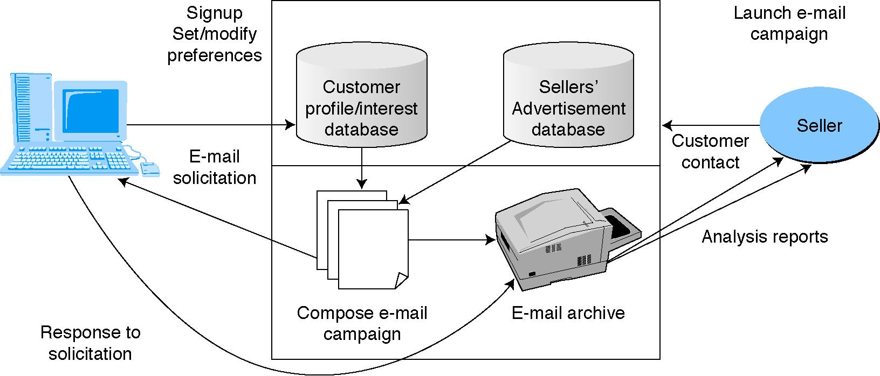
Fig. 1: Framework for Admediation

- Online Events, Promotions, and Attractions
  - Major considerations when implementing an online ad campaign:
    - Target audience of online surfers clearly understood
    - Traffic to the site should be estimated, and a powerful enough server used handle the expected traffic volume
    - Assessment of results is needed to evaluate the budget and promotion strategy
    - Consider co-branding

Special Advertising Topics:
Permission Advertising:
- spamming
Using e-mail to send unwanted ads (sometimes floods of ads)
- permission advertising (permission marketing)
Advertising (marketing) strategy in which customers agree to accept advertising and marketing materials
Ad management
Methodology and software that enable organizations to perform a variety of activities involved in Web advertising (e.g., tracking viewers, rotating ads)
Localization
The process of converting media products developed in one environment (e.g., country) to a form culturally and linguistically acceptable in countries outside the original target market
Internet radio
A Web site that provides music, talk, and other entertainment, both live and stored, from a variety of radio stations
Ad Content
  - The content of ads is extremely important, and companies use ad agencies to help in content creation for the Web just as they do for other advertising media
  - Content is especially important to increase stickiness

Software Agents in Marketing and Advertising Applications:
- A Framework for Classifying EC Agents: Agents that Support:
  - Need identification (what to buy)
  - Product brokering (from whom to buy)
  - Merchant brokering and comparisons
  - Buyer-seller negotiation
  - Purchase and delivery
  - After-sale service and evaluation
- Character-Based Animated Interactive Agents
- Avatars
Animated computer characters that exhibit humanlike movements and behaviors
- Social computing
An approach aimed at making the human-computer interface more natural
- Chatter bots
Animation characters that can talk (chat)

